# Database

## What is a Database?

🡪Database is a systematic collection of data.

🡪Databases support storage and manipulation of data.

🡪Databases make data management easy. Let's discuss few examples.

An online telephone directory would definitely use database to store data pertaining to people, phone numbers, other contact details, etc.

Your electricity service provider is obviously using a database to manage billing, client related issues, to handle fault data, etc.

Let's also consider the facebook. It needs to store, manipulate and present data related to members, their friends, member activities, messages, advertisements and lot more.

## What is a Database Management System (DBMS)?

🡪Database Management System (DBMS) is a collection of programs which enables its users to access database, manipulate data, reporting / representation of data.

🡪It also helps to control access to the database.

🡪Database Management Systems are not a new concept and as such had been first implemented in 1960s.

🡪Charles Bachmen's Integrated Data Store (IDS) is said to be the first DBMS in history.

## Types of DBMS

* **Hierarchical** - this type of DBMS employs the "parent-child" relationship of storing data. This type of DBMS is rarely used nowadays. Its structure is like a tree with nodes representing records and branches representing fields. The windows registry used in Windows XP is an example of a hierarchical database. Configuration settings are stored as tree structures with nodes.
* **Network DBMS** - this type of DBMS supports many-to many relations. This usually results in complex database structures.  RDM Server is an example of a database management system that implements the network model.
* **Relational DBMS** - this type of DBMS defines database relationships in form of tables, also known as relations. Unlike network DBMS, RDBMS does not support many to many relationships. Relational DBMS usually have pre-defined data types that they can support. This is the most popular DBMS type in the market. Examples of relational database management systems include MySQL, Oracle, and Microsoft SQL Server database.
* **Object Oriented Relation DBMS** - this type supports storage of new data types. The data to be stored is in form of objects. The objects to be stored in the database have attributes (i.e. gender, ager) and methods that define what to do with the data. PostgreSQL is an example of an object-oriented relational DBMS.

**Structured Query Language - SQL**

# SQL Server Management Studio (SSMS):

🡪Client tool used to write and execute queries.

Select Database engine as server type 🡪3 options displayed

🡪SQL Server Analysis Service

🡪SQL Server Reporting Service

🡪SQL Server Integration Service

🡪SQL server name – IP address of server, (local)/just ‘.’

SQL Server Management Studio 🡪 2 authentication

🡪Windows authentication

🡪SQL authentication (Username and password)

🡪SSMS is a client tool and not server by itself.

🡪Developer Machines connect to SQL Database server using SSMS.

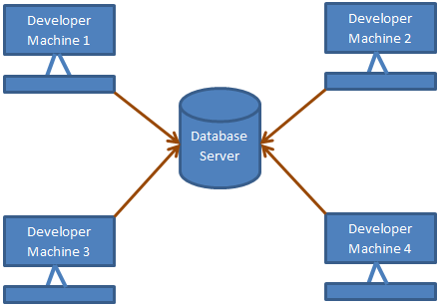

SQL server will display system database in object explorer.

# Creating, altering and dropping database

**Create Database**

🡪2 ways 🡪 Graphically or by writing Query.

Graphically 🡪Select new database folder in object explorer🡪Enter database name and click OK.

Query 🡪 CREATE DATABSE DB2

2 files are created once database are created

.MDF file 🡪 Data file (contains actual data) – Master Data File

.LDF file 🡪 Transaction Log file (Used to recover from database) – Log Data File

**Alter DB name after creating**

Sp_renameDB ‘DB1’,’ newDB1’ - System Stored Procedures

Or

Alter database DatabaseName modify name = NewDatabaseName

**Delete or Drop Database:**

Drop Database [databasename]

DROP DATABASE [NEWDB1]

🡪Cannot drop the database if it is currently being used

Cannot drop the database 'DB2', because it does not exist or you do not have permission.

🡪The above error message gets displayed.

Alter Database [NEWDB1] SET SINGLE_USER WITH ROLLBACK IMMEDIATE

🡪If other users are connected to that DB, use above alter query to put the database in single user mode and then drop the database.

🡪With Rollback immediate option, will rollback all incomplete transactions and closes connection to database.

🡪System Database cannot be dropped.

🡪Dropping database will delete all .MDF and .LDF files.

MDF🡪Master Database File

LDF🡪Log Database File

# Creating and working with Tables

Primary Key and Foreign Key are Constraints.

* Tables can be created in SSMS graphically or using Query.
* Primary key is used to uniquely identify each row/record within the table.
* Primary Key does not allow null.
* A table can have only one primary key.

Graphically,

🡪Right click on table 🡪New Table.

🡪Enter Column name, Data type and allow null.

🡪Right Click on table and click save (Ctrl +S).

🡪Right click on firs column and mention as Primary key.

Using Query,

Use [2904DB1] 🡪Use Database

Go

Create Table tblGender

(

ID int NOT NULL Primary Key, [Column Name, Data type, Null/Not NULL, Key]

Gender Varchar(50) NOT NULL [Column Name, Data type, Null/Not NULL]

)

Insert Values into tables graphically,

🡪Right Click Table name and select edit top 200 rows.

Foreign Key using graphical method,

🡪Right click on table and click on design.

🡪Again right click on column and click on relationships.

🡪 Click on the elipses button, that is present in Tables and Column Specification row

* Select Primary key table its column and foreign key table its column.

By using Query:

ALTER TABLE dbo.tblPerson

ADD CONSTRAINT tblperson_GENDERID_FK

FOREIGN KEY (GENDERID) REFERENCES tblGender(ID)

**Syntax for foreign key**

**ALTER TABLE** FOREIGNKEYTABLE

**ADD CONSTRAINT** FOREIGNKEYTABLE_FOREIGNKEYCOLUMN_FK

FOREIGN KEY (FOREIGNKEYCOLUMN)

REFERENCES PRIMARYKEYTABLE (PRIMARYKEYCOLUMN)

* Foreign key is used to maintain database integrity.
* Foreign key in a table points to the primary key in another table.
* A foreign key constraint prevents invalid data being inserted into the foreign key column.

🡪To display list of available tables in the selected Database

SELECT * FROM INFORMATION_SCHEMA.TABLES

select * from sys.tables;

The following constraints are commonly used in SQL:

* [**NOT NULL**](https://www.w3schools.com/sql/sql_notnull.asp) - Ensures that a column cannot have a NULL value
* [**UNIQUE**](https://www.w3schools.com/sql/sql_unique.asp) - Ensures that all values in a column are different
* [**PRIMARY KEY**](https://www.w3schools.com/sql/sql_primarykey.asp) - A combination of a NOT NULL and UNIQUE. Uniquely identifies each row in a table
* [**FOREIGN KEY**](https://www.w3schools.com/sql/sql_foreignkey.asp) - Uniquely identifies a row/record in another table
* [**CHECK**](https://www.w3schools.com/sql/sql_check.asp) - Ensures that all values in a column satisfies a specific condition
* [**DEFAULT**](https://www.w3schools.com/sql/sql_default.asp) - Sets a default value for a column when no value is specified
* [**INDEX**](https://www.w3schools.com/sql/sql_create_index.asp) - Used to create and retrieve data from the database very quickly

# Identity column

* If a column is marked as identity. System automatically generates values for that particular column.

🡪Right click on column and set identity as YES.

🡪set seed value(start Value) and increment value🡪save the table

🡪right click on column name and check the properties🡪identity displayed as TRUE

alter table tblPers  
add Id int identity(5,1)

Create Table Tbl1

(

EmpID int NOT NULL IDENTITY,

Name Varchar(50)

)

By Default seed – 1 and Increment – 1

**Workaround:**

To change the **Prevent saving changes that require the table re-creation** option, follow these steps:

Open SQL Server Management Studio (SSMS).

On the **Tools** menu, click **Options**.

In the navigation pane of the **Options** window, click **Designers**.

Select or clear the **Prevent saving changes that require the table re-creation** check box, and then click **OK**.

**Inserting Explicit Values:**

Insert into tblUserdetails values('Charu')

Insert into tblUserdetails values(2,'Charu')

Below Error message gets displayed:

An explicit value for the identity column in table 'tblUserdetails' can only be specified when a column list is used and IDENTITY_INSERT is ON.

**To explicitly supply a value for identity column**

🡪First turn on identity insert - SET Identity_Insert tblPerson ON.  
🡪In the insert query specify the column list(mention column names).

SET IDENTITY_INSERT tblUserdetails ON

Insert into tblUserdetails(ID,Name) values (1,'Charu')

Insert into tblUserdetails values('kumaru')

Error message while inserting the values into table when IDENTITY_INSERT is ON.

Explicit value must be specified for identity column in table 'tblUserdetails' either when IDENTITY_INSERT is set to ON or when a replication user is inserting into a NOT FOR REPLICATION identity column.

SET IDENTITY_INSERT tblUserdetails OFF

🡪If you have deleted all the rows in a table, and you want to reset the identity column value, use DBCC CHECKIDENT command.

DBCC – Database consistency check commands

🡪This command will reset PersonId identity column.

DBCC CHECKIDENT(tblPerson, RESEED, 0)

Checking identity information: current identity value '8'.

DBCC execution completed. If DBCC printed error messages, contact your system administrator.

Retrieving Last Generated Identity Value

🡪There are several ways in sql server, to retrieve the last identity value that is generated. 🡪The most common way is to use SCOPE_IDENTITY() built in function.

🡪Apart, from using SCOPE_IDENTITY(), you also have @@IDENTITY and IDENT_CURRENT('TableName') function

**🡪SCOPE_IDENTITY()** - returns the last identity value that is created in the same session and in the same scope.  
**🡪@@IDENTITY** - returns the last identity value that is created in the same session and across any scope.  
**🡪IDENT_CURRENT('TableName')** - returns the last identity value that is created for a specific table across any session and any scope.

**Create Trigger Example**

Create Trigger Trforinsert on Tbl1 for Insert

as

Begin

Insert into Tbl1 values('Kenny')

End

Select SCOPE_IDENTITY()

Select @@IDENTITY

Select IDENT_CURRENT('Tbl1')

# ADDING DEFAULT CONSTRAINT:

**🡪 Default constraint is used to insert default value into a column. Default value will be added to all new records, if no other value is specified including NULL.(IF NULL is specified system will display NULL in DB)**

* **Adding additional column to the table**

ALTER TABLE tblPerson

ADD NICKNAME INT NULL;

**🡪Syntax for DEFAULT Constraint**

ALTER TABLE { TABLE_NAME }  
ADD CONSTRAINT { CONSTRAINT_NAME }  
DEFAULT { DEFAULT_VALUE } FOR { EXISTING_COLUMN_NAME }

ALTER TABLE DEFAULTTABLE

ADD CONSTRAINT DEFCONS

DEFAULT 'UNKNOWN' FOR NICKNAME

INSERT INTO DEFAULTTABLE(ID,NAME) VALUES (13,'ARJUNKUMAR')

* **EDIT DATATYPE FOR A COLUMN**

**🡪ALTER** TABLE table_name. **ALTER** COLUMN column_name **datatype**

ALTER TABLE [DEFAULTTABLE]

ALTER COLUMN NICKNAME VARCHAR(MAX);

* **INSERT VALUES INTO TABLE**

INSERT INTO DEFAULTTABLE(ID,NAME,NICKNAME) VALUES (11,'ARUNKUMAR','ARUN')

* **DROP default constraint**

ALTER TABLE { TABLE_NAME }   
DROP CONSTRAINT { CONSTRAINT_NAME }

ALTER TABLE DEFAULTTABLE

DROP CONSTRAINT DEFCONS

# Cascading Referential Integrity Constraint:

**🡪**Cascading referential integrity constraint allows to define the actions Microsoft Sql Server should take when user attempts to delete or update a key to which an existing foreign key points (Not in Foreign Key Table).

**Changing/alter column name in table:**

* **SP_RENAME ‘TABLE_NAME.OLD_COLUMN_NAME’,’NEW_COLUMN_NAME’**

**EG.** SP_RENAME 'TB2.AGE','GENDER'

**OUTPUT:** Caution: Changing any part of an object name could break scripts and stored procedures.

**Add foreign key constraint to a column:**

ALTER TABLE TB1

ADD CONSTRAINT FK_TB1

FOREIGN KEY (GENDERID) REFERENCES TB2(ID)

**the following options when setting up Cascading referential integrity constraint**

1. **No Action**: This is the default behaviour. No Action specifies that if an attempt is made to delete or update a row with a key referenced by foreign keys in existing rows in other tables, an error is raised and the DELETE or UPDATE is rolled back.

The DELETE statement conflicted with the REFERENCE constraint "tblperson_GENDERID_FK". The conflict occurred in database "3004DB", table "dbo.tblPerson", column 'GENDERID'.

The statement has been terminated.

1. **Set Default:** Specifies that if an attempt is made to delete or update a row with a key referenced by foreign keys in existing rows in other tables, all rows containing those foreign keys are set to default values.
2. **Set NULL**: Specifies that if an attempt is made to delete or update a row with a key referenced by foreign keys in existing rows in other tables, all rows containing those foreign keys are set to NULL.
3. **Cascade**: Specifies that if an attempt is made to delete or update a row with a key referenced by foreign keys in existing rows in other tables, all rows containing those foreign keys are also deleted or updated.

By default, we get an error and the DELETE or UPDATE statement is rolled back.

# Check Constraint

**🡪** Check constraint is used to limit range of values that can be entered for a column.

* To know column data type of table 🡪Highlight table 🡪 ALT+F1.
* Constraint is a Boolean expression which returns TRUE or FALSE.
* NULL is the value passed 🡪 Boolean expression returns NULL (Unknown Value).

Create check constraint using graphical method or

ALTER TABLE tbl1

ADD CONSTRAINT CK_TBL1_AGE

CHECK (AGE >=0 AND AGE <100)

Example

//

CREATE TABLE Persons (

ID int NOT NULL,

LastName varchar(255) NOT NULL,

FirstName varchar(255),

Age int,

City varchar(255),

CONSTRAINT CHK_Person CHECK (Age>=18 AND City='Sandnes')

);

//

TO DELETE CHECK CONSTARINT

ALTER TABLE tbl1

DROP CONSTRAINT CK_TBL1_AGE

# Unique Key Constraint

🡪We use UNIQUE constraint to enforce uniqueness of a column i.e the column shouldn't allow any duplicate values.

We can add a Unique constraint thru the designer or using a query.

**To add a unique constraint using SQL server management studio designer:**

1. Right-click on the table and select Design  
2. Right-click on the column, and select Indexes/Keys.  
3. Click Add  
4. For Columns, select the column name you want to be unique.  
5. For Type, choose Unique Key.  
6. Click Close, Save the table.

**To create the unique key using a query:**

Alter Table Table_Name  
Add Constraint Constraint_Name Unique(Column_Name)

Alter table Tbl3

Add Constraint UQ_Tbl3_Emailid Unique(Emailid)

Alter table Tbl3

Add Constraint UQ_Tbl3_Name Unique(Name)

Insert into Tbl3 values (101,'ARVI','a@a.com')

Msg 2627, Level 14, State 1, Line 1

Violation of UNIQUE KEY constraint 'UQ_Tbl3_Name'. Cannot insert duplicate key in object 'dbo.Tbl3'. The duplicate key value is (ARVI).

The statement has been terminated.

🡺A table can have, only one primary key. If you want to enforce uniqueness on 2 or more columns, then we use unique key constraint.

**1.** A table can have only one primary key, but more than one unique key  
**2.** Primary key does not allow nulls, where as unique key allows one null

**Adding constraint while creating the table**

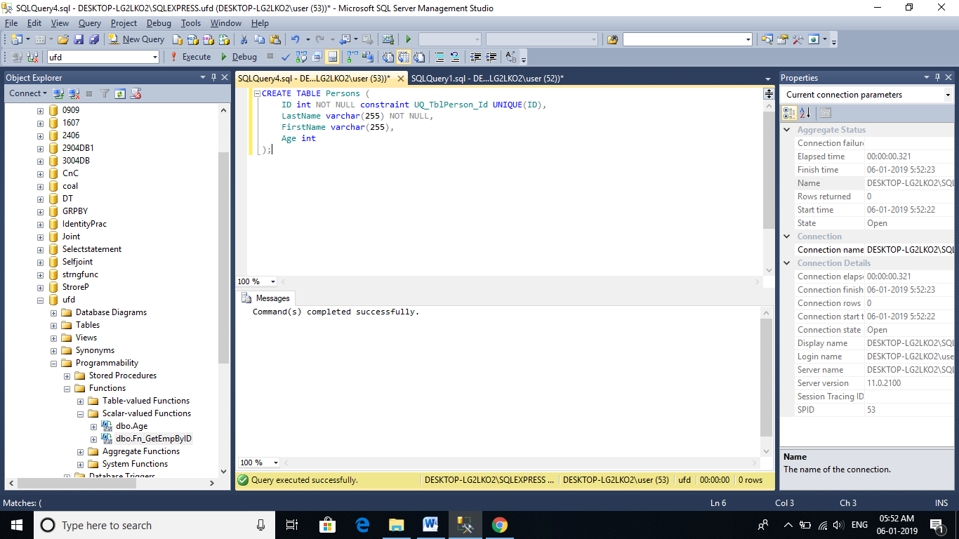

**To drop the constraint**

**1.** Right click the constraint and delete.

Or

**2.** Using a query  
Alter Table tblPerson  
Drop COnstraint UQ_tblPerson_Email

Alter Table Tbl3

Drop Constraint UQ_Tbl3_Name

# Select Statement:

**Basic select statement syntax**  
SELECT Column_List  
FROM Table_Name

**If you want to select all the columns, you can also use *. For better performance use the column list, instead of using *.**

SELECT *  
FROM Table_Name

Select * from Test1

Query Can be scripted using Right Click on Table 🡪Script Table as SELECT TO.

This query will fetch the entire column list even the other DB is selected.

USE [Selectstatement]

GO

SELECT [SerialNumber]

,[Name]

,[Mobilenumber]

FROM [Selectstatement]. [dbo].[Test1]

GO

**DB.Schema.Tablename**

**To Select distinct rows use DISTINCT keyword**

SELECT DISTINCT Column_List  
FROM Table_Name  
  
**Example**: Select distinct city from tblPerson

Select Distinct Name from Test1

Select Distinct SerialNumber, Name from Test1

**Filtering rows with WHERE clause**

SELECT Column_List  
FROM Table_Name  
WHERE Filter_Condition

**Example:** Select Name, Email from tblPerson where City = 'London'  
  
**Note:** Text values, should be present in single quotes, but not required for numeric values.

Select * from Test1 where Mobilenumber=1111111

**List Of Operators**

**= 🡪Equal To**

**<> 🡪Not Equal To**

**> 🡪Greater than**

**< 🡪Less than**

**>= 🡪Greater than or equal to**

**<= 🡪Less than or equal to**

**IN 🡪Specify List of Values**

**BETWEEN 🡪Specify range of values**

**LIKE 🡪Specify pattern**

**NOT 🡪Not in List, range etc**

**% 🡪Specifies zero or more characters**

**_** 🡪**Specifies exactly one character**

**[ ] 🡪Any character within bracket followed by %**

**[^] 🡪Not any character with in brackets followed by %**

Select * from Test1 where Mobilenumber=1111111

Select * from Test1 where SerialNumber > 105

Select * from Test1 where SerialNumber < 105

Select * from Test1 where SerialNumber <> 105

Select * from Test1 where SerialNumber != 105

Select * from Test1 where Serial

Number IN (100,105,110)

Select * from Test1 where SerialNumber Between 100 AND 105

Select * from Test1 where Name LIKE 'Kums%'

% - WildCard

Select * from Test1 where Name NOT LIKE 'Kums%'

Select * from Test1 where Name LIKE '%ur%'

Select * from Test1 where Name LIKE '_ur_'

Select * from Test1 where Name LIKE '[K]%'

Select * from Test1 where Name LIKE '[^K]%'

Select * from Test1 where Name LIKE '%[U234]'

**Joining Multiple conditions using AND & OR**

Select * from Test1 where (Name = 'GURU' OR Name = 'GURU2') AND Mobilenumber = 66673

**Sorting Rows using Order By**

Select * from Test1 Order by Name 🡪 By Default Ascending Order

Select * from Test1 Order by Name DESC

Select * from Test1 Order by Name DESC, Mobilenumber ASC

**Selecting Top n or Top n Percentage of rows (from overall Table)**

* Top Keyword is used when Table is very Large.

Select Top 2 * from Test1

Select Top 50 percent * from Test1

Select top 1 * from Test1 Order by Name

# Group By

In SQL Server we have got lot of aggregate functions. Examples

1. Count()  
2. Sum()  
3. avg()  
4. Min()  
5. Max()  
  
**Group by** clause is used to group a selected set of rows into a set of summary rows by the values of one or more columns or expressions. It is always used in conjunction with one or more aggregate functions.

Select Sum(Salary) from Saldetail

Select Sum(Age) from Saldetail

Select Max(Age) from Saldetail

Select Min(Salary) from Saldetail

Select Avg(Salary) from Saldetail

**Query for retrieving total salaries by city**: 

We are applying SUM() aggregate function on Salary column, and grouping by city column. This effectively adds, all salaries of employees with in the same city.

**Select City, SUM(Salary) as TotalSalary**  
**from tblEmployee**  
**Group by City**  
  
**Note:** If you omit, the group by clause and try to execute the query, you get an error - Column 'tblEmployee.City' is invalid in the select list because it is not contained in either an aggregate function or the GROUP BY clause.

Select Department, Sum(Salary) as TotalSalary

from Saldetail

Msg 8120, Level 16, State 1, Line 1

Column 'Saldetail.Department' is invalid in the select list because it is not contained in either an aggregate function or the GROUP BY clause.

Select Department, Sum(Salary) as TotalSalary 🡪 ALIAS

from Saldetail

Group By Department

Select Age, Sum(Salary) as TotalSalary

from Saldetail

Group By Age

Select Age, Department, Sum(Salary) as TotalSalary

from Saldetail

Group By Age

Msg 8120, Level 16, State 1, Line 1

Column 'Saldetail.Department' is invalid in the select list because it is not contained in either an aggregate function or the GROUP BY clause.

**Query for retrieving total salaries by city and by gender**: It's possible to group by multiple columns. In this query, we are grouping first by city and then by gender. 

**Select City, Gender, SUM(Salary) as TotalSalary**  
**from tblEmployee**  
**group by City, Gender**

Select Department,Age, Sum(Salary) as TotalSalary

from Saldetail

Group By Department,Age

Select Count(*) from Saldetail 🡪 Aggregate function

Select Count(Name) from Saldetail

Select Department,Age, Sum(Salary) as TotalSalary, Count(Name) as [Total Employees]

from Saldetail

Group By Department,Age

**Where & Having**

Select Department,Age, Sum(Salary) as TotalSalary, Count(Name) as [Total Employees]

from Saldetail

Where Department = 'CS'

Group By Department,Age

Select Department,Age, Sum(Salary) as TotalSalary, Count(Name) as [Total Employees]

from Saldetail

Group By Department,Age

Having Department = 'CS'

Select Department,Age, Sum(Salary) as TotalSalary, Count(Name) as [Total Employees]

from Saldetail

Where Age = 20

Group By Department,Age

Select Department,Age, Sum(Salary) as TotalSalary, Count(Name) as [Total Employees]

from Saldetail

Group By Department,Age

Having Age = 20

**Difference between Where and Having**

1. WHERE clause can be used with - Select, Insert, and Update statements, where as HAVING clause can only be used with the Select statement.

2. WHERE filters rows before aggregation (GROUPING), where as, HAVING filters groups, after the aggregations are performed.

3.Aggregate functions cannot be used in the WHERE clause, unless it is in a sub query contained in a HAVING clause, whereas, aggregate functions can be used in Having clause.

Select Name,Sum(Salary) from Saldetail

Group By Name

Having SUM(Salary) > 1000

Select Name,Sum(Salary) from Saldetail

Where SUM(Salary) > 1000

Group By Name

An aggregate may not appear in the WHERE clause unless it is in a subquery contained in a HAVING clause or a select list, and the column being aggregated is an outer reference.

# Joins

**🡪Joins in SQL server** are used to query (retrieve) data from 2 or more related tables. In general tables are related to each other using foreign key constraints.

**In SQL server, there are different types of JOINS.**  
1. CROSS JOIN  
2. INNER JOIN   
3. OUTER JOIN

**Outer Joins are again divided into 3 types**  
1. Left Join or Left Outer Join  
2. Right Join or Right Outer Join  
3. Full Join or Full Outer Join

Create table tblDepartment

(

ID int primary key,

DepartmentName nvarchar(50),

Location nvarchar(50),

DepartmentHead nvarchar(50)

)

Go

Insert into tblDepartment values (1, 'IT', 'London', 'Rick')

Insert into tblDepartment values (2, 'Payroll', 'Delhi', 'Ron')

Insert into tblDepartment values (3, 'HR', 'New York', 'Christie')

Insert into tblDepartment values (4, 'Other Department', 'Sydney', 'Cindrella')

Go

Create table tblEmployee

(

ID int primary key,

Name nvarchar(50),

Gender nvarchar(50),

Salary int,

DepartmentId int foreign key references tblDepartment(Id)

)

Go

Insert into tblEmployee values (1, 'Tom', 'Male', 4000, 1)

Insert into tblEmployee values (2, 'Pam', 'Female', 3000, 3)

Insert into tblEmployee values (3, 'John', 'Male', 3500, 1)

Insert into tblEmployee values (4, 'Sam', 'Male', 4500, 2)

Insert into tblEmployee values (5, 'Todd', 'Male', 2800, 2)

Insert into tblEmployee values (6, 'Ben', 'Male', 7000, 1)

Insert into tblEmployee values (7, 'Sara', 'Female', 4800, 3)

Insert into tblEmployee values (8, 'Valarie', 'Female', 5500, 1)

Insert into tblEmployee values (9, 'James', 'Male', 6500, NULL)

Insert into tblEmployee values (10, 'Russell', 'Male', 8800, NULL)

Go

**General Formula for Joins**

SELECT      ColumnList  
FROM           LeftTableName  
JOIN_TYPE  RightTableName  
ON                 JoinCondition

**Note:** **JOIN or INNER JOIN means the same. It's always better to use INNER JOIN, as this explicitly specifies your intention**

🡪**INNER JOIN returns only the matching rows between both tables.**

**🡪Non-matching rows are eliminated**.

Select Name,Gender,Salary,DepartmentName

from tblEmployee

INNER JOIN tblDepartment

ON tblEmployee.DepartmentId=tblDepartment.ID

Select tblemployee.ID,Name,Salary,Location

from tblEmployee

INNER JOIN tblDepartment

ON tblEmployee.DepartmentId=tblDepartment.ID

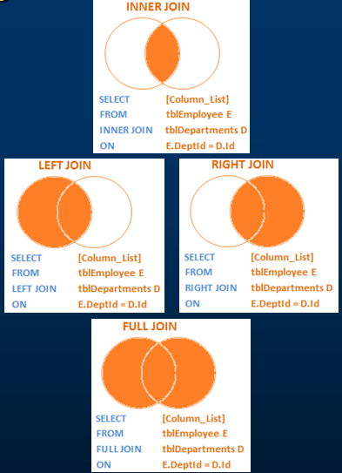

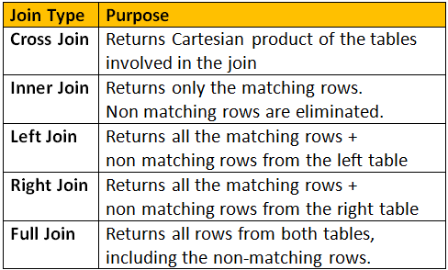

Update tblEmployee

SET Departmentid=Null

where Name='Valarie'

**OUTER Join**

1. Left Outer join
2. Right Outer join
3. Full Outer join

* **LEFT JOIN(Left Outer Join)** returns all the matching rows + non matching rows from the left table.

**🡪** In reality, INNER JOIN and LEFT JOIN are extensively used.

Select tblemployee.ID,Name,Salary,Location

from tblEmployee

LEFT OUTER JOIN tblDepartment

ON tblEmployee.DepartmentId=tblDepartment.ID

Select E.ID,Name,Salary,Location

from tblEmployee E

LEFT OUTER JOIN tblDepartment D

ON E.DepartmentId=D.ID

* Right Outer Join -- returns all the matching rows + non-matching rows from the right table.

Select E.ID,Name,Salary,Location

from tblEmployee E

RIGHT OUTER JOIN tblDepartment D

ON E.DepartmentId=D.ID

**FULL JOIN or FULL OUTER JOIN**

🡪I want all the rows from both the tables involved in the join.

🡪Returns all the rows from both the tables, including the non-matching rows.

Select Name,Gender,Salary,Location

from tblEmployee

FULL OUTER JOIN tbldepartment

ON tblEmployee.DepartmentId=tblDepartment.ID

* Displays matching records, non matching records from employee table and non- matching records from the Department table.

**CROSS JOIN**

🡪CROSS JOIN, produces the cartesian product of the 2 tables involved in the join. For example, in the Employees table we have 10 rows and in the Departments table we have 4 rows. So, a cross join between these 2 tables produces 40 rows

🡪Cross Join shouldn't have ON clause. 

Select Name,Gender,Salary,Location

from tblEmployee

CROSS JOIN tbldepartment

# Advanced Joins

* Also called as Intelligent Joins.

🡪Retrieve only Non-matching rows from Left Table.

🡪**Query:**

SELECT       Name, Gender, Salary, DepartmentName  
FROM           tblEmployee E  
LEFT JOIN   tblDepartment D  
ON                 E.DepartmentId = D.Id  
WHERE        D.Id IS NULL

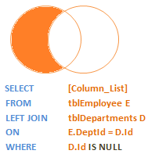

Select Name,Gender,DepartmentName,Location

from tblEmployee e

Left Outer Join tblDepartment d

On e.DepartmentId=d.ID

where DepartmentId IS NULL

**retrieve only the non matching rows from the right table**

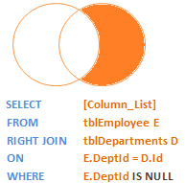

**Query:**  
SELECT         Name, Gender, Salary, DepartmentName  
FROM             tblEmployee E  
RIGHT JOIN    tblDepartment D  
ON                   E.DepartmentId = D.Id  
WHERE          E.DepartmentId IS NULL

Select Name,Gender,DepartmentName,Location

from tblEmployee e

Right Outer Join tblDepartment d

On e.DepartmentId=d.ID

where DepartmentId IS NULL

**retrieve only the non-matching rows from both the left and right table. Matching rows should be eliminated.**

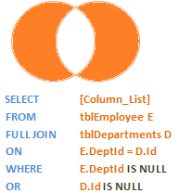

**Query:**  
SELECT         Name, Gender, Salary, DepartmentName  
FROM              tblEmployee E  
FULL JOIN      tblDepartment D  
ON                   E.DepartmentId = D.Id  
WHERE          E.DepartmentId IS NULL  
OR                   D.Id IS NULL

Select Name,Gender,DepartmentName,Location

from tblEmployee e

Full Outer Join tblDepartment d

On e.DepartmentId=d.ID

where DepartmentId IS NULL

OR

d.ID IS NULL

* Should not use = to compare NULL, must use IS NULL or IS NOT NULL

# Self join in sql server

* Joining a table with itself.

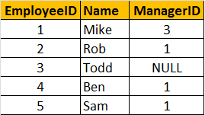

Write a query which gives the following result

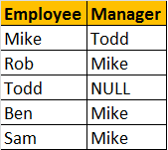

**Self Join Query:**

A MANAGER is also an EMPLOYEE. Both the, EMPLOYEE and MANAGER rows, are present in the same table. Here we are joining tblEmployee with itself using different alias names, E for Employee and M for Manager. We are using LEFT JOIN, to get the rows with ManagerId NULL. You can see in the output TODD's record is also retrieved, but the MANAGER is NULL. If you replace LEFT JOIN with INNER JOIN, you will not get TODD's record.

* joining a table with itself is called as **SELF JOIN**

Select E.Name as Employee, M.Name as Manager  
from tblEmployee E  
Left Join tblEmployee M  
On E.ManagerId = M.EmployeeId

LEFT OUTER JOIN – SELF JOIN

Select * from tblemployee

Select E.Name as Employee, M.Name as Manager

from tblEmployee E

LEFT OUTER JOIN tblEmployee M

On E.ManagerId = M.EmployeeId

INNER JOIN – SELF JOIN

Select e.Name AS [Employee Name], m.Name AS [Manager Name]

from tblemployee e

INNER JOIN tblemployee m

ON e.EmployeeID=m.ManagerID

RIGHT OUTER JOIN – SELF JOIN

Select e.Name AS [Employee Name], m.Name AS [Manager Name]

from tblemployee e

RIGHT OUTER JOIN tblemployee m

ON e.EmployeeID=m.ManagerID

FULL OUTER JOIN – SELF JOIN

Select e.Name AS [Employee Name], m.Name AS [Manager Name]

from tblemployee e

FULL OUTER JOIN tblemployee m

ON e.EmployeeID=m.ManagerID

CROSS JOIN – SELF JOIN

Select e.Name AS [Employee Name], m.Name AS [Manager Name]

from tblemployee e

CROSS JOIN tblemployee m

# Different ways to replace NULL in sql server

**Replacing NULL value using ISNULL() function:**

We are passing 2 parameters to IsNULL() function. If M.Name returns NULL, then 'No Manager' string is used as the replacement value.

SELECT E.Name as Employee, ISNULL(M.Name,'No Manager') as Manager  
FROM tblEmployee E  
LEFT JOIN tblEmployee M  
ON E.ManagerID = M.EmployeeID

Select e.Name AS [Employee Name], ISNULL(m.Name,'NO MANAGER') AS [Manager Name]

from tblemployee e

LEFT OUTER JOIN tblemployee m

ON e.EmployeeID=m.ManagerID

**Replacing NULL value using COALESCE() function:**

🡪COALESCE() function, returns the first NON NULL value.

SELECT E.Name as Employee, COALESCE(M.Name, 'No Manager') as Manager  
FROM tblEmployee E  
LEFT JOIN tblEmployee M  
ON E.ManagerID = M.EmployeeID

Select e.Name AS [Employee Name], COALESCE(m.Name,'NO MANAGER') AS [Manager Name]

from tblemployee e

LEFT OUTER JOIN tblemployee m

ON e.EmployeeID=m.ManagerID

Select ISNULL('ARVINDH','NO MANAGER') AS [Manager Name]

Select COALESCE('ARVINDH','NO MANAGER') AS [Manager Name]

**Replacing NULL value using CASE Statement:**

Syntax:

CASE WHEN EXPRESSION THEN ‘ ’ ELSE ‘ ‘ END

SELECT E.Name as Employee, CASE WHEN M.Name IS NULL THEN 'No Manager'   
 ELSE M.Name END as Manager  
FROM tblEmployee E  
LEFT JOIN tblEmployee M  
ON E.ManagerID = M.EmployeeID

Select e.Name AS [Employee Name], CASE WHEN m.Name IS NULL THEN 'NO MANAGER' ELSE m.Name END as [Manager Name]

from tblemployee e

LEFT OUTER JOIN tblemployee m

ON e.EmployeeID=m.ManagerID

# Coalesce() function in sql server

🡪COALESCE() returns the first Non NULL value.

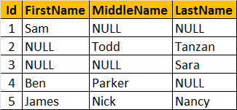

Now, let's write a query that returns the**Name of the Employee**. If an employee, has all the columns filled - **First, Middle and Last Names**, then we only want the **first name**.   
  
If the **FirstName is NULL**, and if **Middle and Last Names are filled** then, we only want the **middle name**. For example, Employee row with Id = 1, has the FirstName filled, so we want to retrieve his FirstName "Sam". Employee row with Id = 2, has Middle and Last names filled, but the First name is missing. Here, we want to retrieve his middle name "Todd". In short, The output of the query should be as shown below.

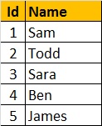

We are passing **FirstName, MiddleName and LastName** columns as parameters to the COALESCE() function. The COALESCE() function returns the first non null value from the 3 columns.  
**SELECT Id, COALESCE(FirstName, MiddleName, LastName) AS Name**  
**FROM tblEmployee**

Select * from Empnamedetails

Select ID, COALESCE(Firstname,Middlename,lastname) AS name from Empnamedetails

# Union and union all in sql server

🡪UNION and UNION ALL operators in SQL Server, are used to combine the result-set of two or more SELECT queries.

**Combining the rows of tblIndiaCustomers and tblUKCustomers using UNION ALL**

Select * from tblindiacustomers

UNION ALL

Select * from tblukcustomers

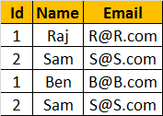

**Combining the rows of tblIndiaCustomers and tblUKCustomers using UNION**

Select * from tblindiacustomers

UNION

Select * from tblukcustomers

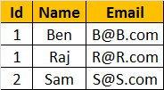

**NOTE:** UNION AND UNION ALL TO **WORK NUMBER, DATATYPES AND THE ORDER OF THE COLUMNS IN THE SELECT STATEMENTS SHOULD BE SAME**.

**Differences between UNION and UNION ALL (Common Interview Question)**

**🡪UNION removes duplicate** rows, whereas **UNION ALL does not**.

🡪UNION, to remove the duplicate rows, sql server has to do a distinct sort, which is time consuming. For this reason, UNION ALL is much faster than UNION.

**Note:** If you want to see the cost of DISTINCT SORT, you can turn on the estimated query execution plan using CTRL + L.

Select ID, NAME from tblindiacustomers

UNION ALL

Select * from tblukcustomers

Msg 205, Level 16, State 1, Line 1

All queries combined using a UNION, INTERSECT or EXCEPT operator must have an equal number of expressions in their target lists.

Select ID, NAME, EMAIL from tblindiacustomers

UNION ALL

Select NAME, EMAIL, ID from tblukcustomers

Conversion failed when converting the nvarchar value 'j@j.com' to data type int.

**🡪If you want to sort, the results of UNION or UNION ALL, the ORDER BY clause should be used on the last SELECT statement.**

Select * from tblindiacustomers

UNION ALL

Select * from tblukcustomers

ORDER BY NAME

Select * from tblindiacustomers

ORDER BY NAME

UNION ALL

Select * from tblukcustomers

Msg 156, Level 15, State 1, Line 3

**Difference between JOIN and UNION**

🡪UNION combines the result-set of two or more select queries into a single result-set which includes all the rows from all the queries in the union

🡪JOINS retrieve data from two or more tables based on logical relationships between the tables.

🡪UNION combines rows from 2 or more tables, where JOINS combine columns from 2 or more table.

# DateTime functions in SQL Server

Datatype for DateTime are

* Time – hh:mm:ss[nnnnnnn]
* Date – YYYY-MM-DD
* Smalldatetime – YYYY-MM-DD [hh:mm:ss]
* Datetime - YYYY-MM-DD [hh:mm:ss][.nnn]
* Datetime2 - YYYY-MM-DD [hh:mm:ss][.nnnnnnn]
* Datetimeoffset - YYYY-MM-DD [hh:mm:ss][.nnnnnnn][+/-][hh:mm:ss] 🡪Timezone Offset

|  |  |  |
| --- | --- | --- |
| **Function** | **Date Time Format** | **Description** |
| GETDATE() | 2012-08-31 20:15:04.543 | Commonly used function |
| CURRENT_TIMESTAMP | 2012-08-31 20:15:04.543 | ANSI SQL equivalent to GETDATE |
| SYSDATETIME() | 2012-08-31 20:15:04.5380028 | More fractional seconds precision |
| SYSDATETIMEOFFSET() | 2012-08-31 20:15:04.5380028 + 01:00 | More fractional seconds precision + Time zone offset |
| GETUTCDATE() | 2012-08-31 19:15:04.543 | UTC Date and Time |
| SYSUTCDATETIME() | 2012-08-31 19:15:04.5380028 | UTC Date and Time, with More fractional seconds precision |

**UTC**stands for **Coordinated Universal Time**, based on which, the world regulates clocks and time. There are slight differences between GMT and UTC, but for most common purposes, UTC is synonymous with GMT.

CREATE TABLE [tblDateTime]

(

[c_time] [time](7) NULL,

[c_date] [date] NULL,

[c_smalldatetime] [smalldatetime] NULL,

[c_datetime] [datetime] NULL,

[c_datetime2] [datetime2](7) NULL,

[c_datetimeoffset] [datetimeoffset](7) NULL

)

INSERT INTO [tblDateTime] VALUES (GETDATE(),GETUTCDATE(),CURRENT_TIMESTAMP,SYSDATETIME(),SYSDATETIMEOFFSET(),SYSUTCDATETIME())

select * from [tblDateTime]

UPDATE tblDateTime

set c_datetimeoffset = '2018-10-14 15:42:04.4760403 +08:00'

WHERE c_datetimeoffset = '2018-10-14 15:42:04.4760403 +00:00'

Select GETDATE()

Select CURRENT_TIMESTAMP

Select SYSDATETIME()

Select SYSUTCDATETIME()

Select SYSDATETIMEOFFSET()

Select GETUTCDATE()

2018-10-14 21:40:13.427

2018-10-14 21:40:13.4263154

2018-10-14 16:10:13.4263154

2018-10-14 21:40:13.4263154 +05:30

2018-10-14 16:10:13.423

# IsDate, Day, Month, Year and DateName DateTime functions in SQL Server

**🡪ISDATE**() - Checks if the given value, is a valid date, time, or datetime. Returns 1 for success, 0 for failure.

**Note**: For datetime2 values, IsDate returns ZERO.

Select ISDATE('PRAGIM') -- returns 0

Select ISDATE(Getdate()) = returns 1

Select ISDATE('2012-08-31 21:02:04.167') - returns 1

Select ISDATE('2012-09-01 11:34:21.1918447') -- returns 0. 🡪datetime2

**🡪Day**() - Returns the **'Day number of the Month'** of the given date.

Select Day(Getdate()) 🡪 14

Select DAY('02-19-2017') 🡪 19 DD-MM-YYYY

**🡪Month**() - Returns the **'Month number of the year'** of the given date

Select MONTH(Getdate()) 🡪 10

Select MONTH('1/02/2018') 🡪 1

**🡪Year**() - Returns the**'Year number'**of the given date

Select YEAR(GETDATE()) 🡪 2018

Select YEAR('02-20-2012') 🡪 2012

MM/DD/YY or YY/MM/DD

**Valid Datepart parameter values**

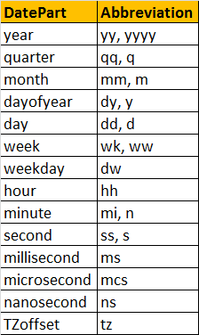

**🡪DateName**(DatePart, Date) - Returns a nvarchar, that represents a part of the given date. This functions takes 2 parameters.

🡪The first parameter **'DatePart'** specifies, the part of the date, we want.

🡪The second parameter, is the actual date, from which we want the part of the Date.

Select DATENAME(Day, '2012-09-30 12:43:46.837') -- Returns 30

Select DATENAME(WEEKDAY, '2012-09-30 12:43:46.837') -- Returns Sunday

Select DATENAME(MONTH, '2012-09-30 12:43:46.837') -- Returns September

Select DATENAME(hh, '2012-09-30 12:43:46.837')

Select DATENAME(ss, '2012-09-30 12:43:46.837')

Select DATENAME(qq, '2012-09-30 12:43:46.837')

Write a query, which returns Name, DateOfBirth, Day, MonthNumber, MonthName, and Year as shown below

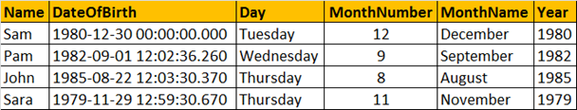

Select Name,Datepfbirth, DateName(WEEKDAY,Datepfbirth) as [DAY], MONTH(Datepfbirth) as [month number],DATENAME(MONTH,Datepfbirth) as [month name],

YEAR(Datepfbirth) as [Year] from tblemployees

# DatePart, DateAdd and DateDiff functions in SQL Server

**🡪DatePart**(DatePart, Date) - Returns an integer representing the specified DatePart.

🡪This function is similar to DateName().

🡪DateName() returns nvarchar, whereas DatePart() returns an integer.

Select DATEPART(weekday, '2012-08-30 19:45:31.793') -- returns 5  
Select DATENAME(weekday, '2012-08-30 19:45:31.793') -- returns Thursday

Select DATEPART(DAY, '2012-08-30 19:45:31.793')

Select DATEPART(MONTH, '2012-08-30 19:45:31.793')

Select DATEPART(YEAR, '2012-08-30 19:45:31.793')

Select DATEPART(HOUR, '2012-08-30 19:45:31.793')

Select DATEPART(MINUTE, '2012-08-30 19:45:31.793')

Select DATEPART(DAY, '2012-08-30 19:45:31.793')

Select DATEPART(SECOND, '2012-08-30 19:45:31.793')

**🡪DATEADD**(datepart, NumberToAdd, date) - Returns the DateTime, after adding specified NumberToAdd, to the datepart specified of the given date.

Select DateAdd(DAY, 20, '2012-08-30 19:45:31.793')

-- Returns 2012-09-19 19:45:31.793

Select DateAdd(DAY, -20, '2012-08-30 19:45:31.793')

-- Returns 2012-08-10 19:45:31.793

Select DateAdd(YEar, -20, '2012-08-30 19:45:31.793')

Select DateAdd(MONTH, -20, '2012-08-30 19:45:31.793')

Select DateAdd(SECOND, -20, '2012-08-30 19:45:31.793')

**🡪DATEDIFF**(datepart, startdate, enddate) - Returns the count of the specified datepart boundaries crossed between the specified startdate and enddate.

Select DATEDIFF(MONTH, '11/30/2005','01/31/2006') -- returns 2  
Select DATEDIFF(DAY, '11/30/2005','01/31/2006') -- returns 62

Select DATEDIFF(DAY, GetDate(),'1991-07-24 20:15:04.543')

* **To calculate Age refer video**

# Stored procedures

**🡪** System Stored Procedure and User Defined SP

🡪A stored procedure is group of T-SQL (Transact SQL) statements.

🡪If you have a situation, where you write the same query over and over again, you can save that specific query as a stored procedure and call it just by it's name.

**Creating a simple stored procedure without any parameters**

🡪To create a stored procedure we use, **CREATE PROCEDURE** or **CREATE PROC** statement

Create Procedure sp_GetEmployeedetails

as

Begin

Select Name,DepartmentID,ID from TblEmployee

END

Exec sp_GetEmployeedetails

Execute sp_GetEmployeedetails

**Note:** You can also right click on the procedure name, in object explorer in SQL Server Management Studio and select EXECUTE STORED PROCEDURE.

**Note:** When naming user defined stored procedures, Microsoft recommends not to use **"sp_"** as a prefix. All system stored procedures, are prefixed with **"sp_"**. This avoids any ambiguity between user defined and system stored procedures and any conflicts, with some future system procedure.

**Creating a stored procedure with input parameters:**

🡪This SP, accepts GENDER and DEPARTMENTID parameters.

🡪Parameters and variables have an @ prefix in their name.

Create proc spGetEmployeedetailsbygenderandDepartmentid

@Gender varchar(10),

@DepartmentID Int

as

Begin

Select Name,Gender,DepartmentID from tblemployee where Gender=@Gender and DepartmentID=@DepartmentID

End

**🡪** Execute directly the procedure without passing parameters.

Exec spGetEmployeedetailsbygenderandDepartmentid

Msg 201, Level 16, State 4, Procedure spGetEmployeedetailsbygenderandDepartmentid, Line 0

Procedure or function 'spGetEmployeedetailsbygenderandDepartmentid' expects parameter '@Gender', which was not supplied.

🡪Execute the procedure with parameters

spGetEmployeedetailsbygenderandDepartmentid 'Male',1

**🡪**Ifthe parameters are interchanged.

Exec spGetEmployeedetailsbygenderandDepartmentid 1, 'Male'

Msg 8114, Level 16, State 1, Procedure spGetEmployeedetailsbygenderandDepartmentid, Line 0

Error converting data type varchar to int.

🡪To avoid mismatch of parameters.

Exec spGetEmployeedetailsbygenderandDepartmentid @DepartmentID=5, @Gender='FeMale'

**To view the text, of the stored procedure**  
1. Use system stored procedure sp_helptext 'SPName'  
OR  
2. Right Click the SP in Object explorer -> Scrip Procedure as -> Create To -> New Query Editor Window

USE [StroreP]

GO

/****** Object: StoredProcedure [dbo].[sp_GetEmployeedetails] Script Date: 29-10-2018 9:11:11 ******/

SET ANSI_NULLS ON

GO

SET QUOTED_IDENTIFIER ON

GO

Create Procedure [dbo].[sp_GetEmployeedetails]

as

Begin

Select Name,DepartmentID,ID from TblEmployee

END

GO

sp_helptext spGetEmployeedetailsbygenderandDepartmentid

**To change the stored procedure, use ALTER PROCEDURE statement:**

Alter proc spGetEmployeedetailsbygenderandDepartmentid

@Gender varchar(10),

@DepartmentID Int

as

Begin

Select Name,Gender,DepartmentID from tblemployee where Gender=@Gender and DepartmentID=@DepartmentID

Order By Name

End

🡪To delete the SP, use DROP PROC 'SPName' or DROP PROCEDURE 'SPName'

Drop Proc sp_GetEmployeedetails

🡪 Encrypt the procedure text 🡪 Secured

Create Proc spGetallemployeedetails

With Encryption

as

Begin

Select * from tblemployee

End

sp_helptext spGetallemployeedetails

The text for object 'spGetallemployeedetails' is encrypted.

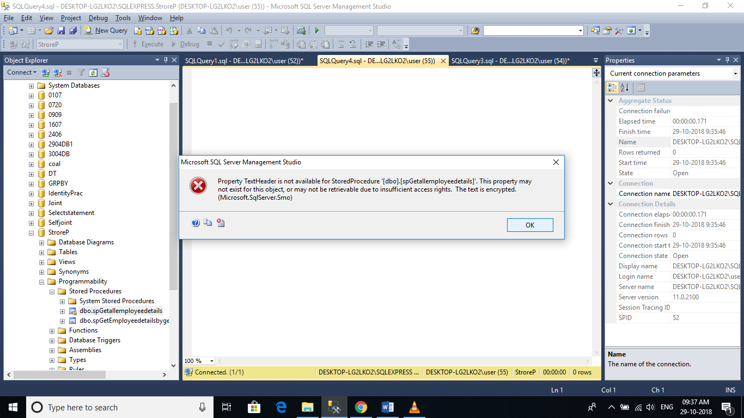

# Create Stored Procedure with Output Parameter

* **To create an SP with output parameter**, we use the keywords OUT or OUTPUT.

Create Procedure spGetemployeecountbygender

@Gender nvarchar(20),

@EmployeeCount int Output

as

Begin

Select @EmployeeCount = COUNT(id)

from [dbo].[TblEmployee]

where Gender = @Gender

End

Declare @TotalEmployee int 🡪 same datatype

Exec spGetemployeecountbygender 'Male', @TotalEmployee Output

Print @TotalEmployee

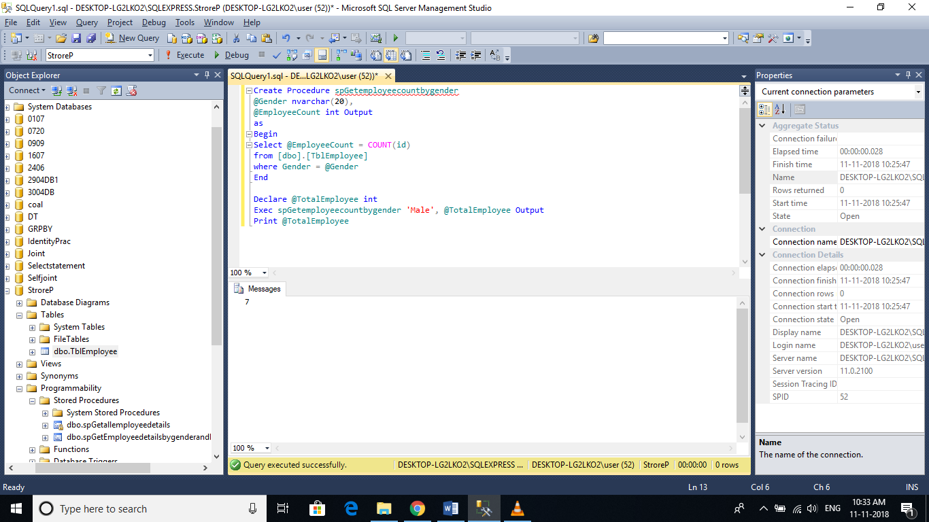

Without Output Keyword:

🡪No values are passed.

🡪Displays NULL.

Declare @TotalEmployee int

Exec spGetemployeecountbygender 'Male', @TotalEmployee

If(@TotalEmployee IS NULL)

Print ‘@TotalEmployee IS NULL’

else

Print ‘@TotalEmployee IS not NULL’

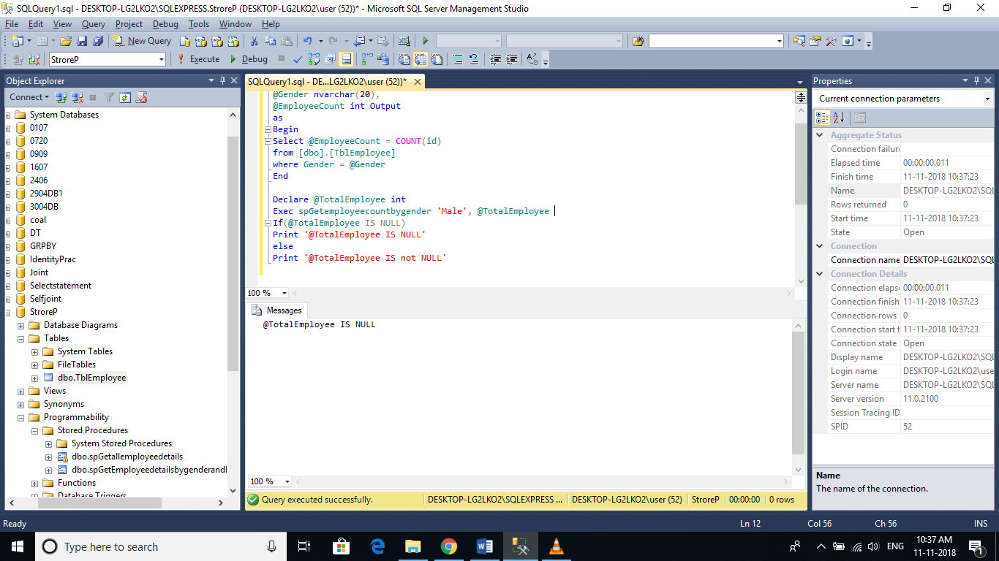

with Output Keyword

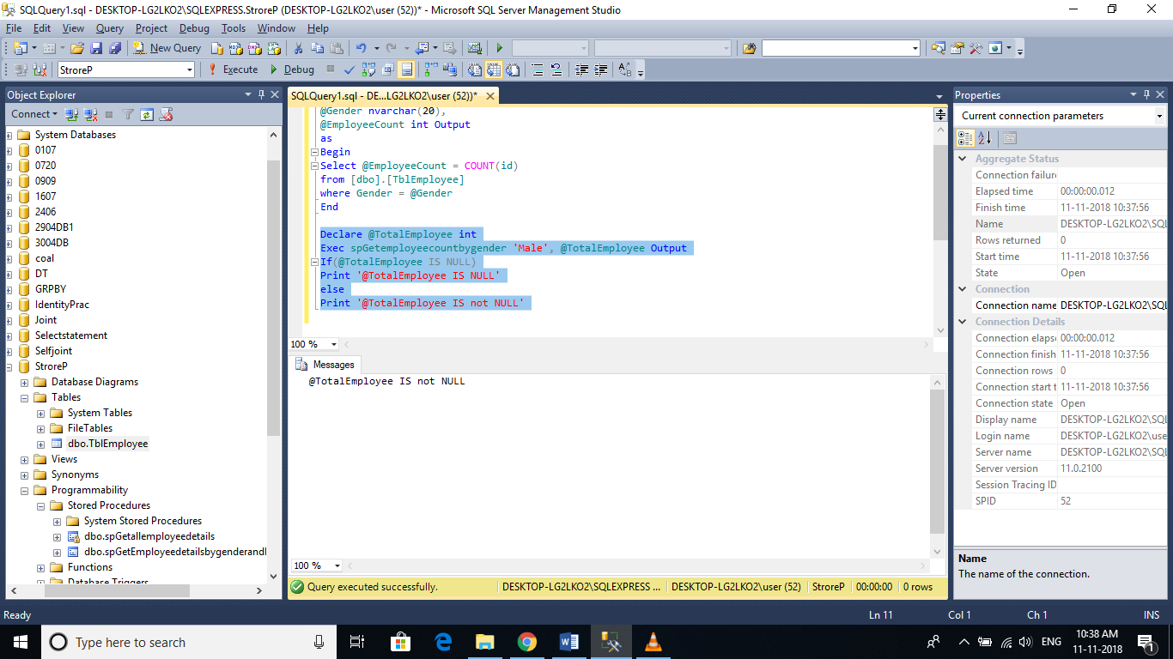

Declare @TotalEmployee int

Exec spGetemployeecountbygender @EmployeeCount = @TotalEmployee Output, @Gender = 'Male'

Print @TotalEmployee

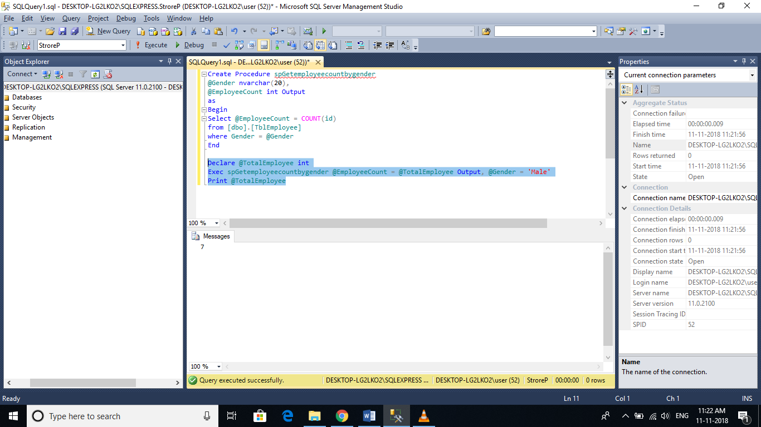

**The following system stored procedures, are extremely useful when working procedures.**

**sp_help** SP_Name :

🡪 View the information about the stored procedure, like parameter names, their datatypes etc.

🡪sp_help can be used with any database object, like tables, views, SP's, triggers etc. 🡪Alternatively, you can also press ALT+F1, when the name of the object is highlighted.

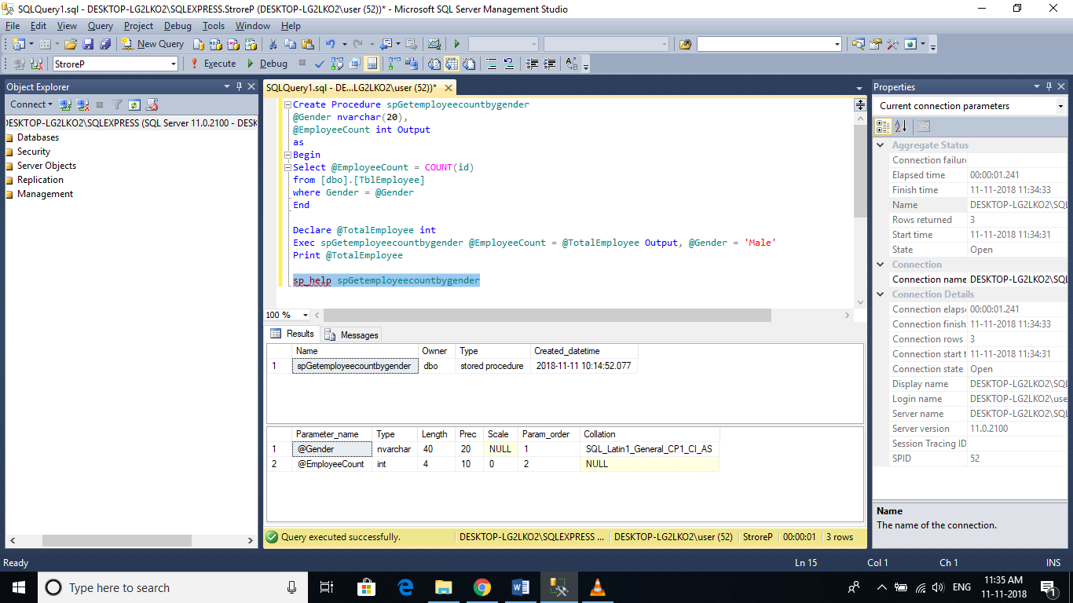

sp_help TblEmployee

🡪highlight the object and press Alt+F1

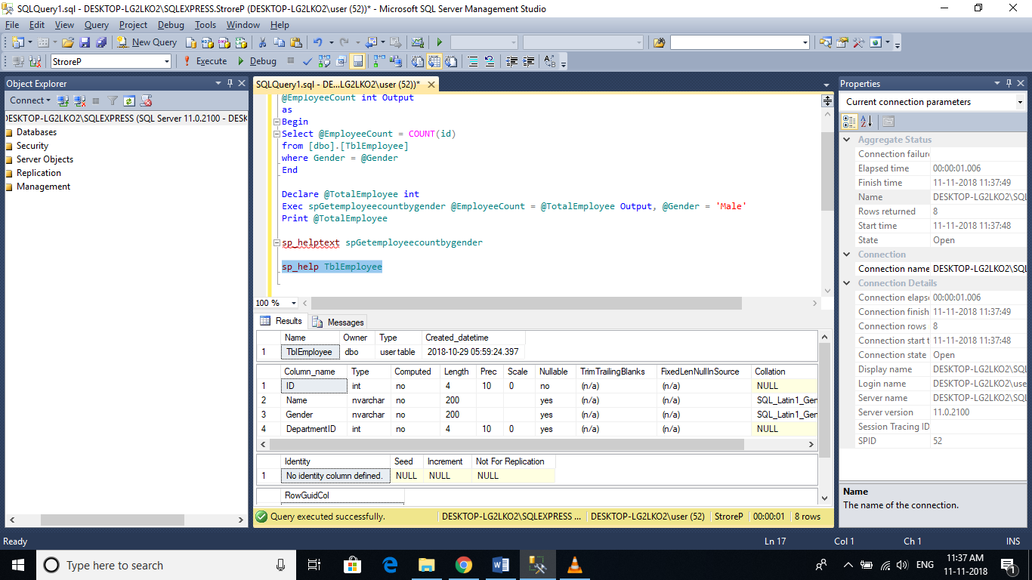

**sp_helptext** SP_Name : View the Text of the stored procedure

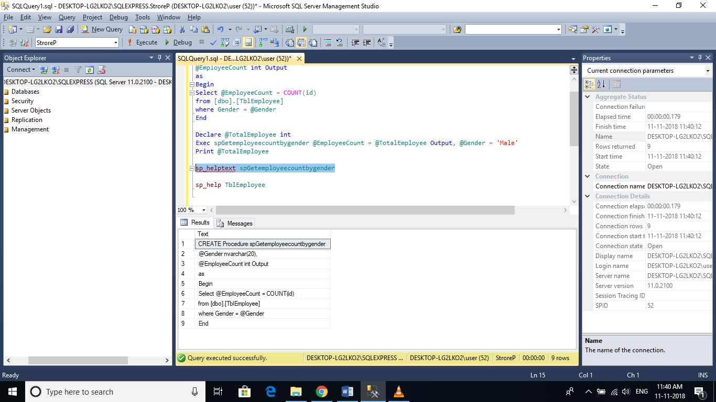

**sp_depends** SP_Name :

🡪View the dependencies of the stored procedure.

🡪This system SP is very useful, especially if you want to check, if there are any stored procedures that are referencing a table that you are about to drop. sp_depends can also be used with other database objects like table etc.

sp_depends spGetemployeecountbygender

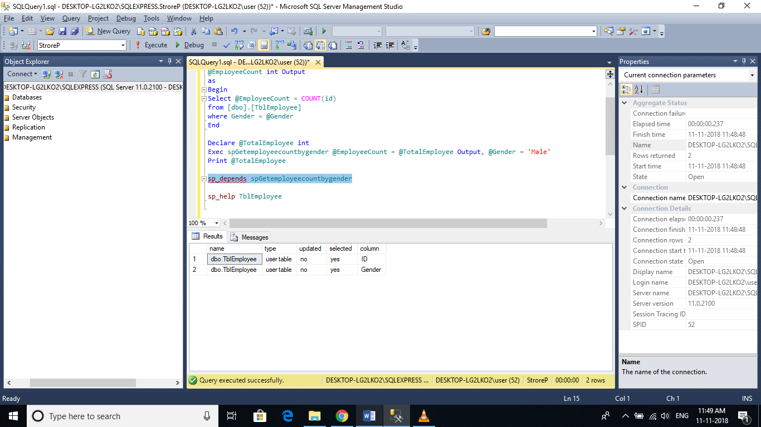

sp_depends TblEmployee

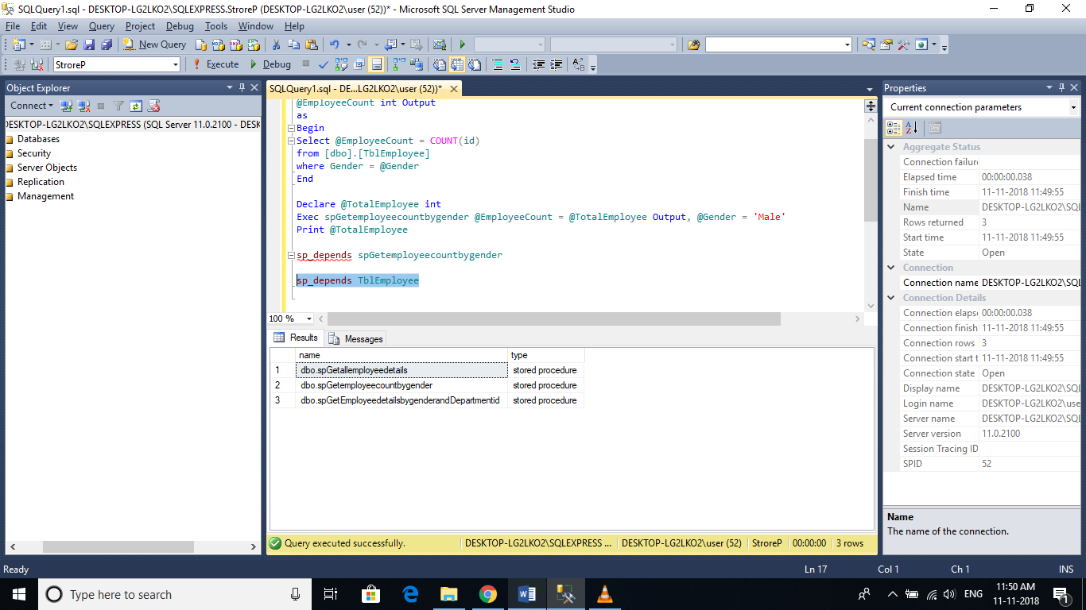

**Note:** All parameter and variable names in SQL server, need to have the @symbol.

# Output Parameters or Return Values

**What are stored procedure status variables?**

🡪Whenever, you execute a stored procedure, it returns an integer status variable.

🡪Usually, zero indicates success, and non-zero indicates failure.

To see this yourself, execute any stored procedure from the object explorer, in sql server management studio.   
**1.** Right Click and select 'Execute Stored Procedure  
**2.** If the procedure, expects parameters, provide the values and click OK.  
**3.** Along with the result that you expect, the stored procedure, also returns a Return Value = 0

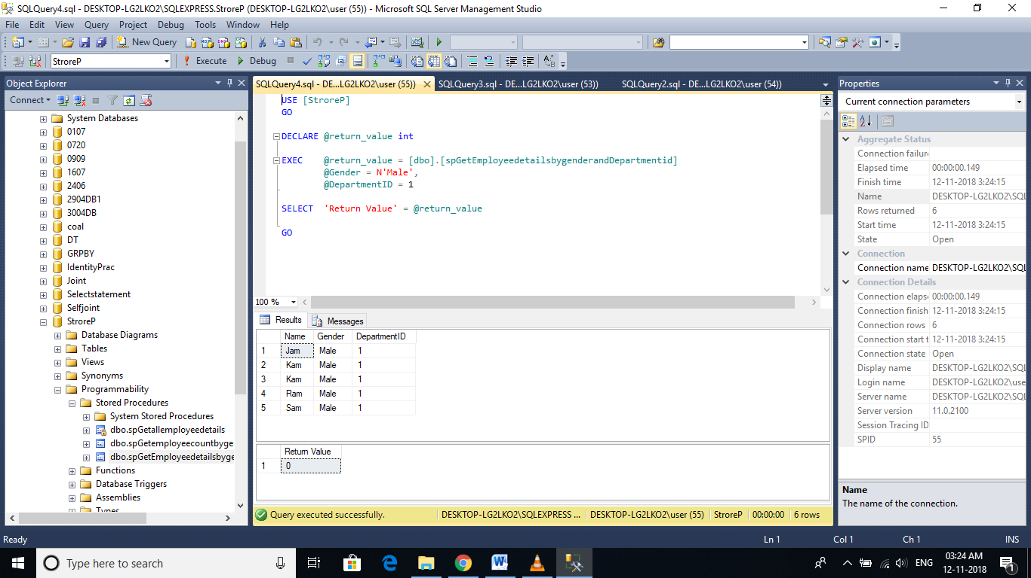  
🡪So, from this we understood that, when a stored procedure is executed,

🡪it returns an integer status variable. With this in mind, let's understand the difference between output parameters and RETURN values. We will use the Employees table below for this purpose.

**stored procedure using return variables**

Create Procedure spgettotalemployeecount2

as

Begin

return (Select count(ID) from TblEmployee)

End

Declare @Totalemployees int

Exec @Totalemployees = spgettotalemployeecount2

Select @Totalemployees

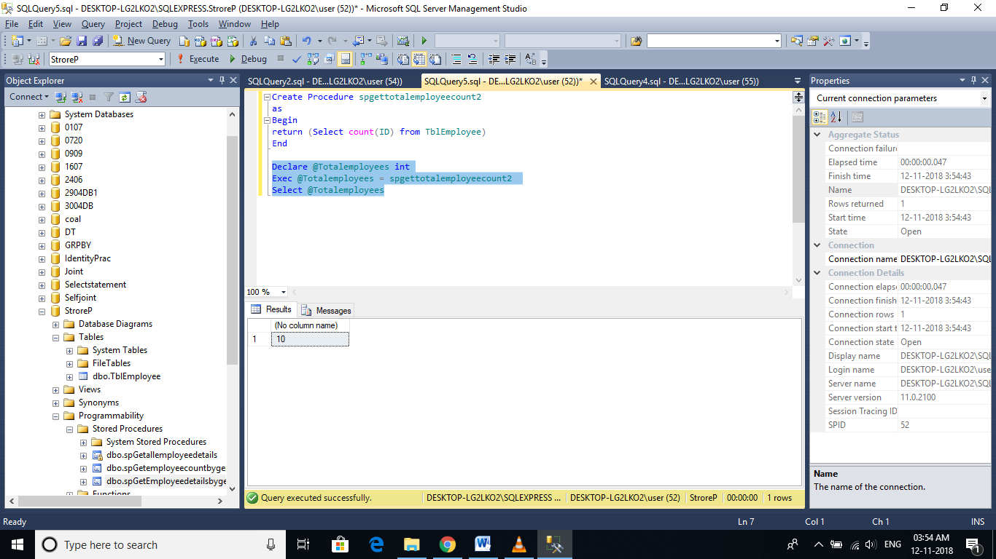

**In this SP, we are retrieving the Name of the employee, based on their Id, using the output parameter @Name.**

Create Procedure spGetemployeename

@ID int,

@Name nvarchar(20) out

as

begin

select @Name = Name from TblEmployee where @ID=ID

end

Declare @Name nvarchar(20)

Exec spGetemployeename 11,@Name out

Print 'Employee name is '+ @Name

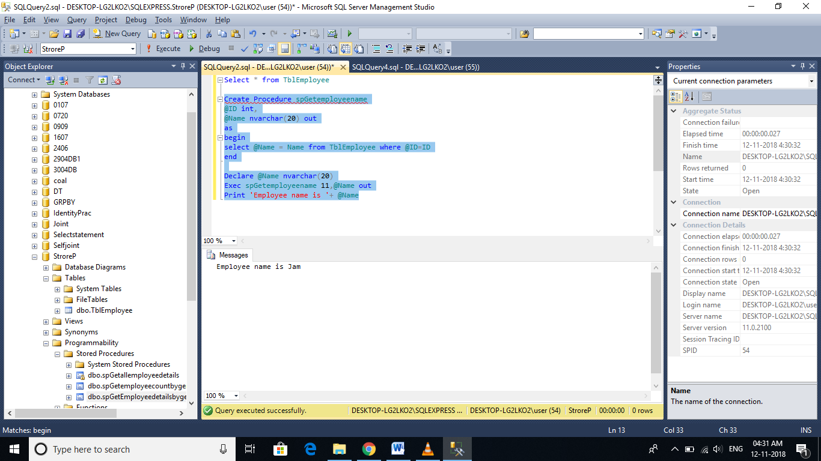

**Now let's try to achieve the same thing, using return status variables.**

Create Procedure spGetemployeename2

@ID int

as

begin

return (select Name from TblEmployee where @ID=ID)

end

Declare @Name nvarchar(20)

Exec @Name=spGetemployeename2 11

Print 'Employee name is '+ @Name

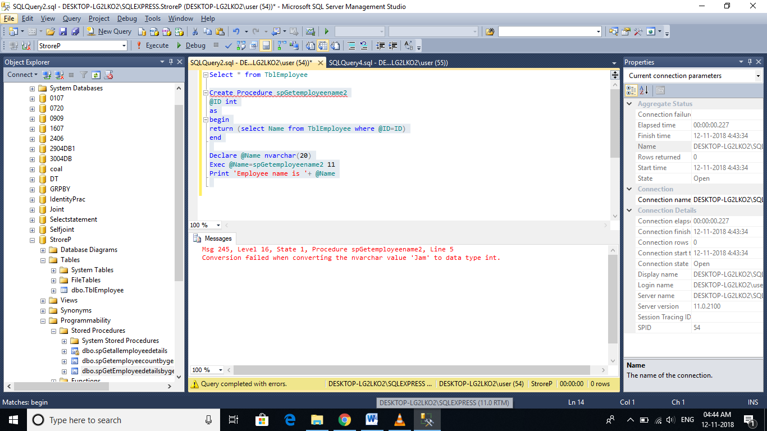

🡪returns an error stating 'Conversion failed when converting the nvarchar value 'Sam' to data type int.'.

🡪The return status variable is an integer, and hence, when we select Name of an employee and try to return that we get a conversion error.

🡪So, using return values, we can only return integers, and that too, only one integer.

🡪It is not possible, to return more than one value using return values, where as output parameters, can return any datatype and SP can have more than one output parameters.

🡪I always prefer, using output parameters, over RETURN values.

**Difference between return values and output parameters**

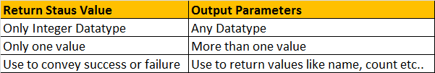

# Advantages of stored Procedures

**The following advantages of using Stored Procedures over adhoc queries (inline SQL)**

1. **Execution plan retention and reusability** - Stored Procedures are compiled and their execution plan is cached and used again, when the same SP is executed again. Although adhoc queries also create and reuse plan, the plan is reused only when the query is textual match and the datatypes are matching with the previous call. Any change in the datatype or you have an extra space in the query then, a new plan is created.
2. **Reduces network traffic** - You only need to send, EXECUTE SP_Name statement, over the network, instead of the entire batch of adhoc SQL code.

**3. Code reusability and better maintainability** - A stored procedure can be reused with multiple applications. If the logic has to change, we only have one place to change, where as if it is inline sql, and if you have to use it in multiple applications, we end up with multiple copies of this inline sql. If the logic has to change, we have to change at all the places, which makes it harder maintaining inline sql.

**4. Better Security** - A database user can be granted access to an SP and prevent them from executing direct "select" statements against a table.  This is fine grain access control which will help control what data a user has access to.

**5. Avoids SQL Injection attack** - SP's prevent sql injection attack

# SQL Injection Attack:

🡪Common form of attacking Web Application.

🡪Root Cause 🡪 Building Sql statements dynamically by concatenating strings.

🡪Avoid Sql Injection in 2 ways 🡪 use parameterised queries or use stored procedures.

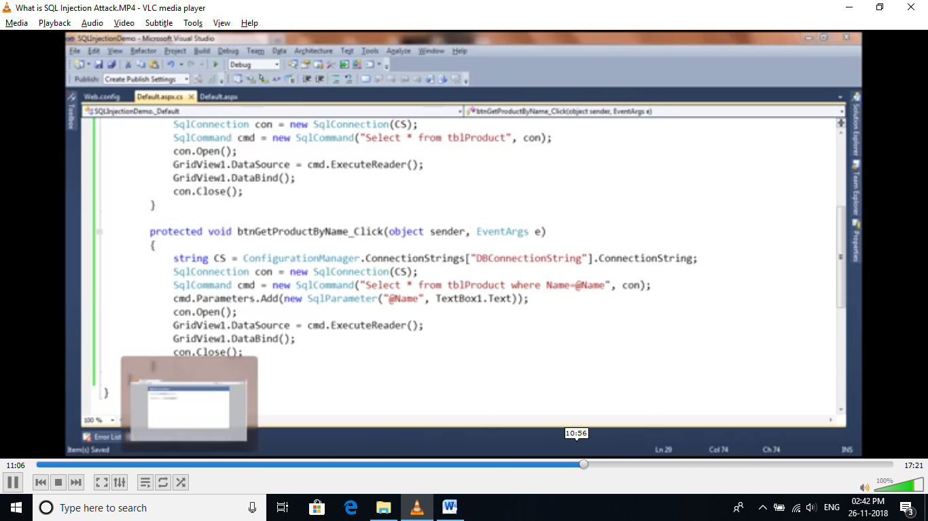



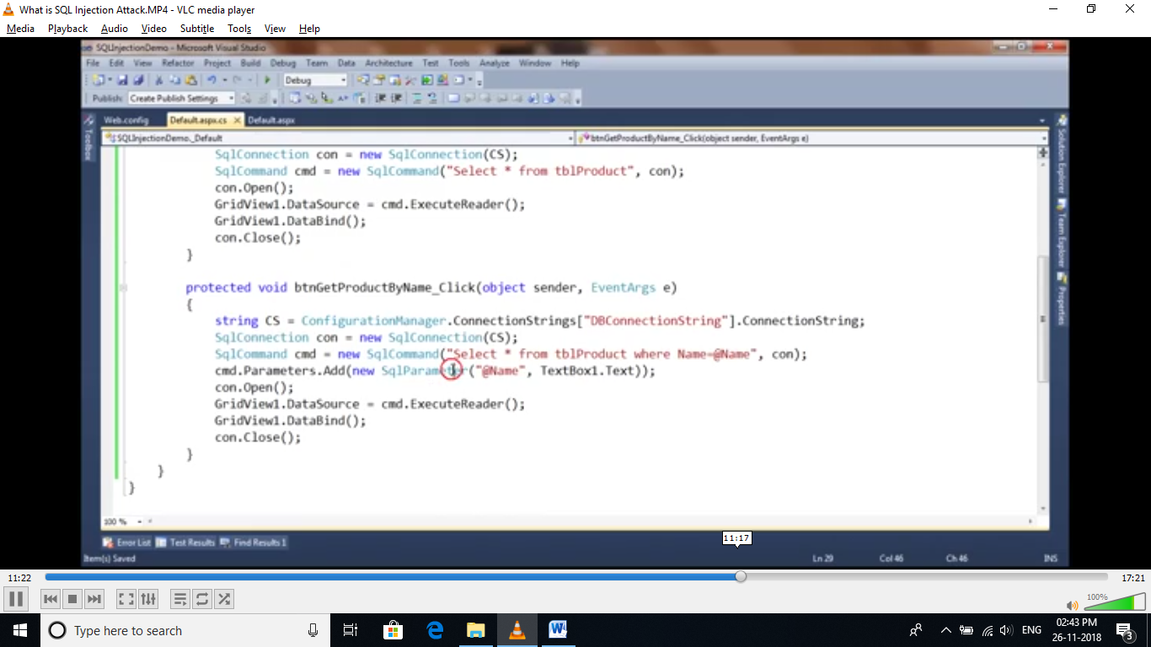

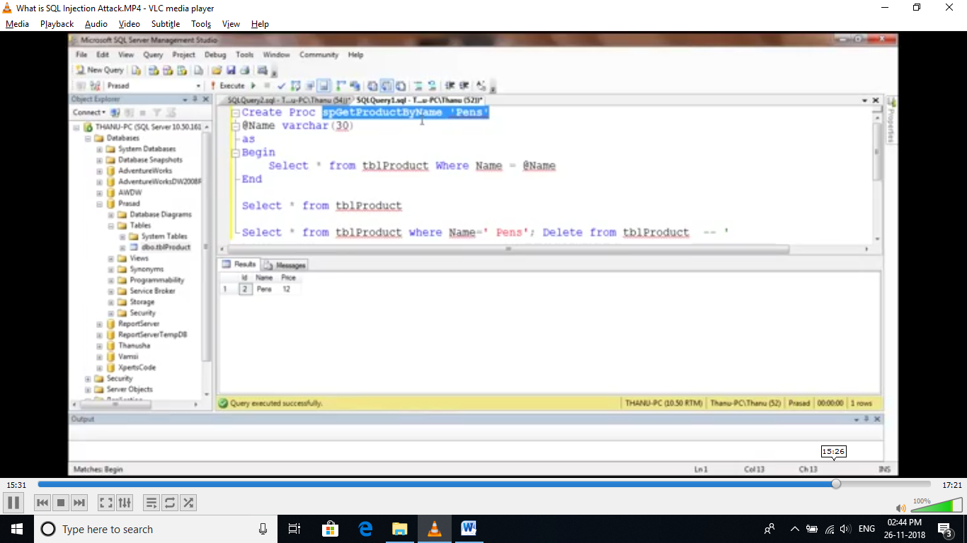

# Built in string functions in sql server 2008

🡪Functions in SQL server can be broadly divided into 2 categories  
**1.** Built-in functions

**2.** User Defined functions

🡺To view list of system functions, expand programmability🡪functions🡪system functions.

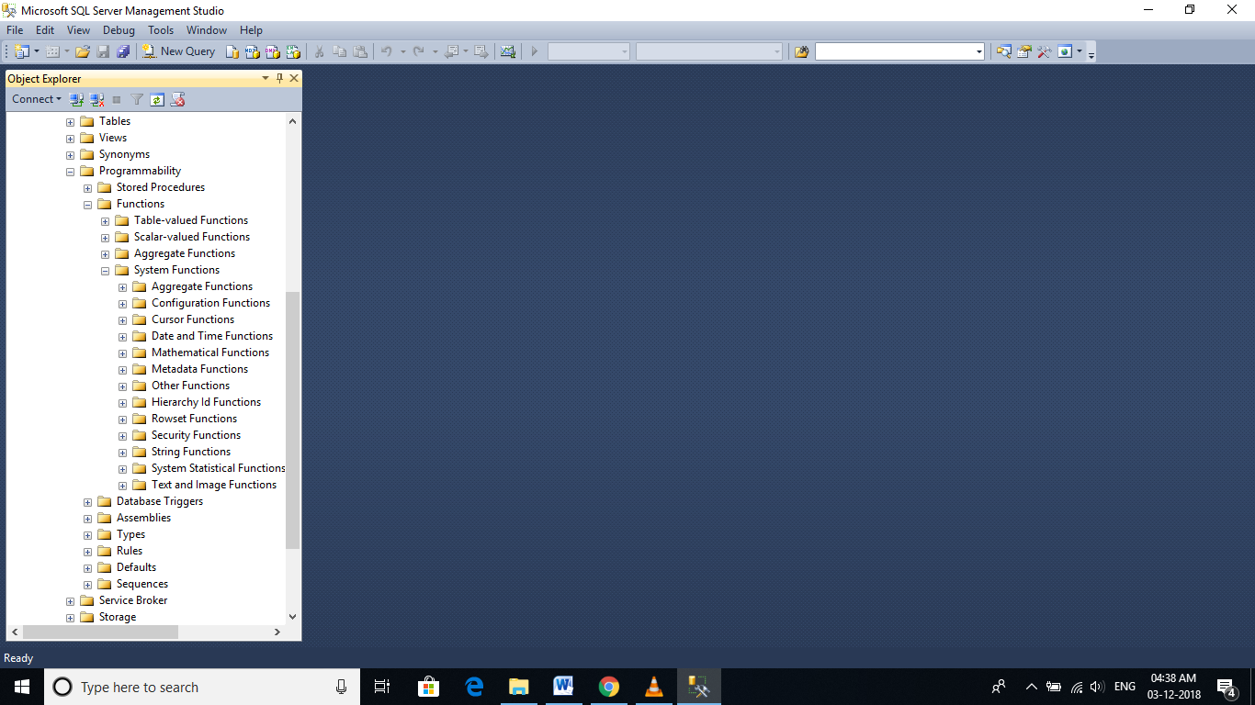

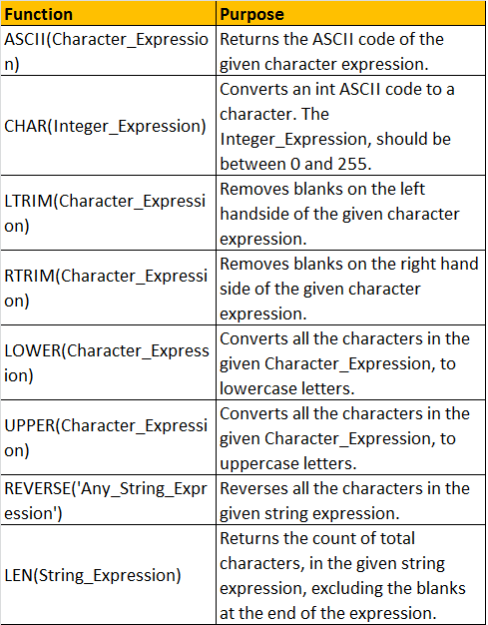

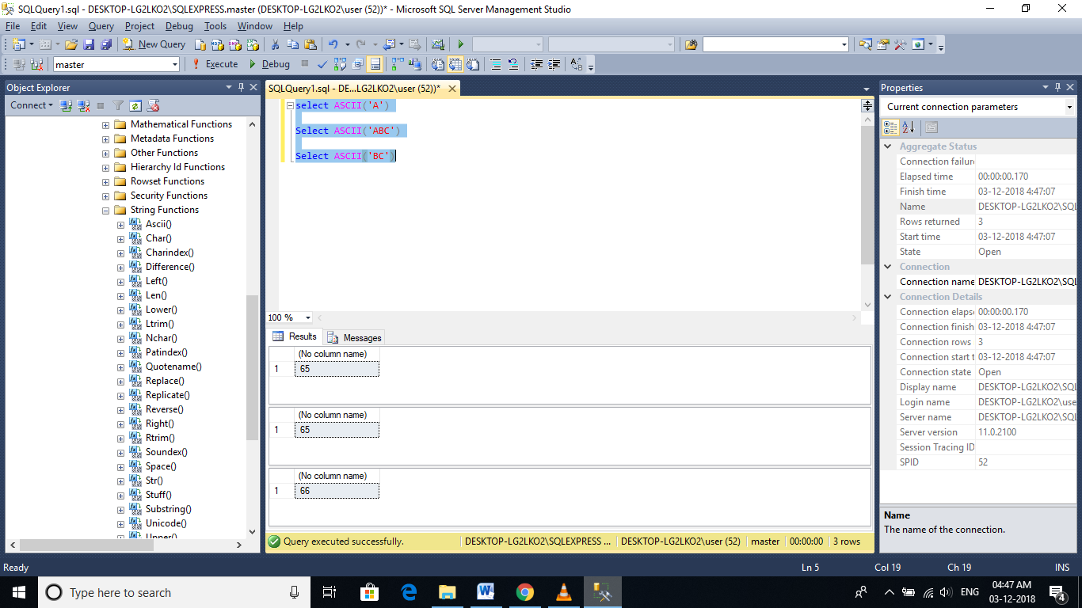

select CHAR(48)

select ASCII('z')

--values must be 0 to 255

--ASCII(A-Z) to CHAR

DECLARE @start int

SET @start=97

WHILE(@start<=122)

Begin

print CHAR(@start)

SET @start=@start+1

End

--ASCII(a-z) to CHAR

DECLARE @start int

SET @start=65

WHILE(@start<=90)

Begin

print CHAR(@start)

SET @start=@start+1

End

--ASCII(48-58) to CHAR

DECLARE @start int

SET @start=48

WHILE(@start<=58)

Begin

print CHAR(@start)

SET @start=@start+1

End

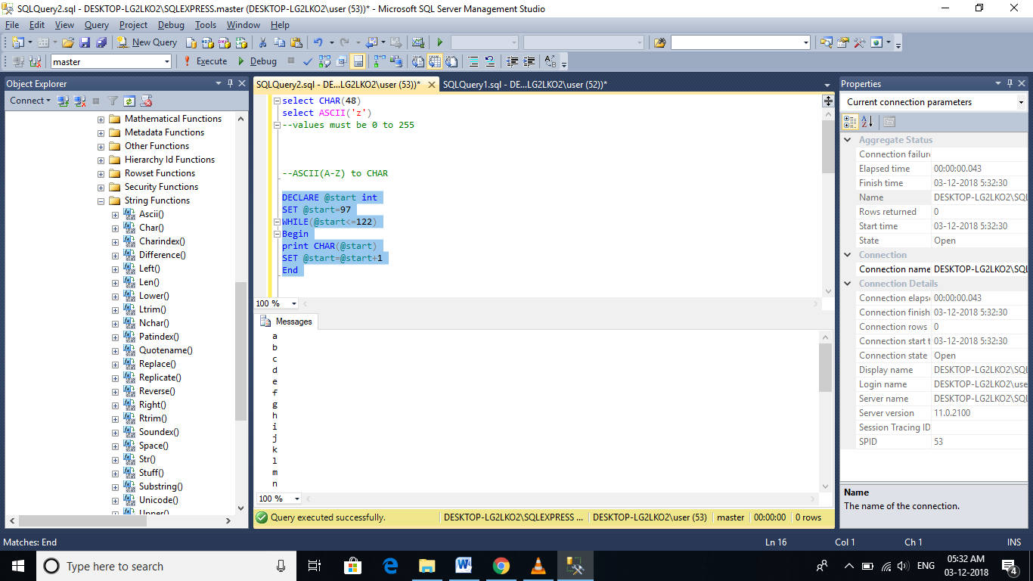

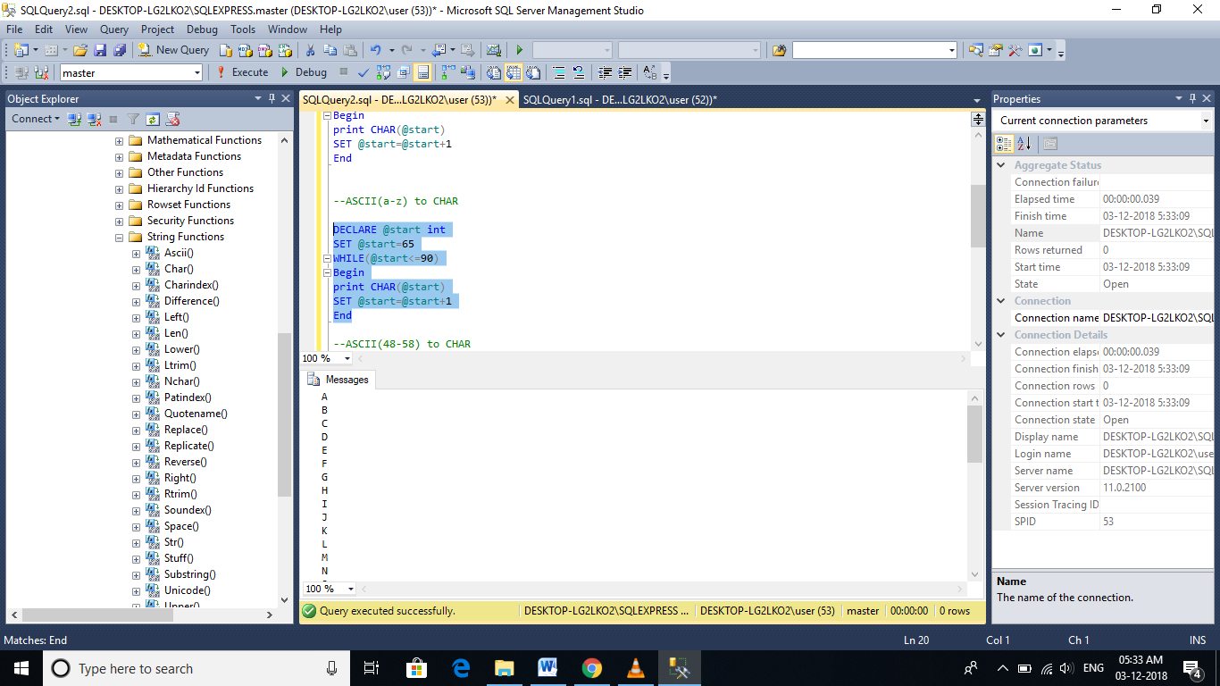

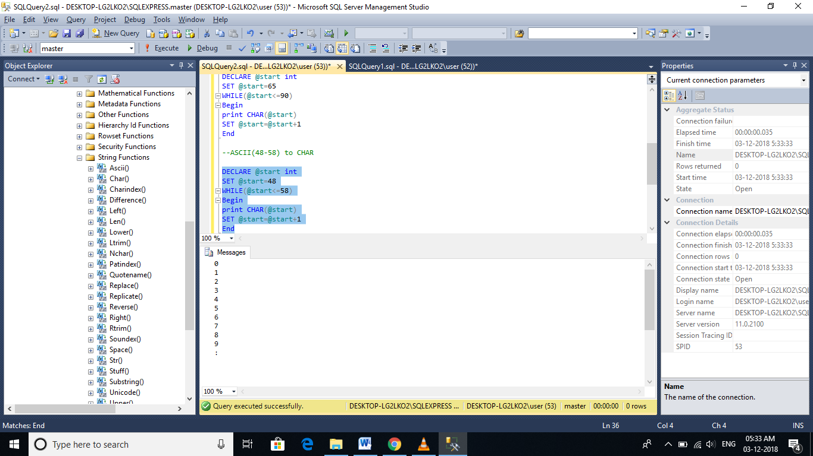

LTRIM AND RTRIM

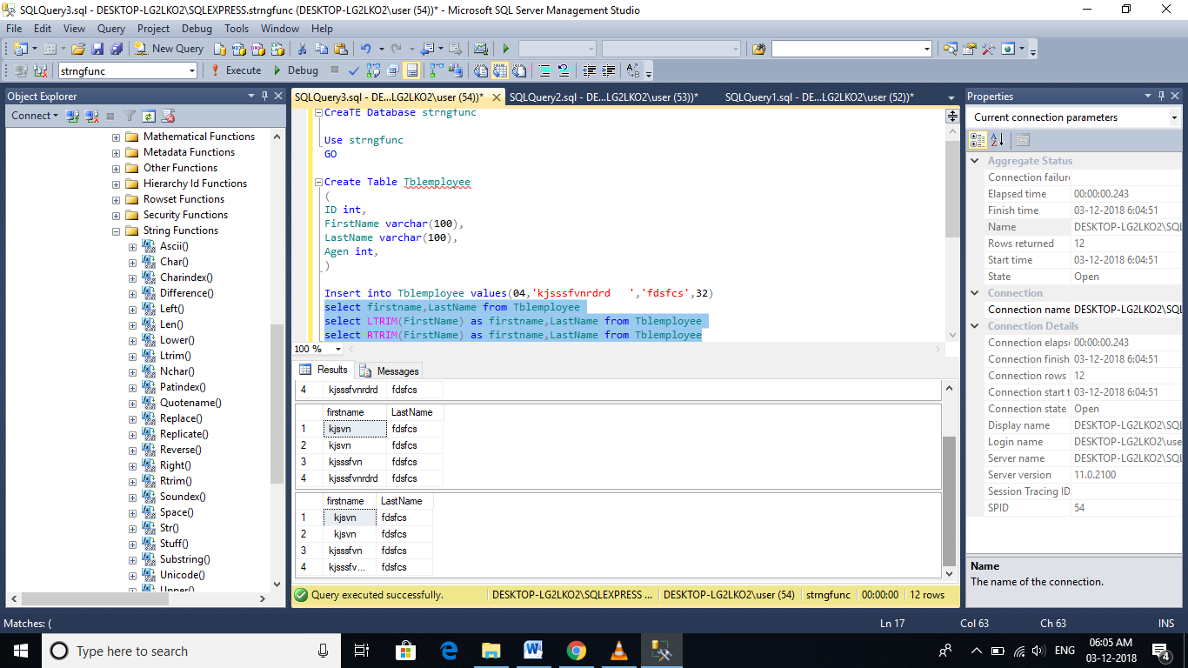

* Use both LTRIM and RTRIM together to remove both Left space and Right space
* RTRIM(LTRIM[])

UPPER and LOWER

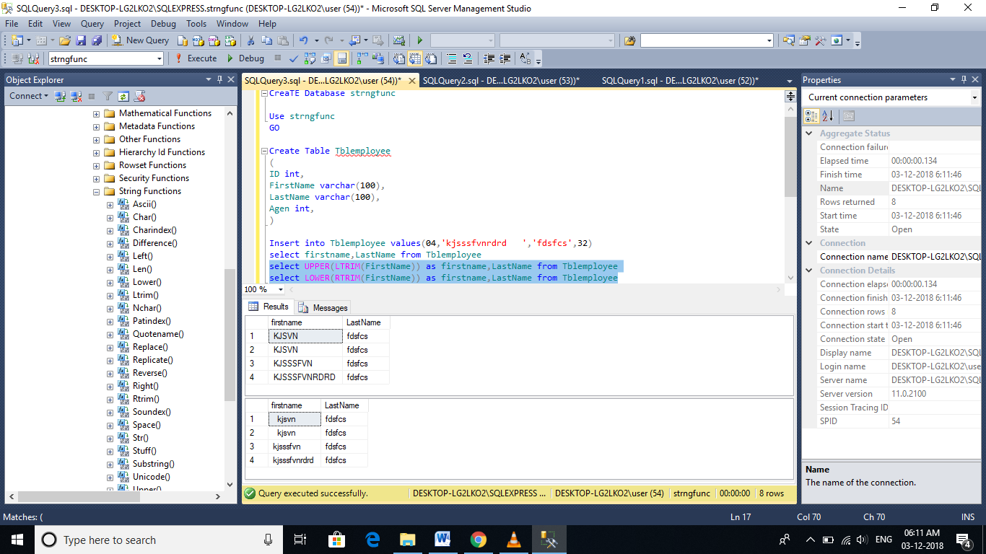

REVERSE

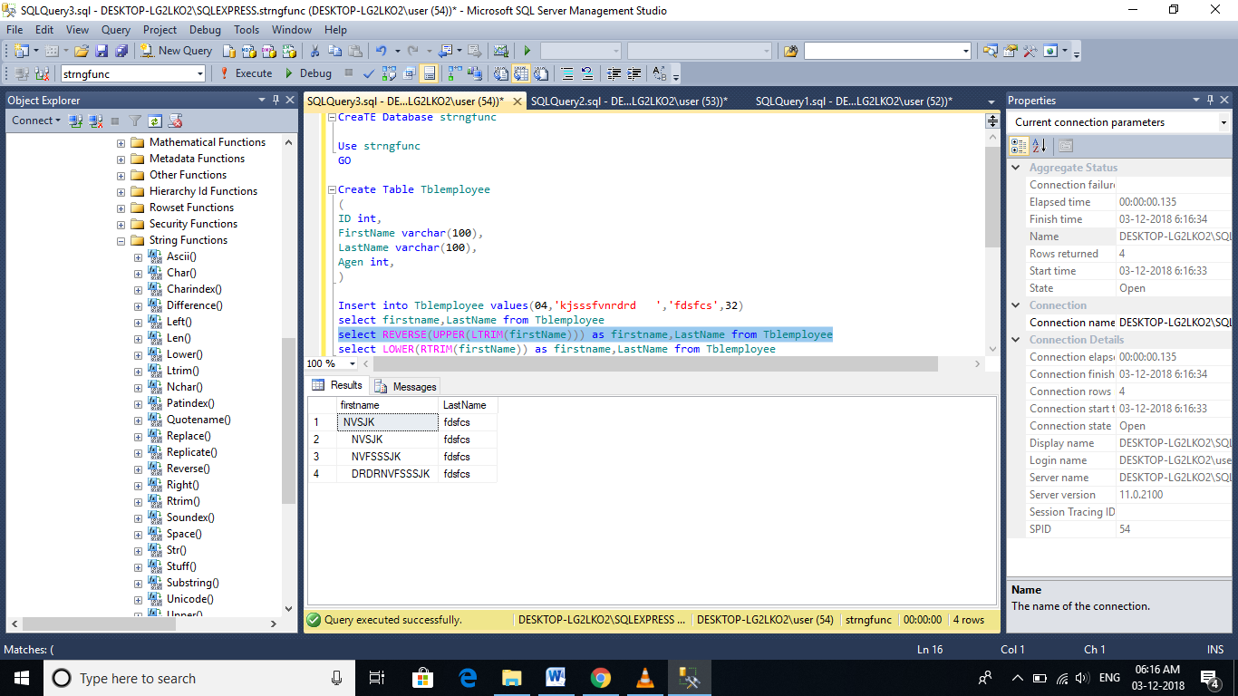

LEN – Length function

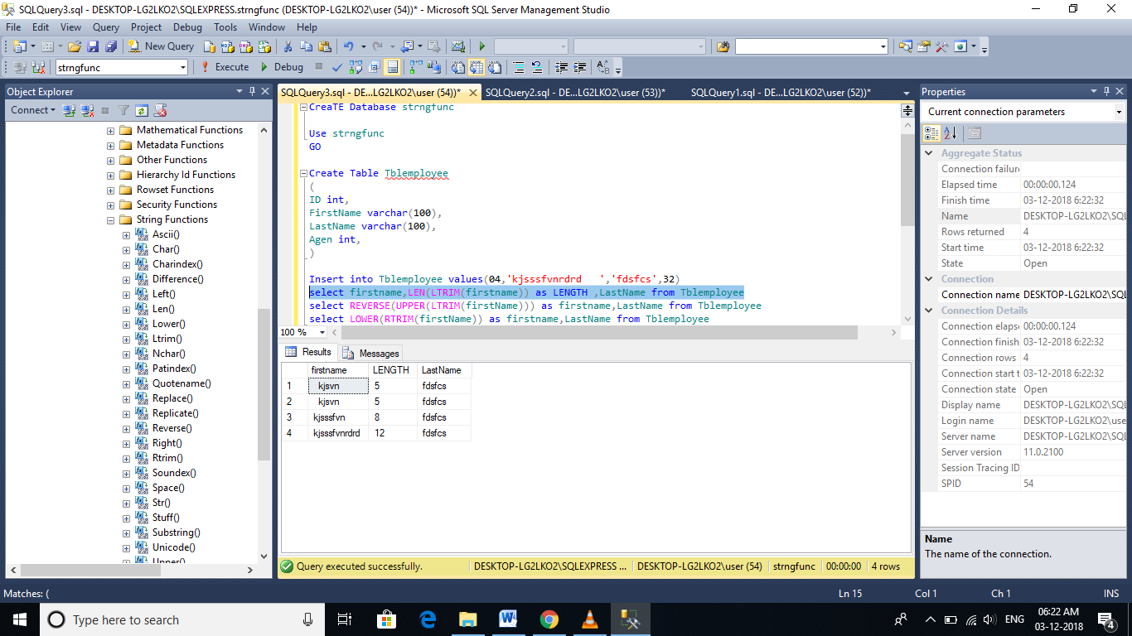

# LEFT, RIGHT, CHARINDEX and SUBSTRING functions

**LEFT**(Character_Expression, Integer_Expression) - Returns the specified number of characters from the left hand side of the given character expression.

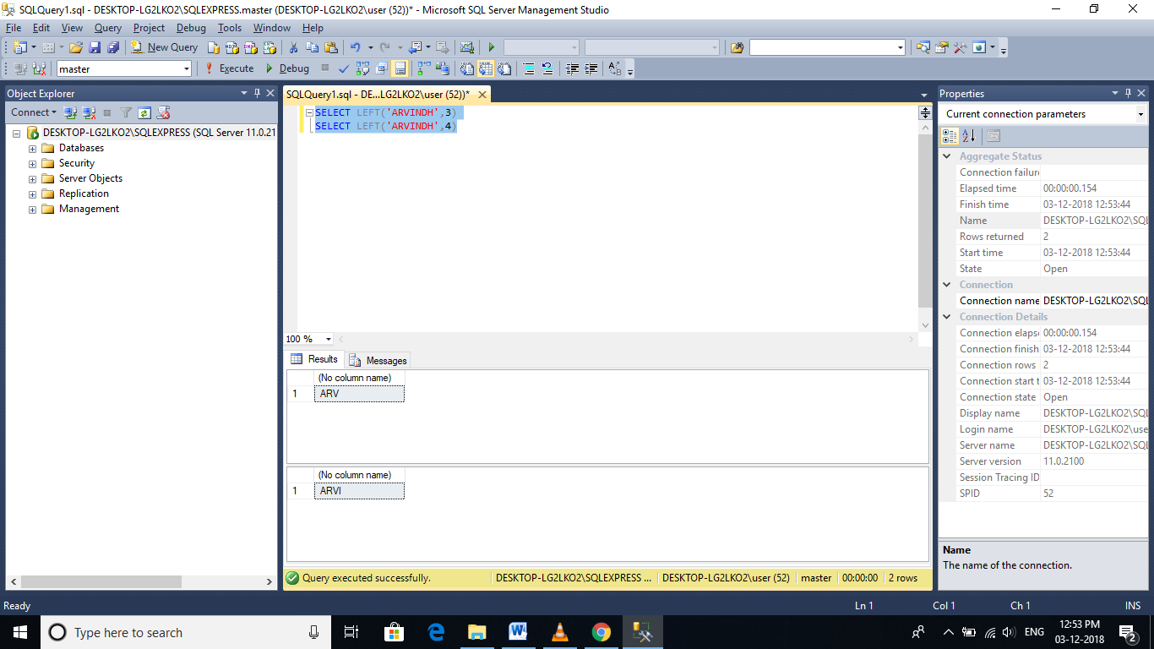

**RIGHT**(Character_Expression, Integer_Expression) - Returns the specified number of characters from the right hand side of the given character expression.

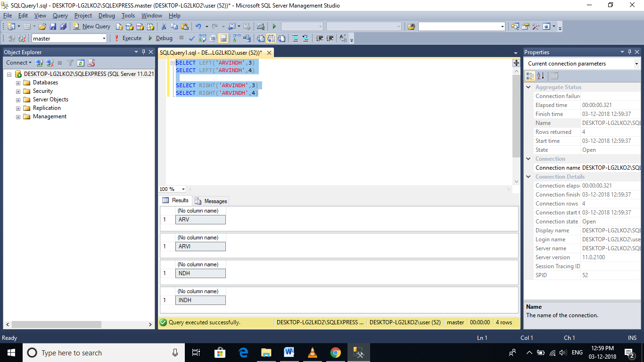

**CHARINDEX**('Expression_To_Find', 'Expression_To_Search', 'Start_Location') - Returns the starting position of the specified expression in a character string. Start_Location parameter is optional.

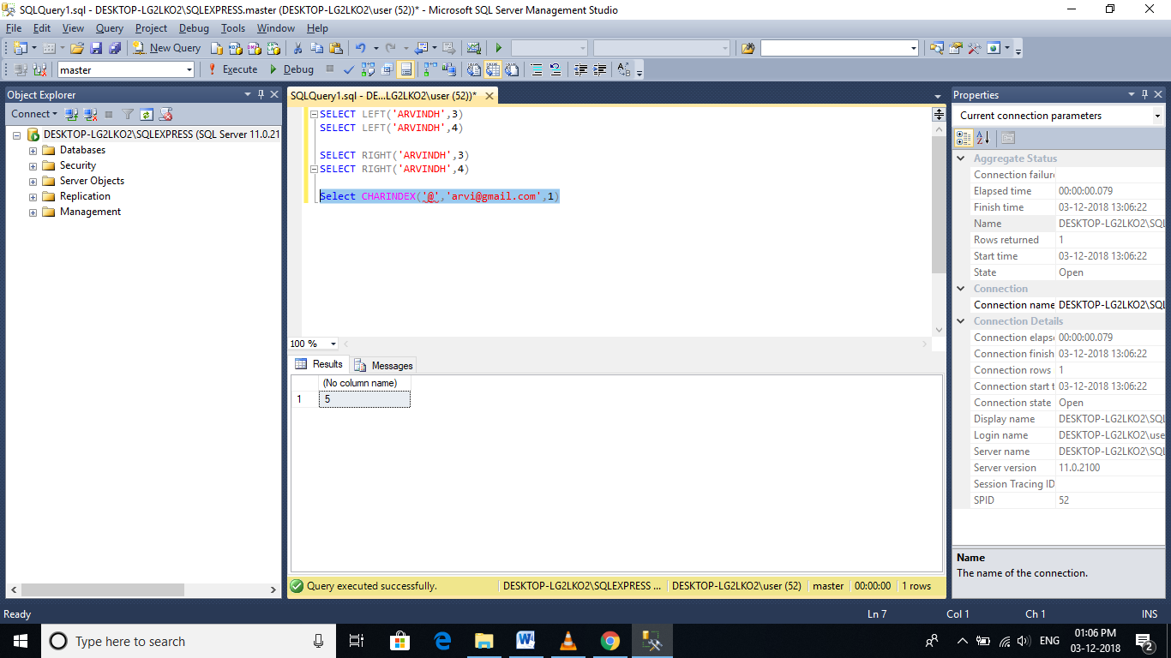

**SUBSTRING**('Expression', 'Start', 'Length') - As the name, suggests, this function returns substring (part of the string), from the given expression. You specify the starting location using the 'start' parameter and the number of characters in the substring using 'Length' parameter. All the 3 parameters are mandatory.

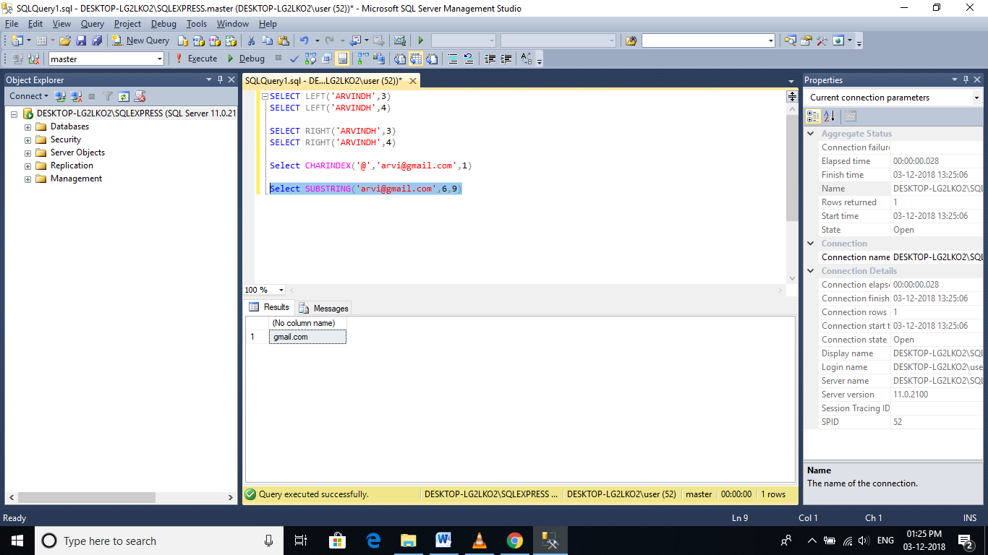

# Replicate, Space, Patindex, Replace and Stuff functions

**REPLICATE(String_To_Be_Replicated, Number_Of_Times_To_Replicate)** - Repeats the given string, for the specified number of times

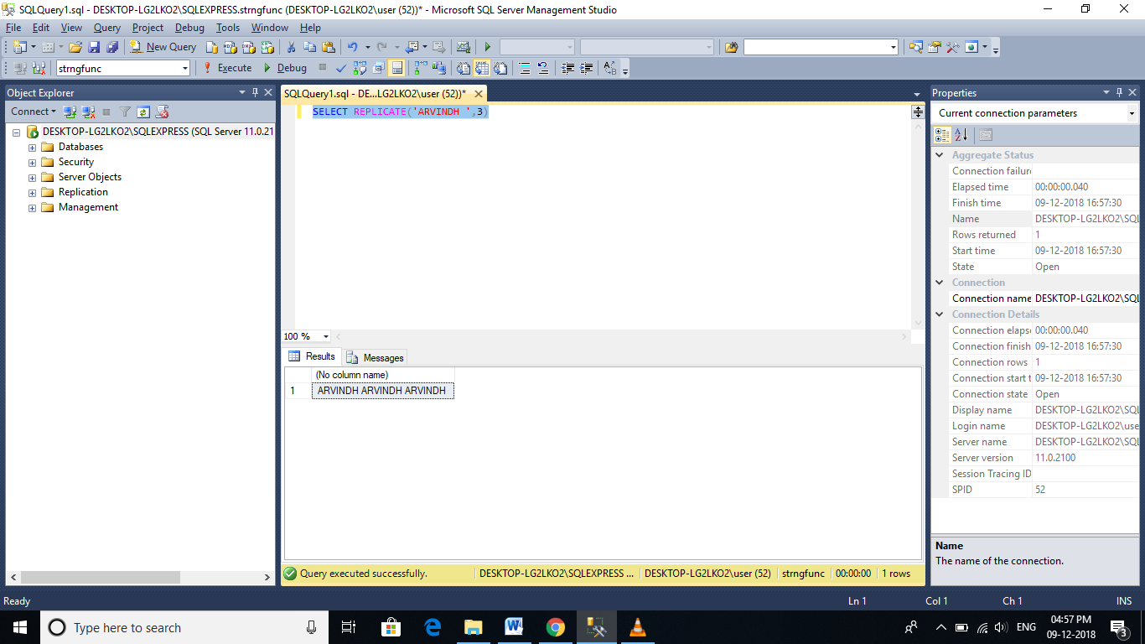

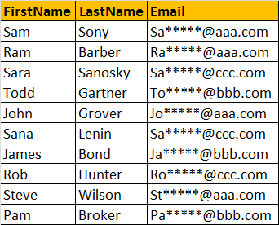

Select FirstName, LastName, SUBSTRING(Email, 1, 2) + REPLICATE('*',5) +   
SUBSTRING(Email, CHARINDEX('@',Email), LEN(Email) - CHARINDEX('@',Email)+1) as Email  
from tblEmployee

example

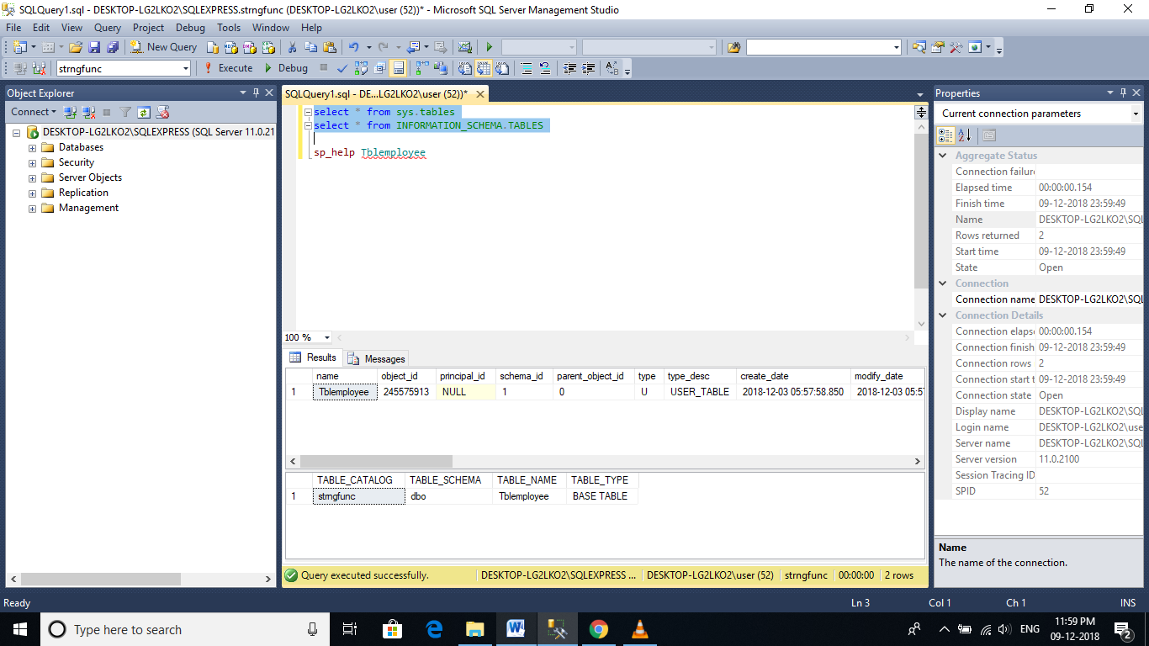

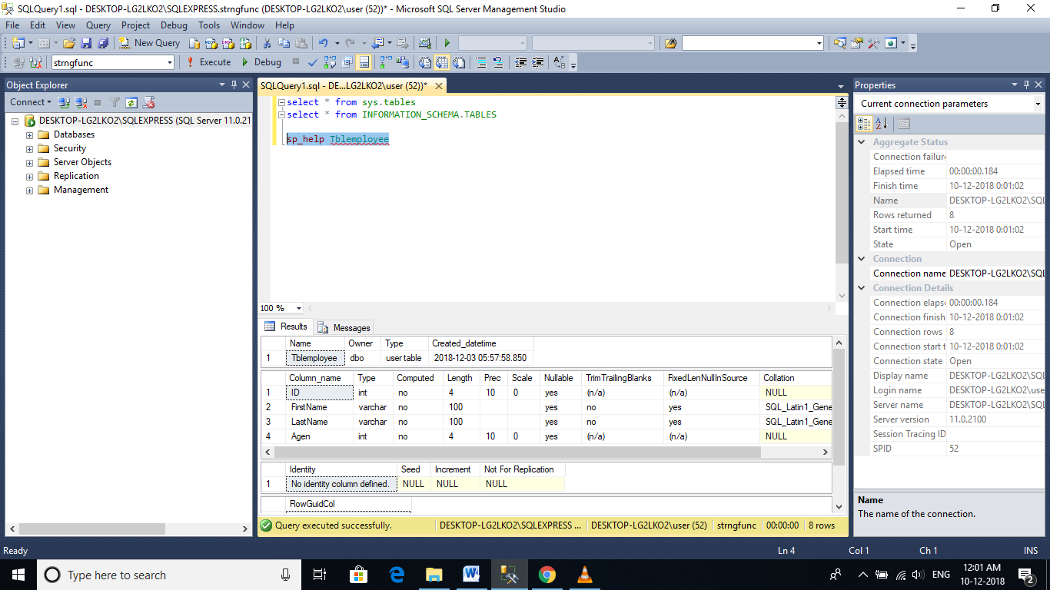

**SPACE(Number_Of_Spaces)** - Returns number of spaces, specified by the Number_Of_Spaces argument.

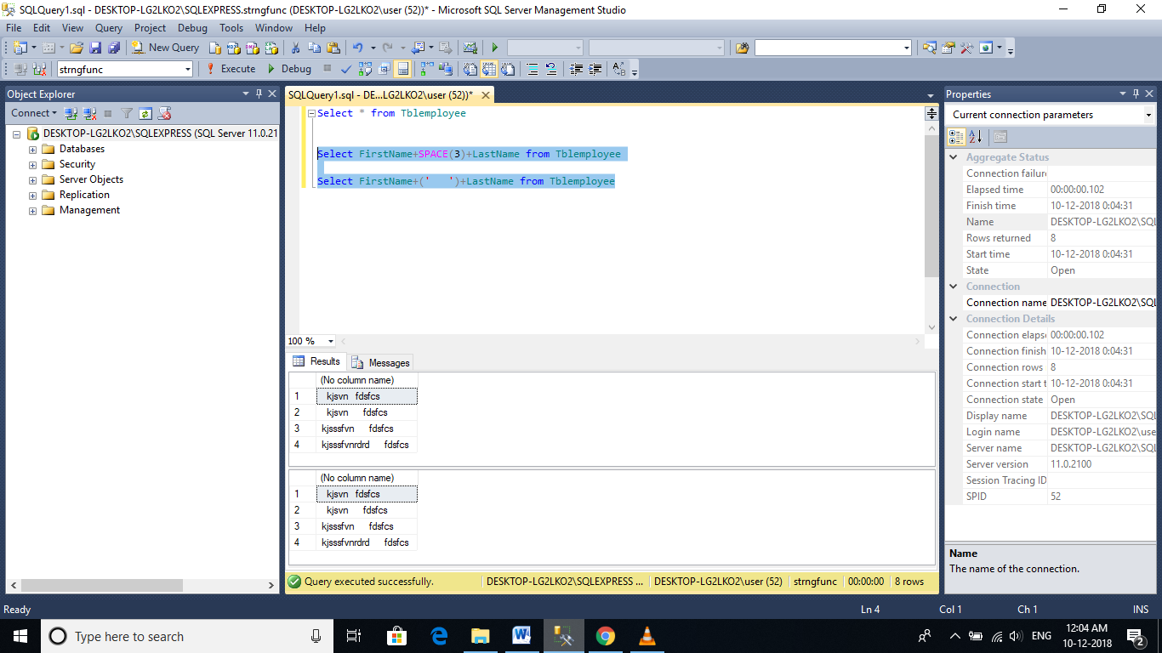

**PATINDEX('%Pattern%', Expression):**  
🡺Returns the starting position of the first occurrence of a pattern in a specified expression.

🡪It takes two arguments, the pattern to be searched and the expression.

🡺PATINDEX() is similar to CHARINDEX().

🡪With CHARINDEX() we cannot use wildcards, where as PATINDEX() provides this capability. If the specified pattern is not found, PATINDEX() returns ZERO.

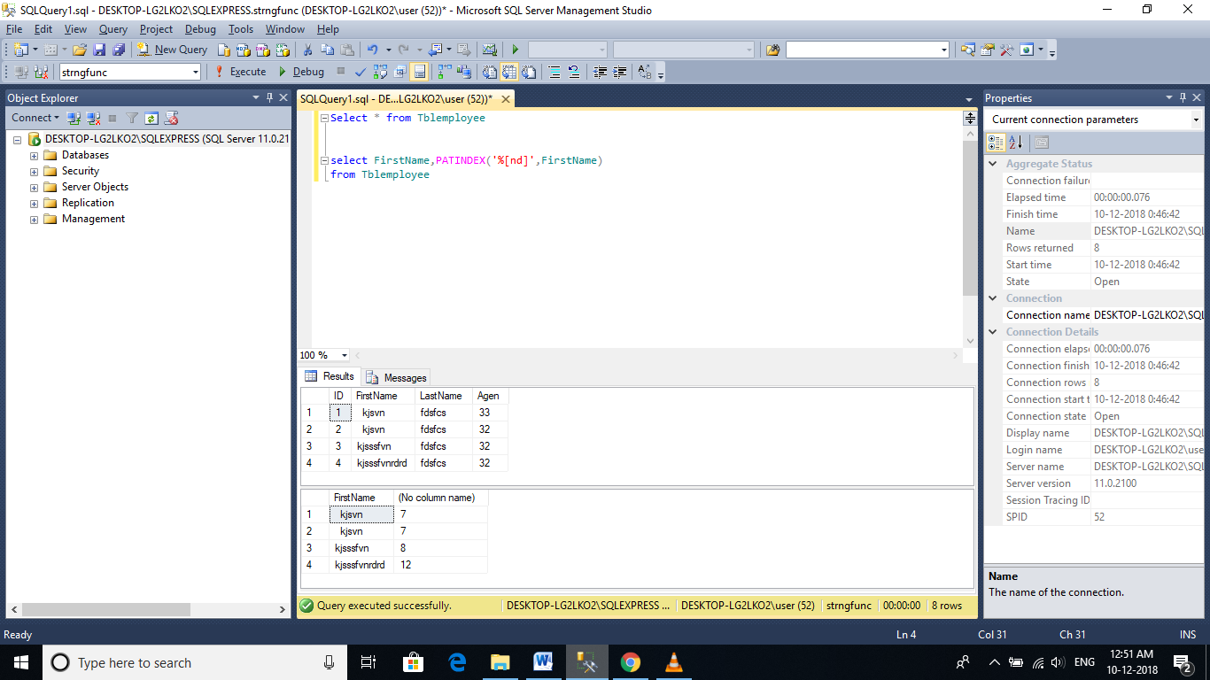

//

update Tblemployee

set Email='mkarvindh@gmail.com'

where ID=1

//

**REPLACE(String_Expression, Pattern , Replacement_Value)**  
Replaces all occurrences of a specified string value with another string value

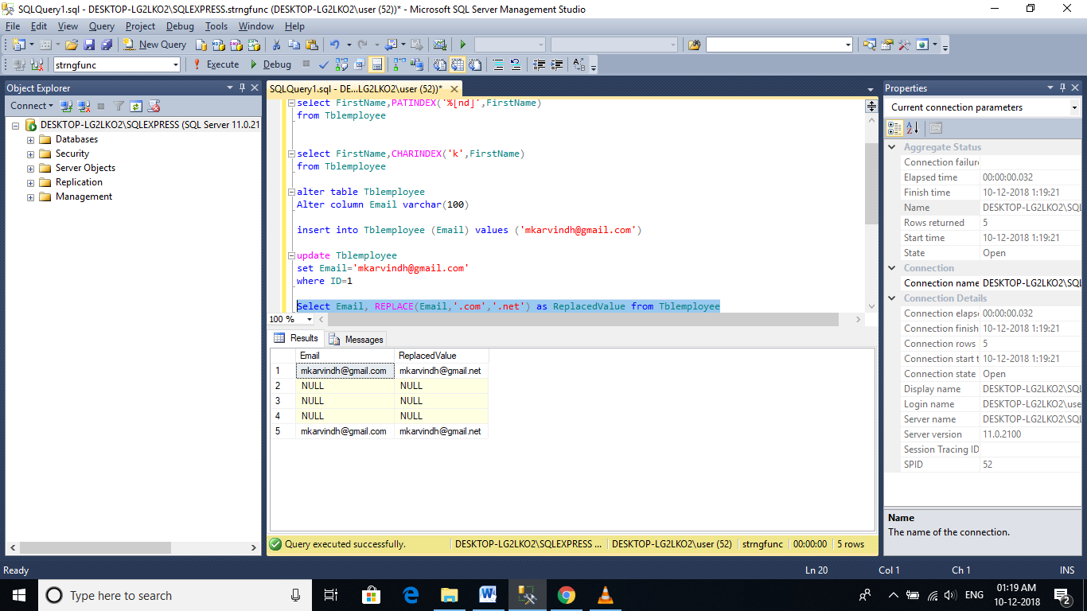

**STUFF(Original_Expression, Start, Length, Replacement_expression)**  
STUFF() function inserts Replacement_expression, at the start position specified, along with removing the charactes specified using Length parameter.

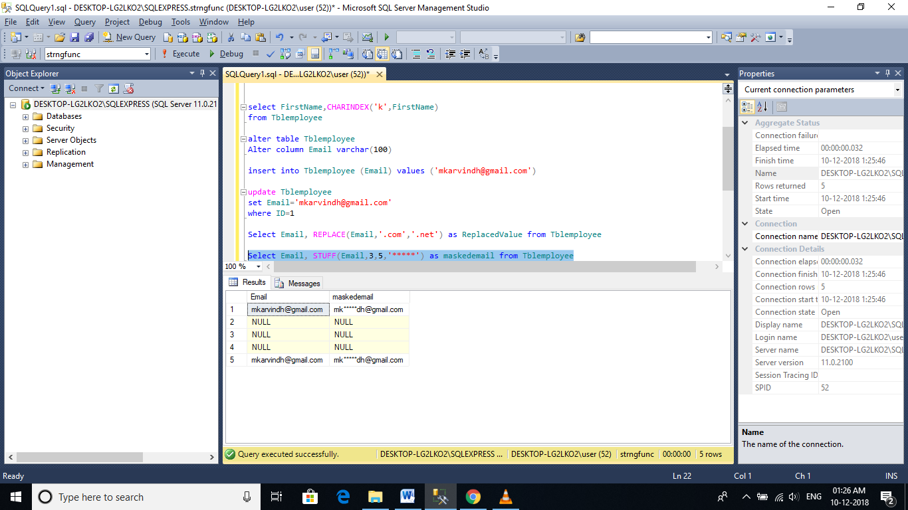

# Cast and Convert functions in SQL Server

🡪To convert one data type to another, CAST and CONVERT functions can be used.

**Syntax of CAST and CONVERT functions from MSDN:**  
CAST ( expression AS data_type [ ( length ) ] )  
CONVERT ( data_type [ ( length ) ] , expression [ , style ] )

🡪From the syntax, it is clear that CONVERT() function has an optional style parameter, where as CAST() function lacks this capability.

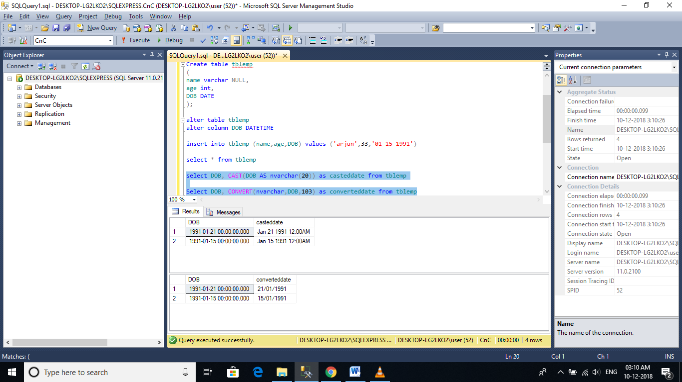

**To get just the date part, from DateTime**  
SELECT CONVERT(VARCHAR(10),GETDATE(),101)

**In SQL Server 2008, Date datatype is introduced, so you can also use**  
SELECT CAST(GETDATE() as DATE)  
SELECT CONVERT(DATE, GETDATE())  
  
**Note:** To control the formatting of the Date part, DateTime has to be converted to NVARCHAR using the styles provided. When converting to DATE data type, the CONVERT() function will ignore the style parameter.

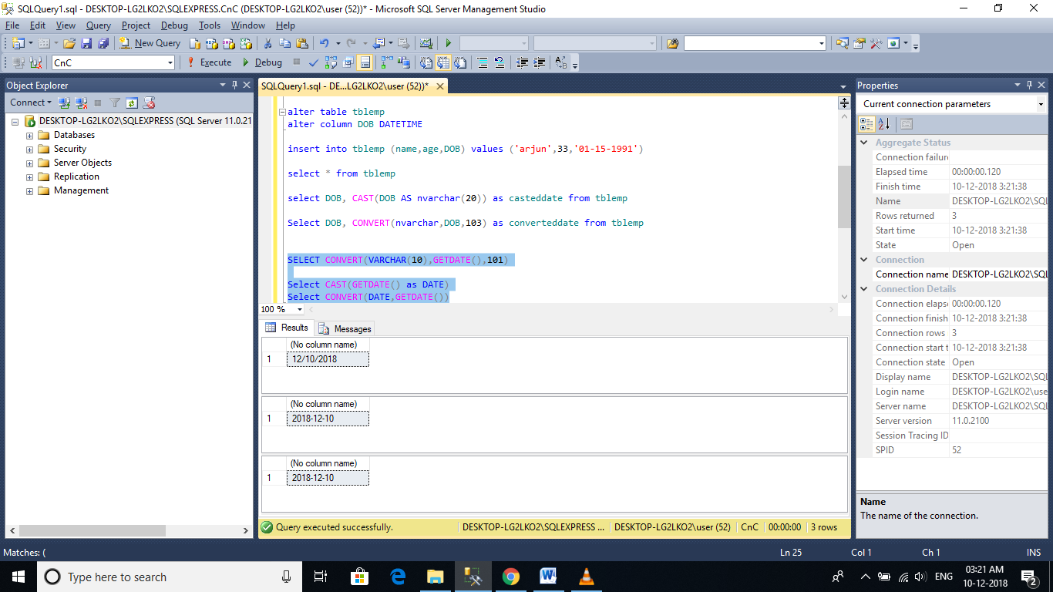

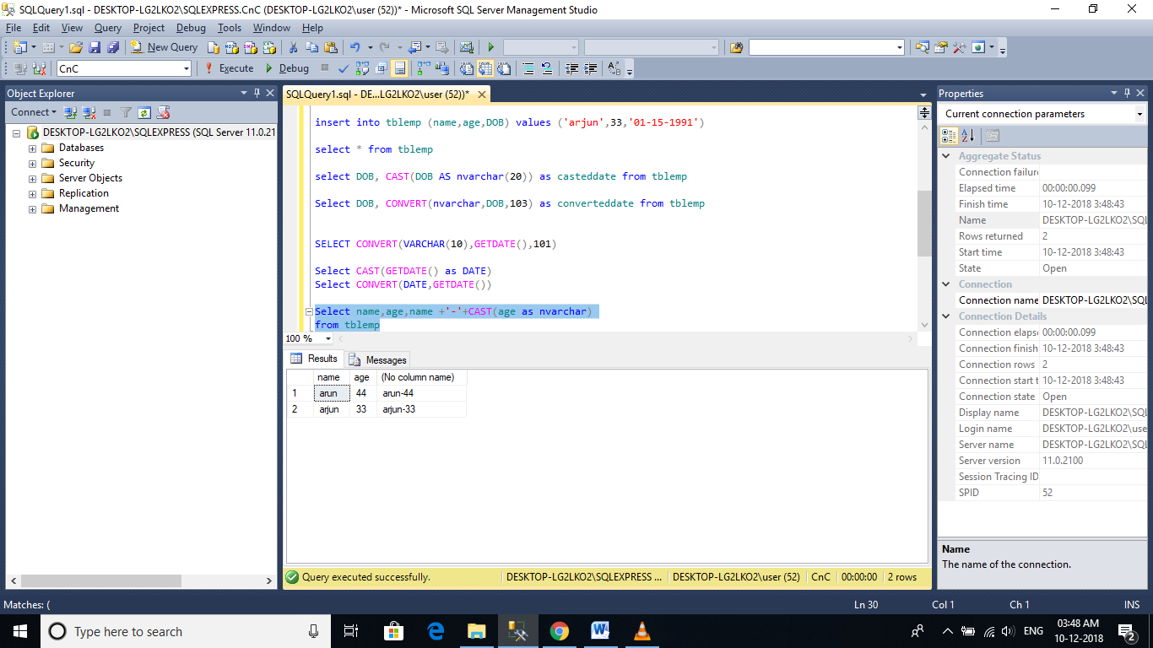

Example **Query:**  
Select CAST(RegisteredDate as DATE) as RegistrationDate,   
COUNT(Id) as TotalRegistrations   
From tblRegistrations   
Group By CAST(RegisteredDate as DATE)

**The following are the differences between the 2 functions.**  
1. Cast is based on ANSI standard and Convert is specific to SQL Server. So, if **portability**is a concern and if you want to use the script with other database applications, use Cast().   
2. Convert provides **more flexibility** than Cast. For example, it's possible to control how you want DateTime datatypes to be converted using styles with convert function.  
🡪The general guideline is to use CAST(), unless you want to take advantage of the style functionality in CONVERT().

**The following table lists a few of the common DateTime styles:**

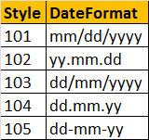

# Mathematical functions in sql server

**ABS ( numeric_expression )** - ABS stands for absolute and returns, the absolute (positive) number

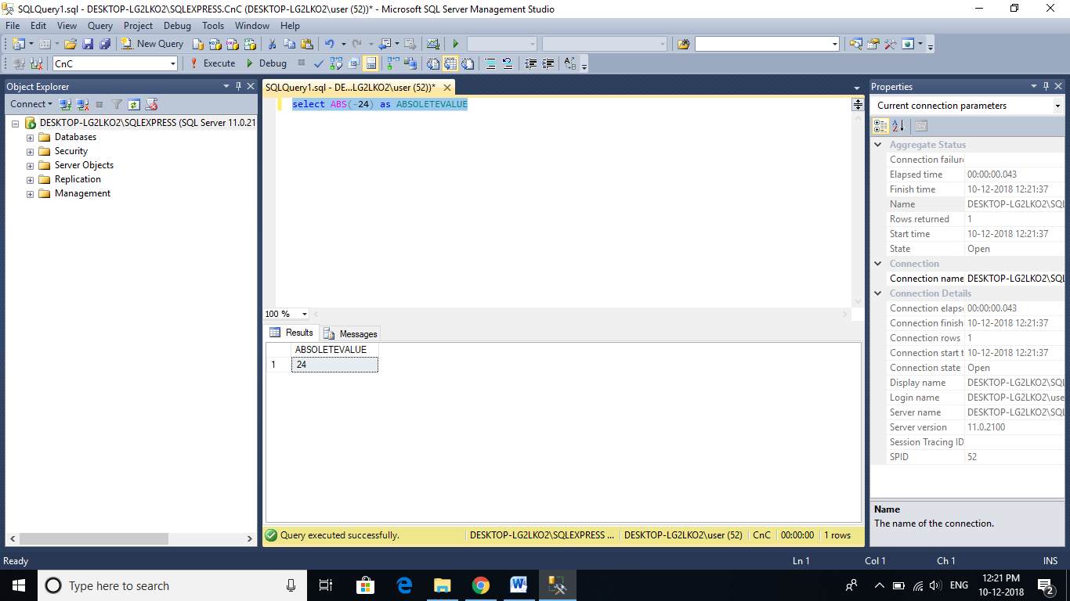

**CEILING ( numeric_expression ) and FLOOR ( numeric_expression )**  
**CEILING**and **FLOOR** functions accept a numeric expression as a single parameter. CEILING() returns the smallest integer value greater than or equal to the parameter, whereas FLOOR() returns the largest integer less than or equal to the parameter.

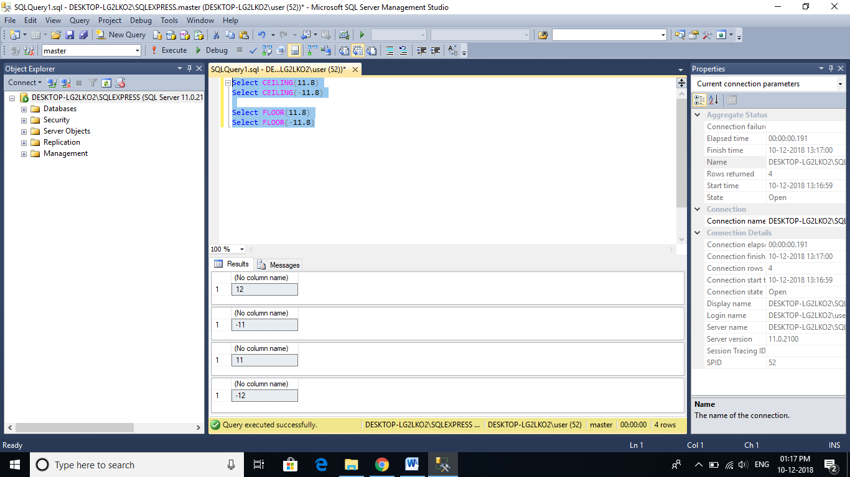

**Power(expression, power)** - Returns the power value of the specified expression to the specified power.

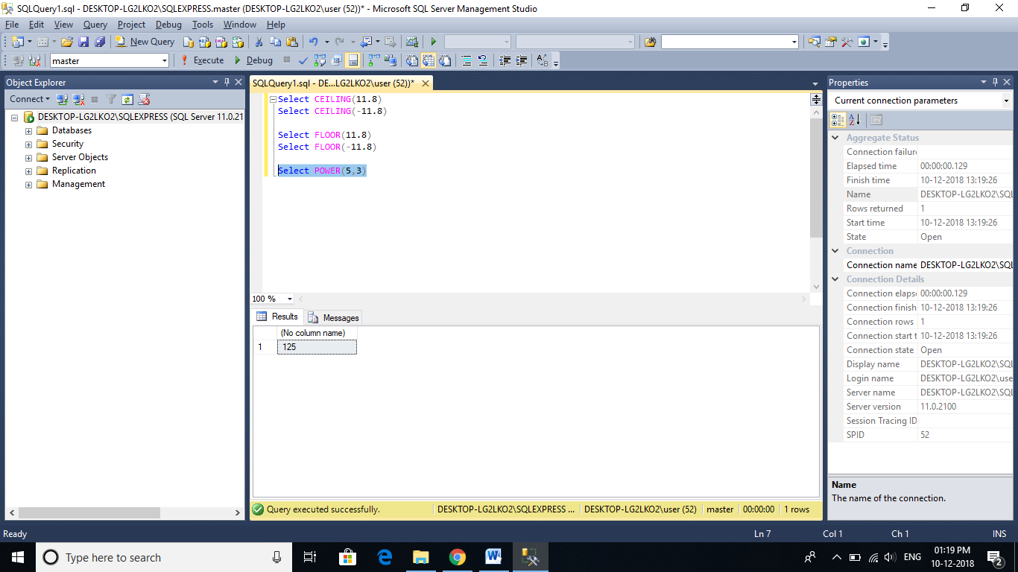

**RAND([Seed_Value])** - Returns a random float number between 0 and 1. Rand() function takes an optional seed parameter. When seed value is supplied the   
  
RADN() function always returns the same value for the same seed.

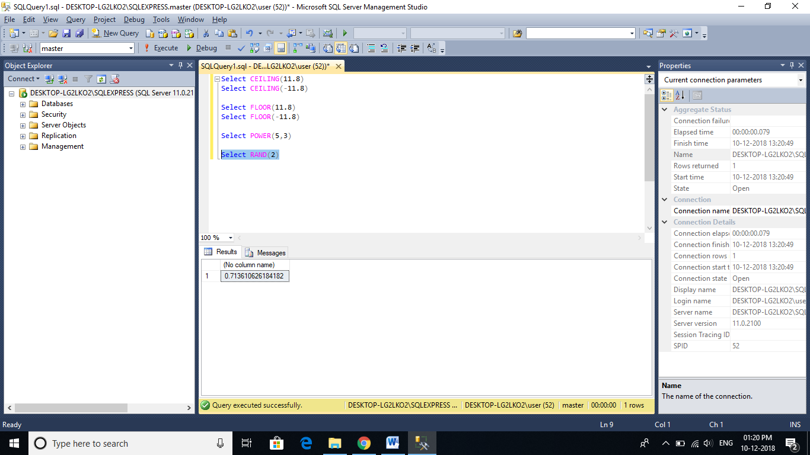

**SQUARE ( Number )** - Returns the square of the given number

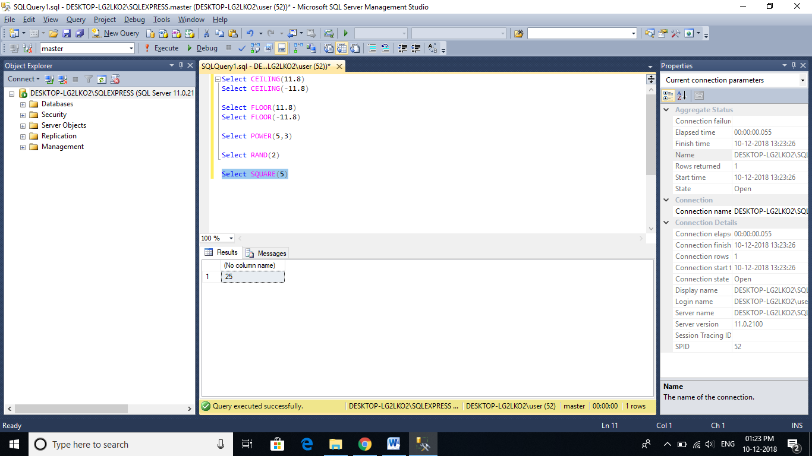

**SQRT ( Number )** - SQRT stands for Square Root. This function returns the square root of the given value

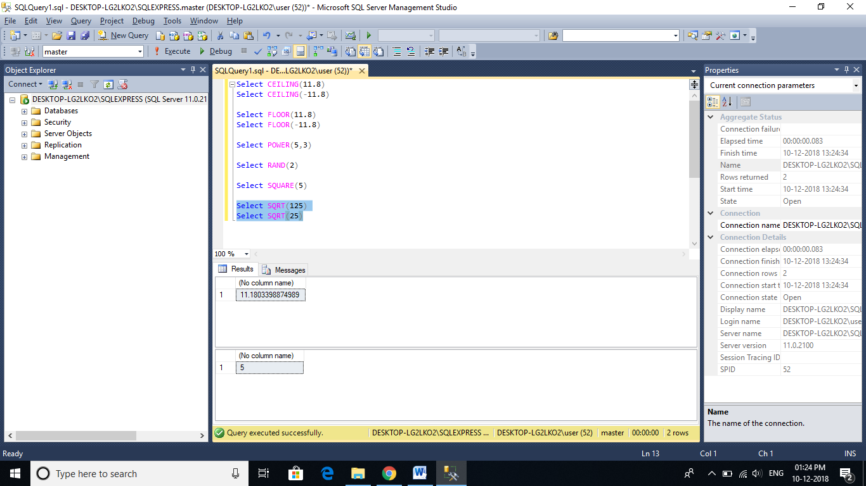

**ROUND ( numeric_expression , length [ ,function ] )** - Rounds the given numeric expression based on the given length. This function takes 3 parameters.   
**1. Numeric_Expression** is the number that we want to round.  
**2. Length parameter**, specifies the number of the digits that we want to round to. If the length is a positive number, then the rounding is applied for the decimal part, where as if the length is negative, then the rounding is applied to the number before the decimal.  
**3. The optional function parameter**, is used to indicate rounding or truncation operations. A value of 0, indicates rounding, where as a value of non zero indicates truncation. Default, if not specified is 0.

**Examples:**  
-- Round to 2 places after (to the right) the decimal point  
Select ROUND(850.556, 2) -- Returns 850.560  
  
-- Truncate anything after 2 places, after (to the right) the decimal point  
Select ROUND(850.556, 2, 1) -- Returns 850.550  
  
-- Round to 1 place after (to the right) the decimal point  
Select ROUND(850.556, 1) -- Returns 850.600  
  
-- Truncate anything after 1 place, after (to the right) the decimal point  
Select ROUND(850.556, 1, 1) -- Returns 850.500  
  
-- Round the last 2 places before (to the left) the decimal point  
Select ROUND(850.556, -2) -- 900.000  
  
-- Round the last 1 place before (to the left) the decimal point  
Select ROUND(850.556, -1) -- 850.000

# Scalar User Defined Functions in sql server

🡪In short **UDF.**

**In SQL Server there are 3 types of User Defined functions**  
1. Scalar functions  
2. Inline table-valued functions  
3. Multistatement table-valued functions

**🡪Scalar functions** may or may not have parameters, but always return a single (scalar) value.

🡪The returned value can be of any data type, except **text, ntext, image, cursor, and timestamp**

**To create a function, we use the following syntax:**  
CREATE FUNCTION Function_Name(@Parameter1 DataType, @Parameter2 DataType,..@Parametern Datatype)  
RETURNS Return_Datatype  
AS  
BEGIN  
    Function Body  
    Return Return_Datatype  
END

CREATE FUNCTION Age(@DOB Date)    
RETURNS INT    
AS    
BEGIN    
DECLARE @Age INT    
SET @Age = DATEDIFF(YEAR, @DOB, GETDATE()) - CASE WHEN (MONTH(@DOB) > MONTH(GETDATE())) OR (MONTH(@DOB) = MONTH(GETDATE()) AND DAY(@DOB) > DAY(GETDATE())) THEN 1 ELSE 0 END   
RETURN @Age    
END

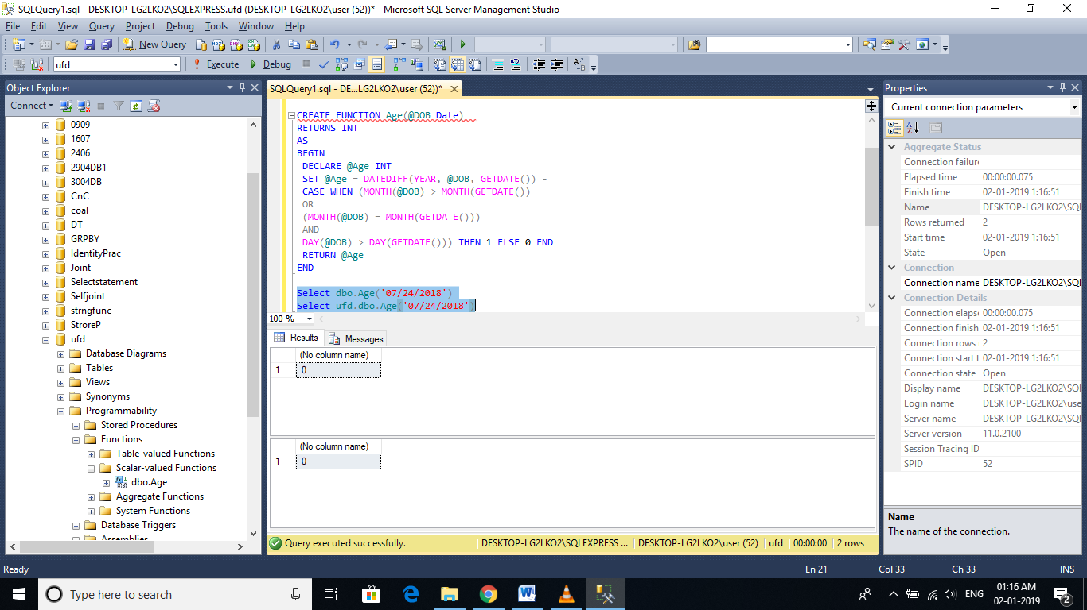

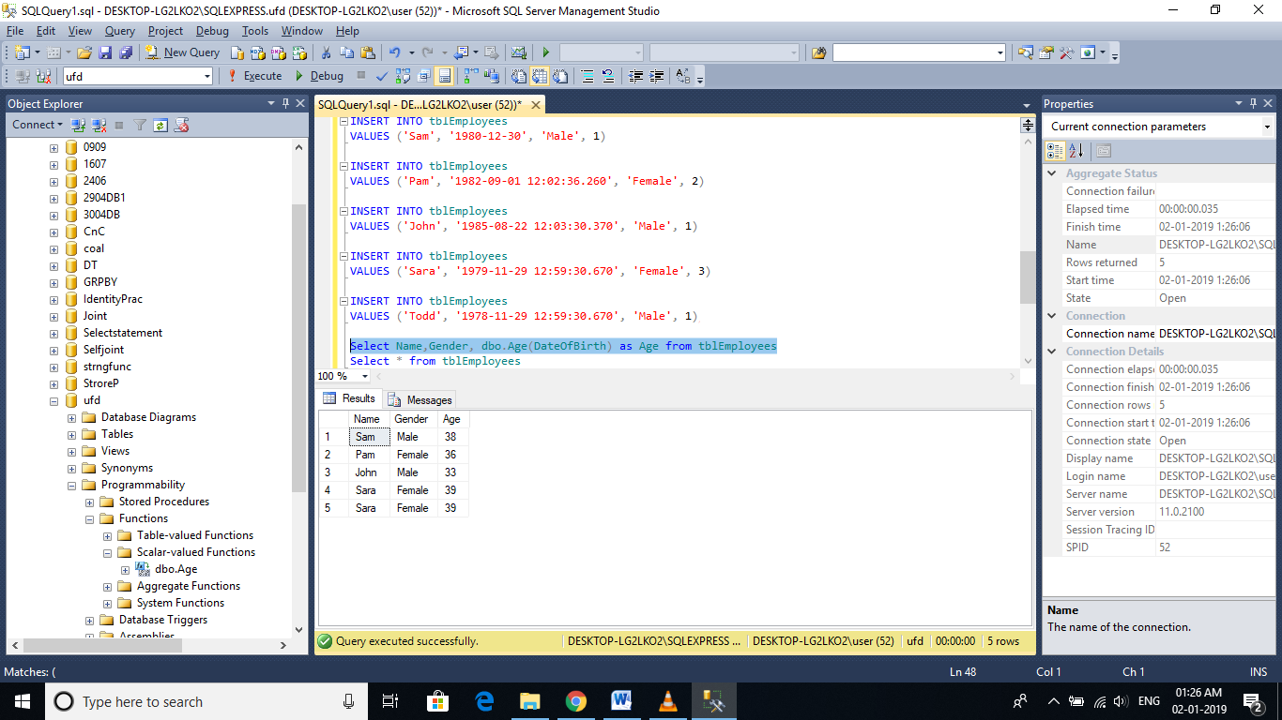

Select Name,Gender, dbo.Age(DateOfBirth) as Age from tblEmployees

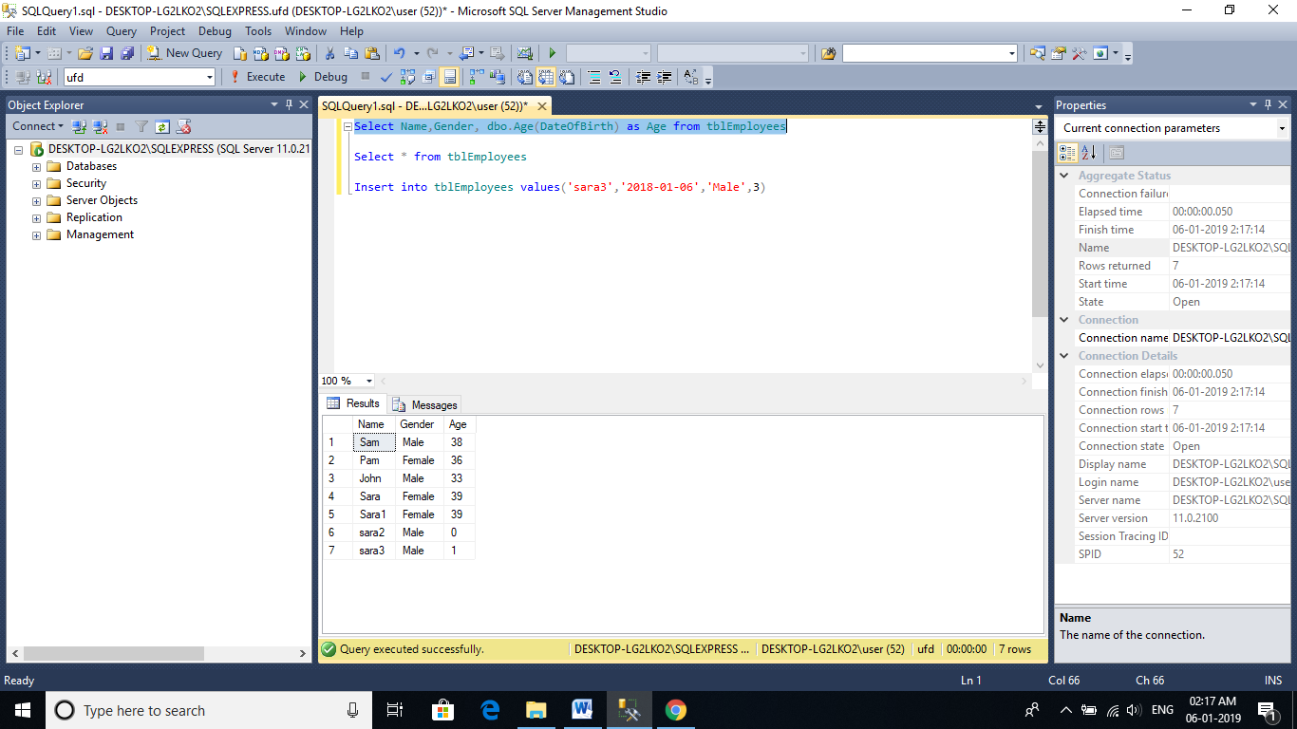

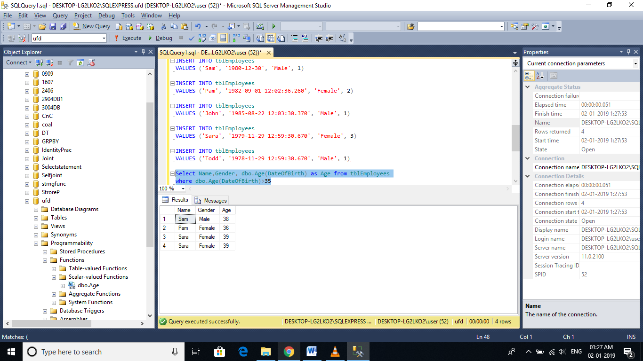

Select Name,Gender, dbo.Age(DateOfBirth) as Age from tblEmployees

where dbo.Age(DateOfBirth)>35

🡪**A stored procedure** also can accept DateOfBirth and return Age, but you cannot use stored procedures in a **select or where clause**.

🡪To alter a function we use ALTER FUNCTION FuncationName statement and to delete it, we use DROP FUNCTION FuncationName.

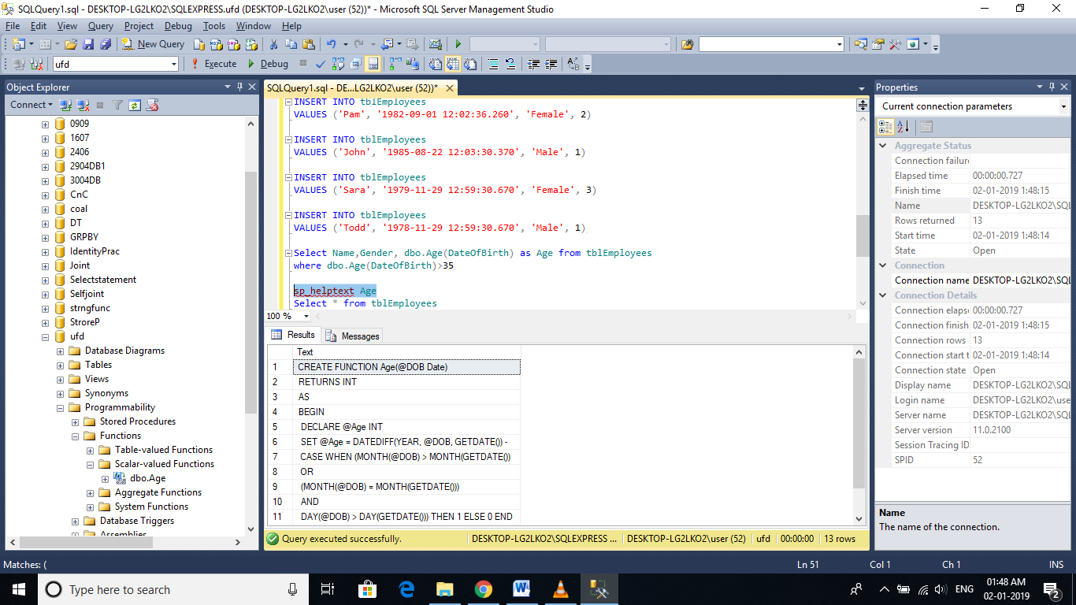

# Inline table valued functions

🡪a scalar function, returns a **single**value. on the other hand, an Inline Table Valued function, return a **table**.

**Syntax for creating an inline table valued function**  
CREATE FUNCTION Function_Name(@Param1 DataType, @Param2 DataType..., @ParamN DataType)  
RETURNS TABLE  
AS

RETURN (Select_Statement)

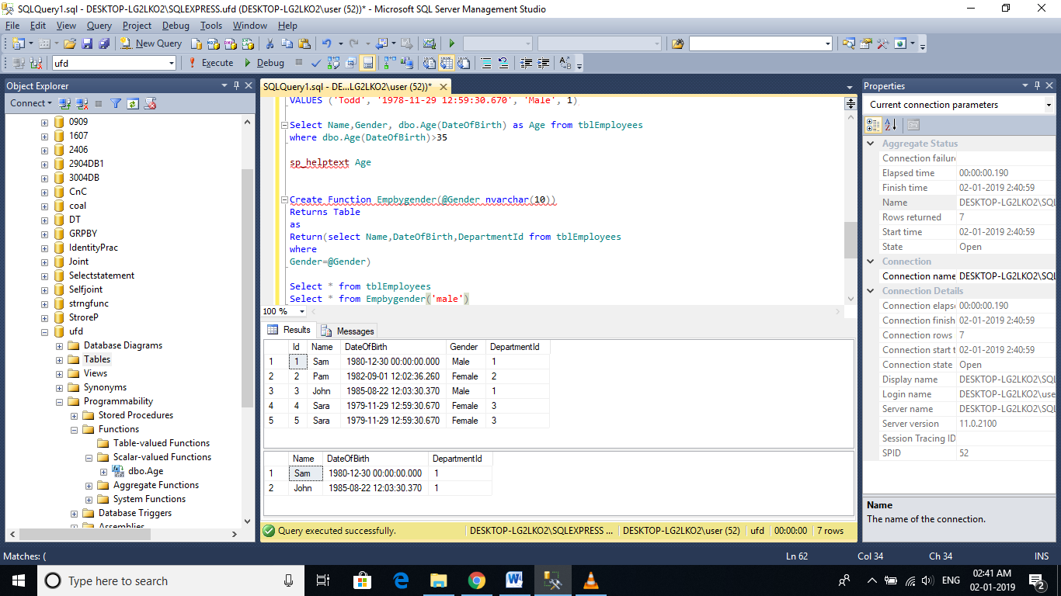

Key Points:

1. We specify **TABLE**as the return type, instead of any **scalar** data type  
2. The **function body** is not enclosed between **BEGIN and END** block. Inline table valued function body, cannot have BEGIN and END block.  
3. The **structure of the table** that gets returned, is determined by the SELECT statement with in the function.

**Where can we use Inline Table Valued functions**  
1. Inline Table Valued functions can be used to achieve the functionality of parameterized views. We will talk about views, in a later session.  
2. The table returned by the table valued function, can also be used in joins with other tables.

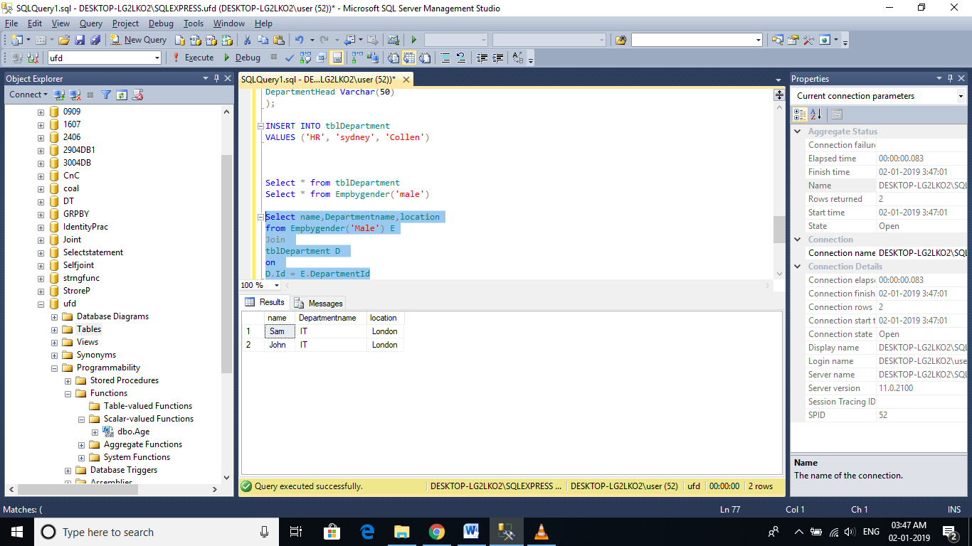

# Multi-Statement Table Valued Functions

🡪Multi statement table valued functions are very similar to Inline Table valued functions, with a few differences.

**Inline Table Valued function(ILTVF):**  
Create Function fn_ILTVF_GetEmployees()  
Returns Table  
as  
Return (Select Id, Name, Cast(DateOfBirth as Date) as DOB  
        From tblEmployees)  
  
  
**Multi-statement Table Valued function(MSTVF):**  
Create Function fn_MSTVF_GetEmployees()  
Returns @Table Table (Id int, Name nvarchar(20), DOB Date)//Declare table structure  
as  
Begin  
Insert into @Table//Insert query   
Select Id, Name, Cast(DateOfBirth as Date)//select query  
From tblEmployees  
Return  
End

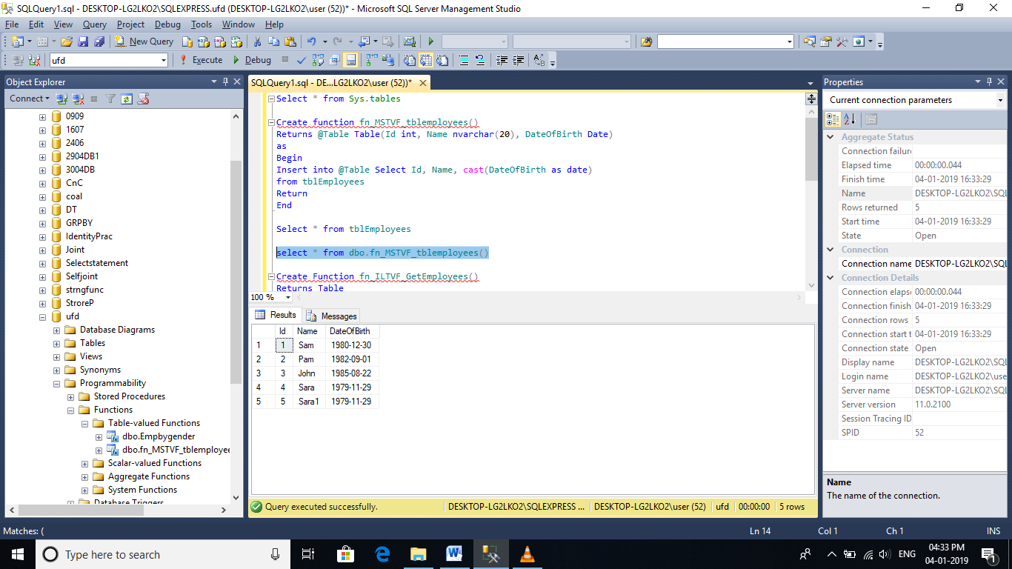

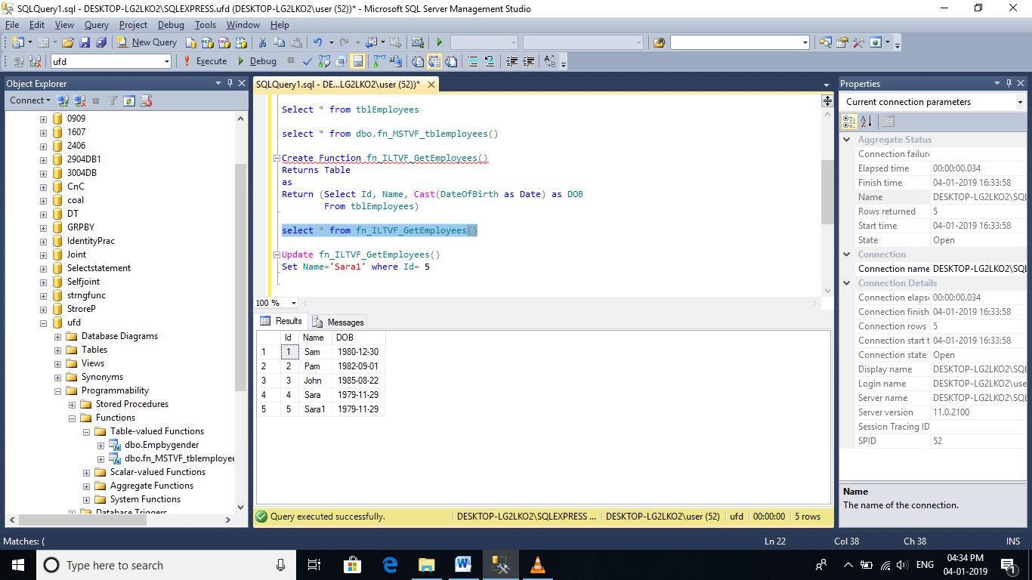

**Calling the Inline Table Valued Function:**  
Select * from fn_ILTVF_GetEmployees()  
  
**Calling the Multi-statement Table Valued Function:**  
Select * from fn_MSTVF_GetEmployees()

**Now let's understand the differences between Inline Table Valued functions and Multi-statement Table Valued functions**  
1. In an Inline Table Valued function, the RETURNS clause cannot contain the structure of the table, the function returns. Where as, with the multi-statement table valued function, we specify the structure of the table that gets returned  
2. Inline Table Valued function cannot have BEGIN and END block, where as the multi-statement function can have.  
3. Inline Table valued functions are better for performance, than multi-statement table valued functions. If the given task, can be achieved using an inline table valued function, always prefer to use them, over multi-statement table valued functions.  
4. It's possible to update the underlying table, using an inline table valued function, but not possible using multi-statement table valued function.  
  
**Updating the underlying table using inline table valued function:**  
This query will change **Sam** to **Sam1**, in the underlying table **tblEmployees**. When you try do the same thing with the multi-statement table valued function, you will get an error stating 'Object 'fn_MSTVF_GetEmployees' cannot be modified.'  
Update fn_ILTVF_GetEmployees() set Name='Sam1' Where Id = 1  
  
**Reason for improved performance of an inline table valued function:**  
Internally, SQL Server treats an inline table valued function much like it would a view and treats a multi-statement table valued function similar to how it would a stored procedure.

# Important concepts related to Functions in sql server

**Deterministic and Nondeterministic Functions:**

🡪Deterministic functions always return the **same result** any time they are called with a specific set of input values and given the same state of the database.   
**Examples**: Sum(), AVG(), Square(), Power() and Count()  
  
**Note**: All aggregate functions are deterministic functions.  
  
**🡪Nondeterministic functions** may return **different results** each time they are called with a specific set of input values even if the database state that they access remains the same.  
**Examples**: GetDate() and CURRENT_TIMESTAMP  
  
Rand() function is a **Non-deterministic function**, but if you provide the **seed value**, the function becomes **deterministic**, as the same value gets returned for the same seed value.

**Encrypting a function definiton using WITH ENCRYPTION OPTION:**  
We have learnt how to encrypt Stored procedure text using WITH ENCRYPTION OPTION in [**Part 18 of this video series**](http://csharp-video-tutorials.blogspot.com/2012/08/stored-procedures-part-18.html). Along the same lines, you can also encrypt a function text. Once, encrypted, you cannot view the text of the function, using **sp_helptext**system stored procedure. If you try to, you will get a message stating 'The text for object is encrypted.'

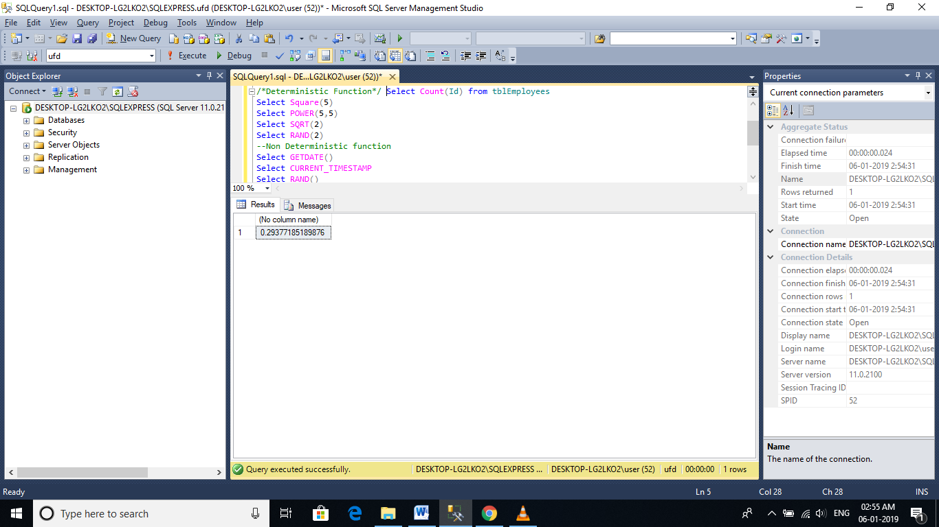

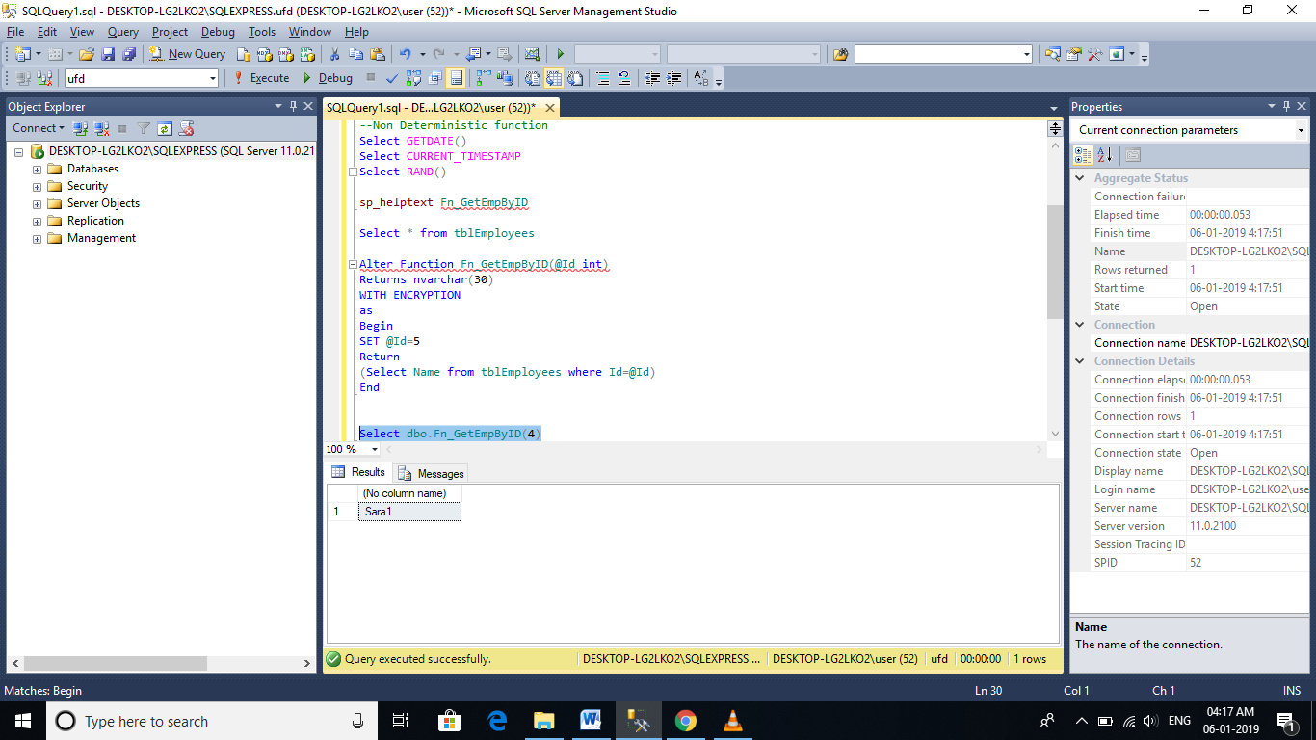

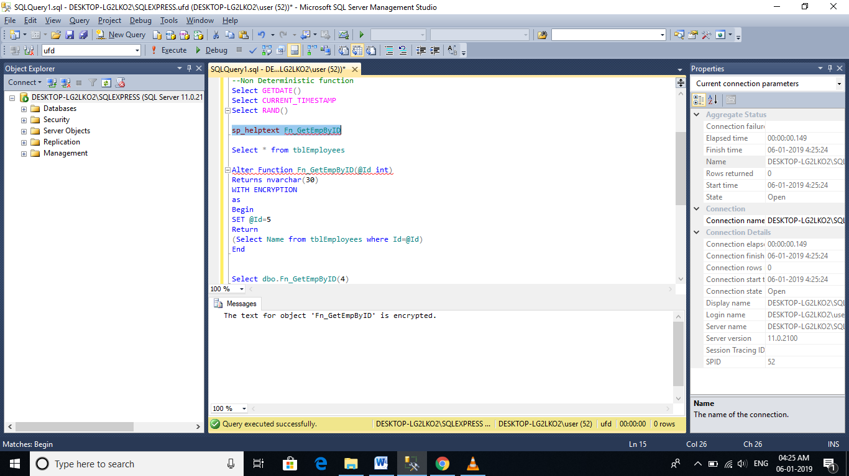

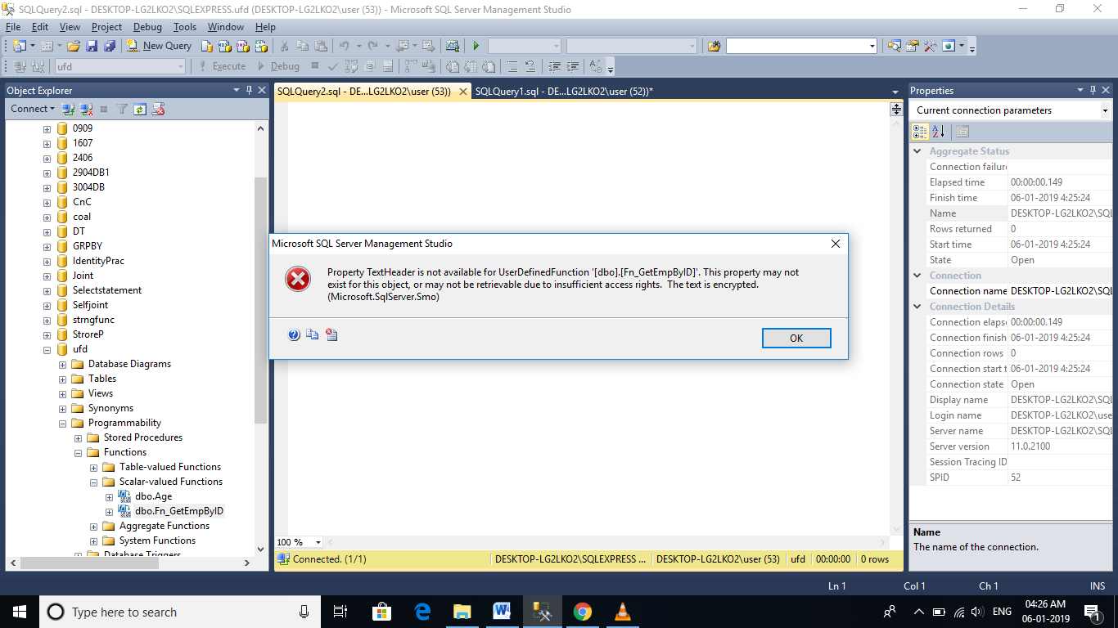

Calling Functions under stored procedure

Reference Link: <https://www.c-sharpcorner.com/UploadFile/rohatash/calling-a-function-from-a-stored-procedure-in-sql-server-201/>

**Creating a function WITH SCHEMABINDING option:**

1. **The function fn_GetEmployeeNameById**(), is dependent on tblEmployees table.   
2. Delete the table **tblEmployees** from the database.   
Drop Table tblEmployees  
3. Now, execute the function fn_GetEmployeeNameById(), you will get an error stating 'Invalid object name tblEmployees'. So, we are able to delete the table, while the function is still refrencing it.  
4. Now, **recreate the table** and insert data, using the scripts provided.  
5. Next, **Alter the function fn_GetEmployeeNameById()**, to use WITH SCHEMABINDING option.  
Alter Function fn_GetEmployeeNameById(@Id int)  
Returns nvarchar(20)  
With SchemaBinding  
as  
Begin  
 Return (Select Name from dbo.tblEmployees Where Id = @Id)  
End  
  
6. Now, **try to drop the table using** - Drop Table tblEmployees. You will get a message stating, 'Cannot DROP TABLE tblEmployees because it is being referenced by object fn_GetEmployeeNameById.'  
  
So, Schemabinding, specifies that the function is bound to the database objects that it references. When SCHEMABINDING is specified, the base objects cannot be modified in any way that would affect the function definition. The function definition itself must first be modified or dropped to remove dependencies on the object that is to be modified.

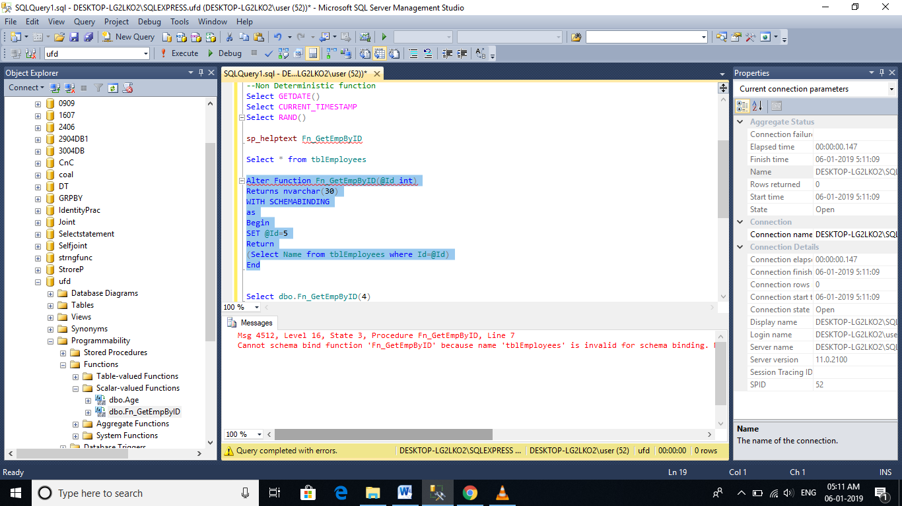

**Note**: You have to use the **2 part object name** i.e, dbo.tblEmployees, to use WITH SCHEMABINDING option. dbo is the schema name or owner name, tblEmployees is the table name.

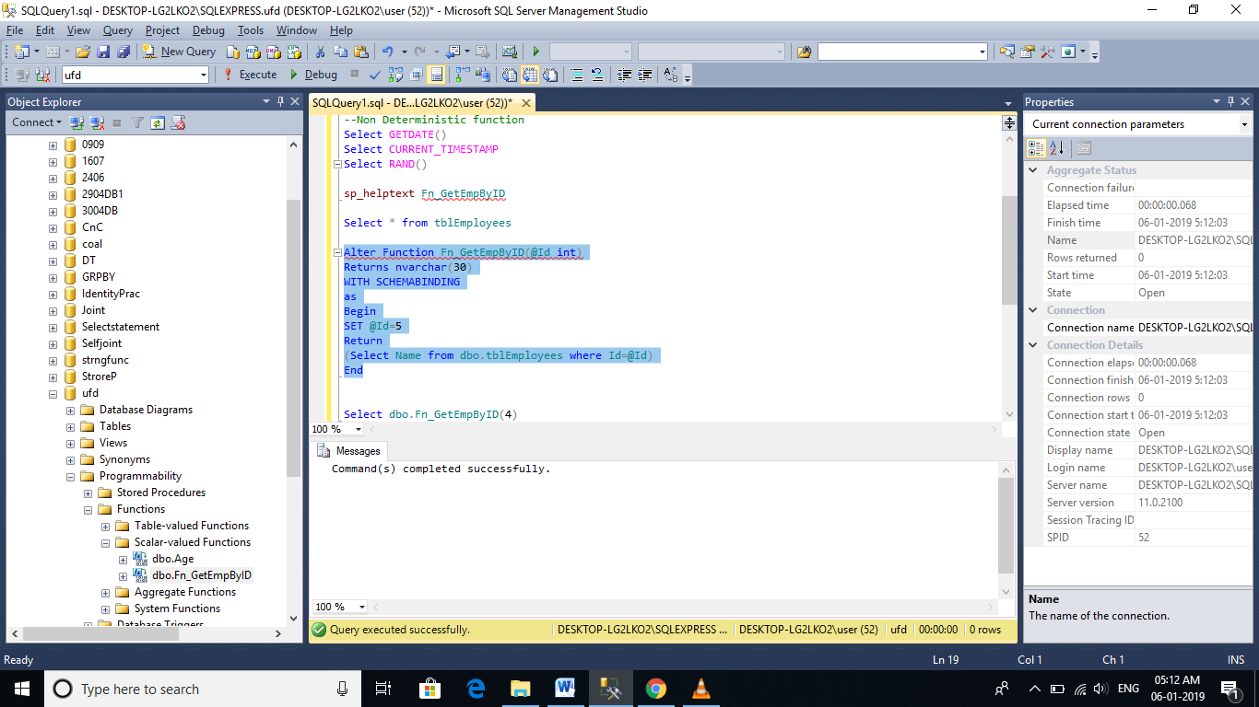

DBO – Database Owner

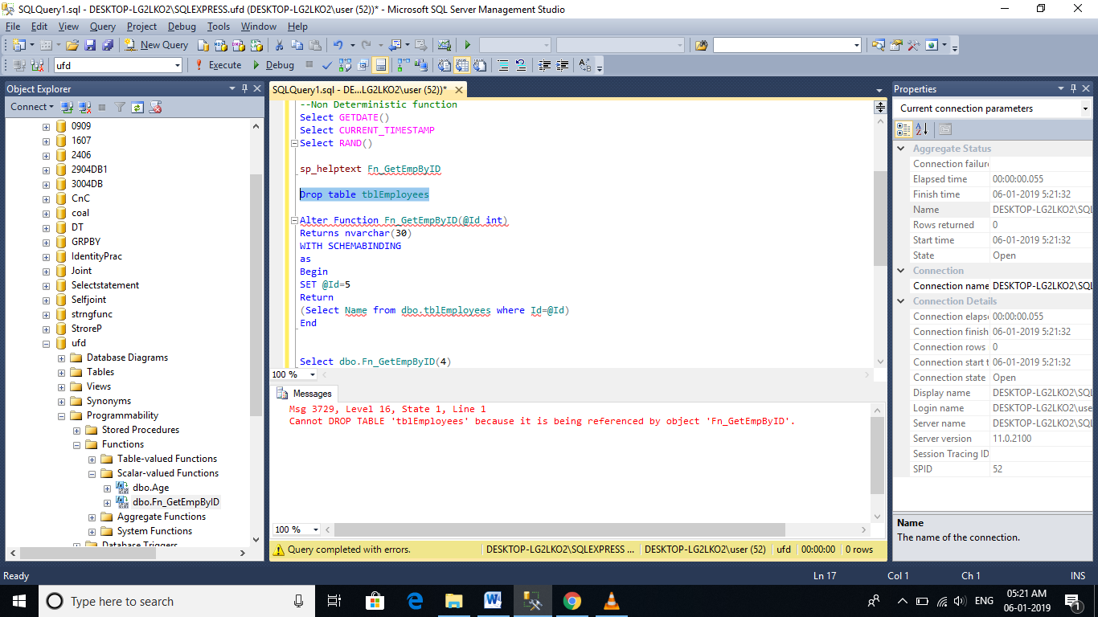

# Temporary tables in SQL Server

**What are Temporary tables?**  
🡪Temporary tables, are very similar to the permanent tables.

🡪Permanent tables get created in the database you specify, and remain in the database permanently, until you delete (drop) them.

🡪On the other hand, temporary tables get created in the TempDB and are automatically deleted, when they are no longer used.

**Different Types of Temporary tables**  
In SQL Server, there are 2 types of Temporary tables - Local Temporary tables and Global Temporary tables.

**How to Create a Local Temporary Table:**  
Creating a local Temporary table is very similar to creating a permanent table, except that you prefix the **table name with 1 pound (#) symbol**. In the example below, **#PersonDetails** is a local temporary table, with Id and Name columns.  
**Create Table #PersonDetails(Id int, Name nvarchar(20))**  
  
**Insert Data into the temporary table:**  
Insert into #PersonDetails Values(1, 'Mike')  
Insert into #PersonDetails Values(2, 'John')  
Insert into #PersonDetails Values(3, 'Todd')  
  
**Select the data from the temporary table:**  
Select * from #PersonDetails

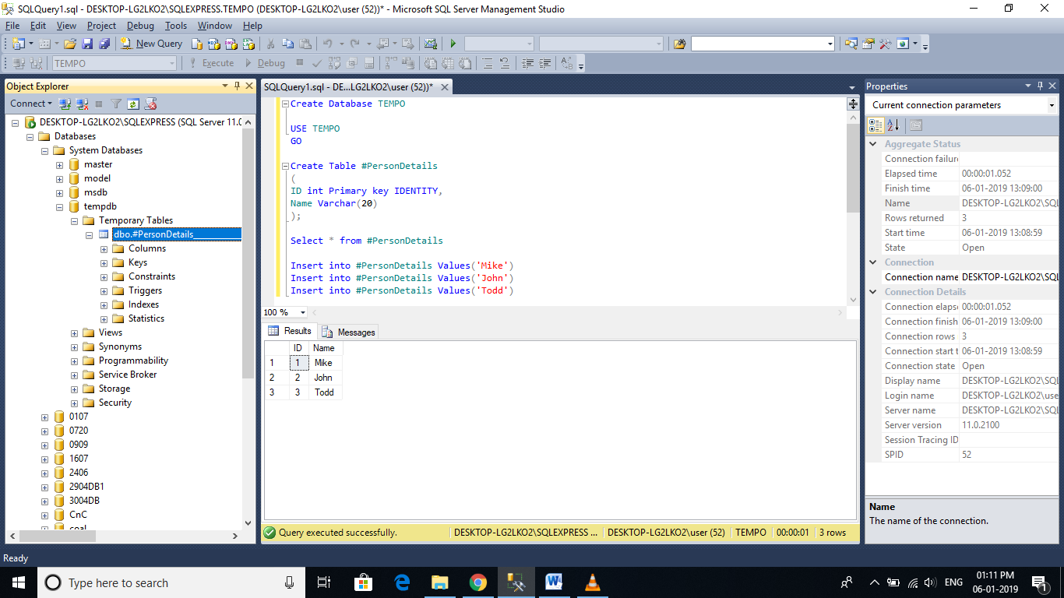

**How to check if the local temporary table is created**

Select name from tempdb..sysobjects   
where name like '#PersonDetails%'

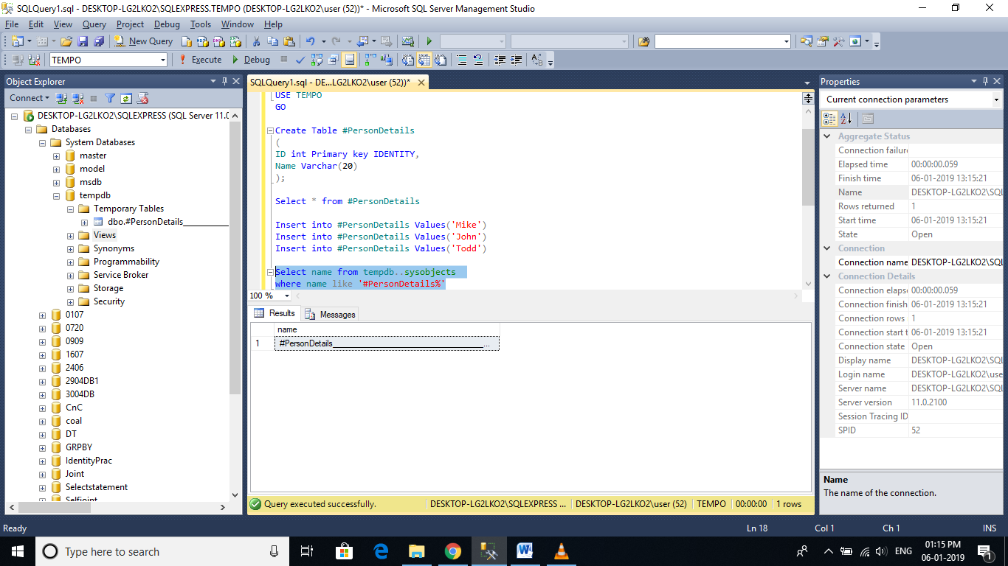

**You can also check the existence of temporary tables** using object explorer. In the object explorer, expand TEMPDB database folder, and then exapand TEMPORARY TABLES folder, and you should see the temporary table that we have created.  
  
**🡪A local temporary table is available, only for the connection** that has created the table.

🡪If you open another query window, and execute the following query you get an error stating 'Invalid object name #PersonDetails'.

🡪This proves that local temporary tables are available, only for the connection that has created them.

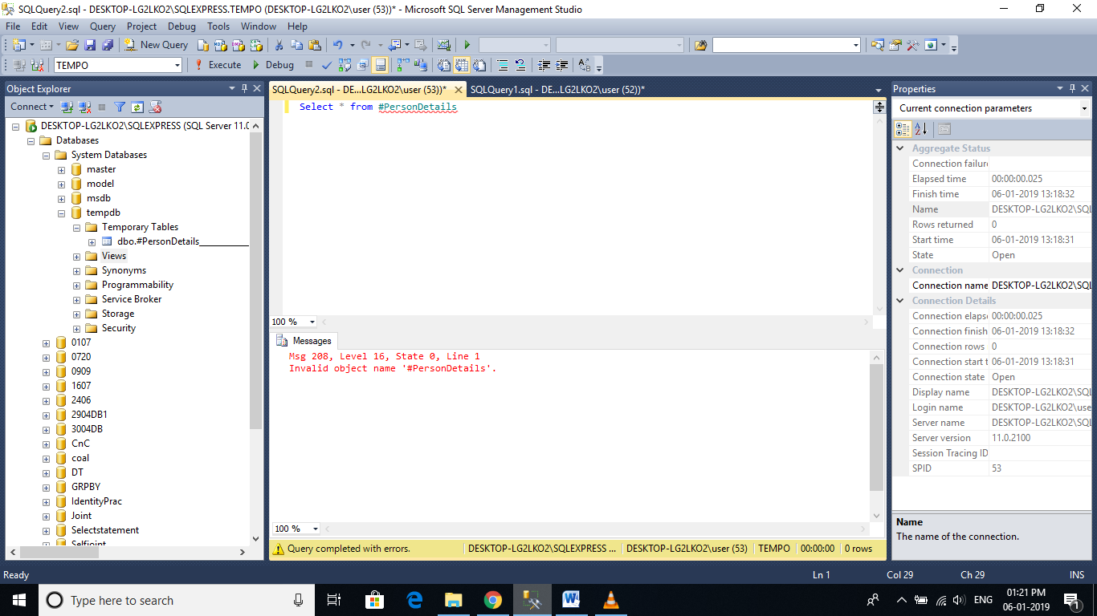

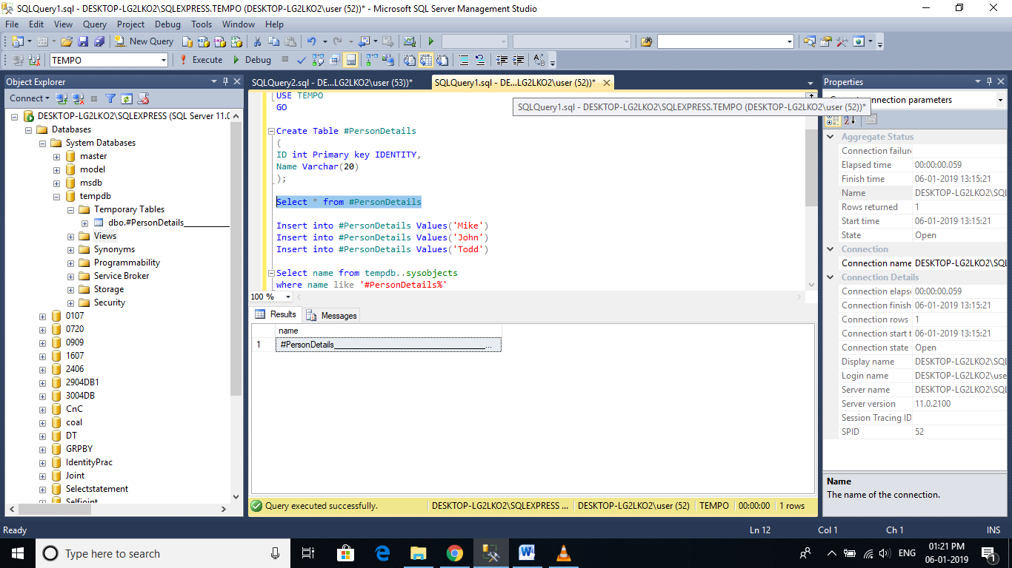

Close the query window.

**🡪A local temporary table is automatically dropped**, when the connection that has created the it, is closed.

🡪If the user wants to explicitly drop the temporary table, he can do so using   
DROP TABLE #PersonDetails

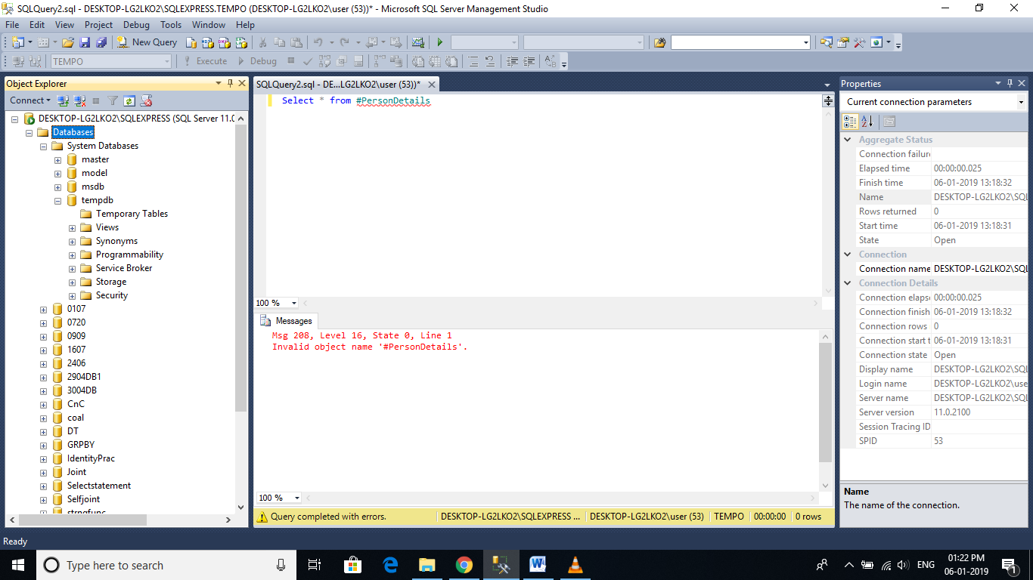

**🡪If the temporary table, is created inside the stored procedure**, it get's dropped automatically upon the completion of stored procedure execution.

🡪The stored procedure below, creates **#PersonDetails** temporary table, populates it and then finally returns the data and destroys the temporary table immediately after the completion of the stored procedure execution.

Create Procedure spCreateLocalTempTable  
as  
Begin  
Create Table #PersonDetails(Id int, Name nvarchar(20))  
  
Insert into #PersonDetails Values(1, 'Mike')  
Insert into #PersonDetails Values(2, 'John')  
Insert into #PersonDetails Values(3, 'Todd')  
  
Select * from #PersonDetails  
End

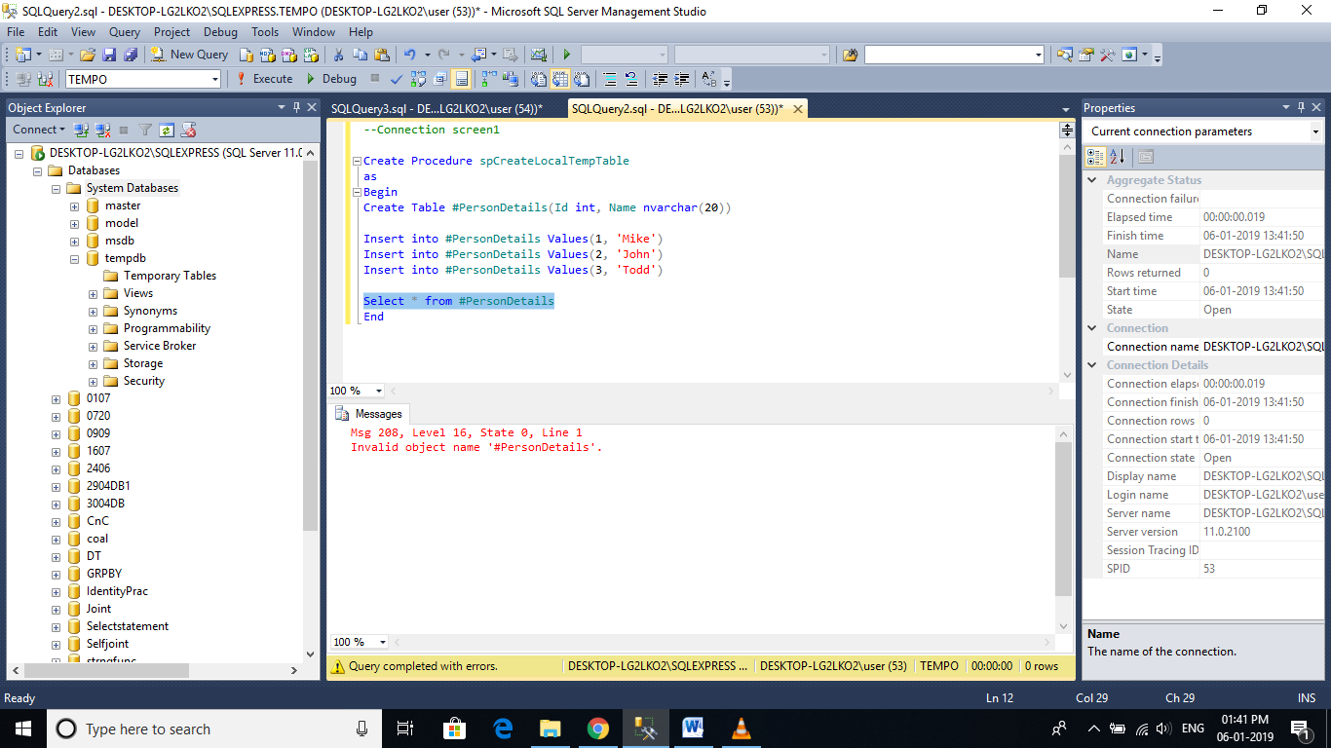

**🡪It is also possible for different connections**, to create a local temporary table with the same name.

🡪For example User1 and User2, both can create a local temporary table with the same name #PersonDetails.

🡪Now, if you expand the Temporary Tables folder in the TEMPDB database, you should see 2 tables with name #PersonDetails and some random number at the end of the name.

🡪To differentiate between, the User1 and User2 local temp tables, sql server appends the random number at the end of the temp table name.

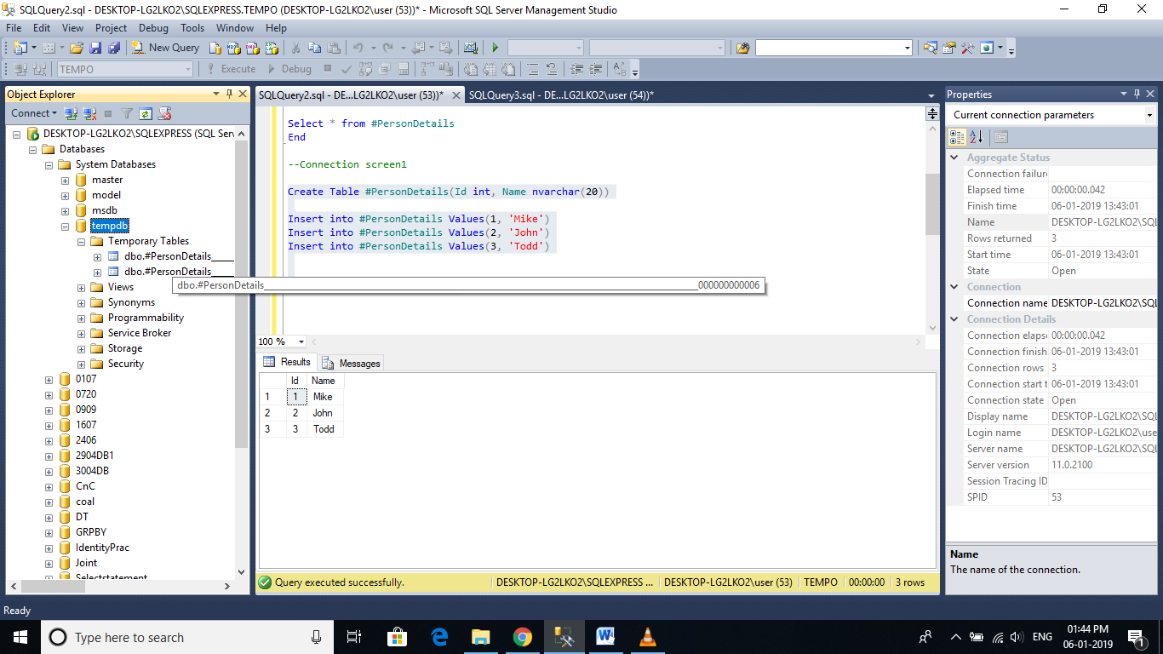

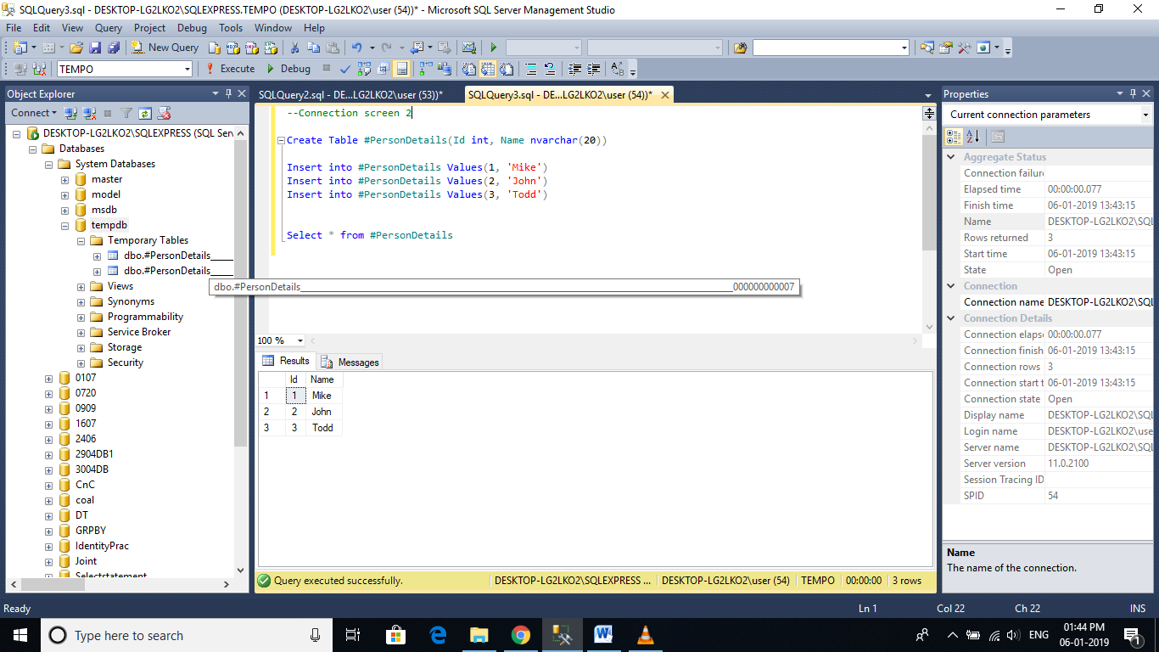

**How to Create a Global Temporary Table:**  
To create a Global Temporary Table, prefix the name of the table with 2 pound (##) symbols. EmployeeDetails Table is the global temporary table, as we have prefixed it with 2 ## symbols.  
Create Table ##EmployeeDetails(Id int, Name nvarchar(20))

🡪Global temporary tables are visible for all sessions and all users until the session which created it, is completed.

🡪When the creator session ends and there is no references to the global temporary table, then it automatically drops.

🡪If there are still references to the table, after creator session ends,

**🡪Multiple users, across multiple connections** can have local temporary tables with the same name, but, a global temporary table name has to be unique, and if you inspect the name of the global temp table, in the object explorer, there will be no random numbers suffixed at the end of the table name.

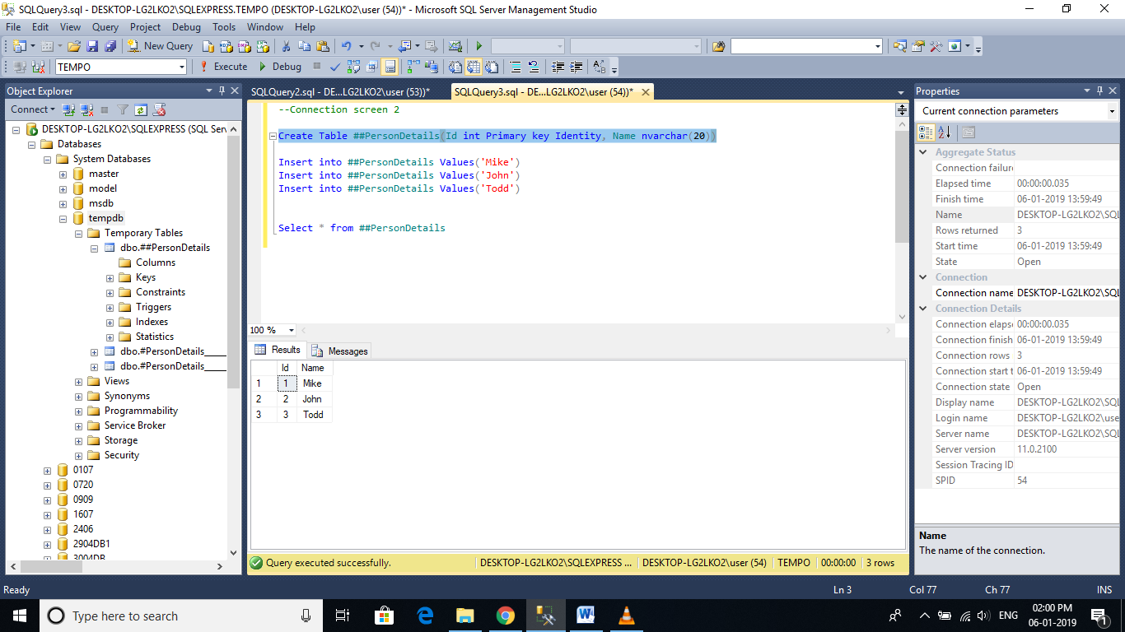

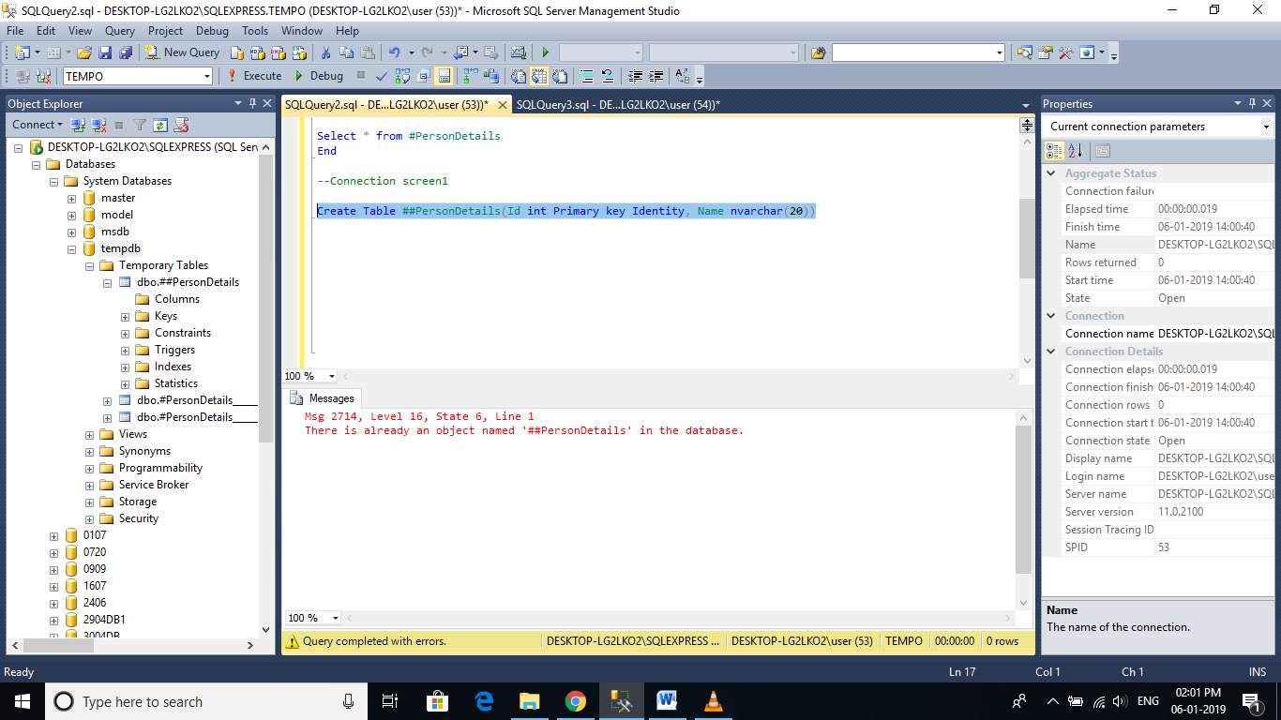

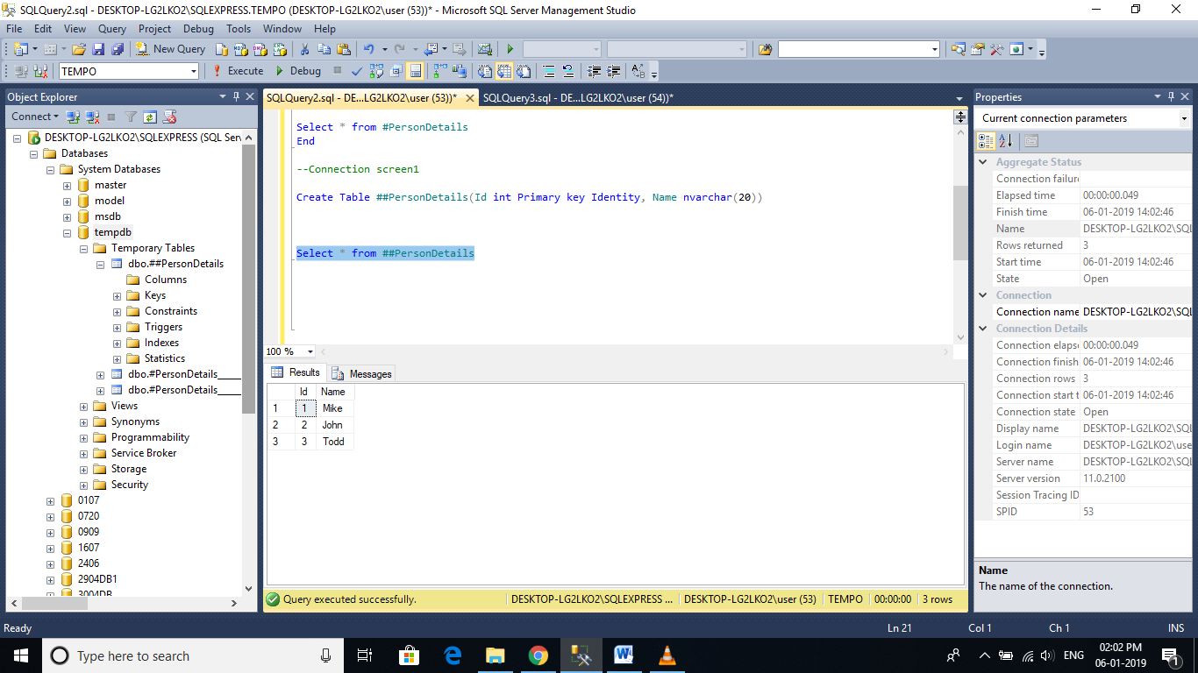

**Difference Between Local and Global Temporary Tables:**  
1. Local Temp tables are prefixed with single pound (#) symbol, where as global temp tables are prefixed with 2 pound (##) symbols.  
  
2. SQL Server appends some random numbers at the end of the local temp table name, where this is not done for global temp table names.  
  
3. Local temporary tables are only visible to that session of the SQL Server which has created it, where as Global temporary tables are visible to all the SQL server sessions  
  
4. Local temporary tables are automatically dropped, when the session that created the temporary tables is closed, where as Global temporary tables are destroyed when the last connection that is referencing the global temp table is closed.

# Why index

Indexes are used by queries to find data from tables quickly. Indexes are created on tables and views. Index on a table or a view, is very similar to an index that we find in a book.  
  
If you don't have an index in a book, and I ask you to locate a specific chapter in that book, you will have to look at every page starting from the first page of the book.  
  
On, the other hand, if you have the index, you lookup the page number of the chapter in the index, and then directly go to that page number to locate the chapter.  
  
Obviously, the book index is helping to drastically reduce the time it takes to find the chapter.  
  
In a similar way, Table and View indexes, can help the query to find data quickly.   
  
In fact, the existence of the right indexes, can drastically improve the performance of the query. If there is no index to help the query, then the query engine, checks every row in the table from the beginning to the end. This is called as Table Scan. Table scan is bad for performance.

**Index Example:**At the moment, the Employees table, does not have an index on SALARY column.  
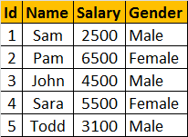  
  
  
**Consider, the following query**  
Select * from tblEmployee where Salary > 5000 and Salary < 7000  
  
To find all the employees, who has salary **greater than 5000 and less than 7000**, the query engine has to check each and every row in the table, resulting in a table scan, which can adversely affect the performance, especially if the table is large. Since there is no index, to help the query, the query engine performs an entire table scan.  
  
**Now Let's Create the Index to help the query:**Here, we are creating an index on Salary column in the employee table  
CREATE Index IX_tblEmployee_Salary   
ON tblEmployee (SALARY ASC)  
  
**The index stores salary of each employee, in the ascending order** as shown below. The actual index may look slightly different.  
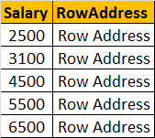

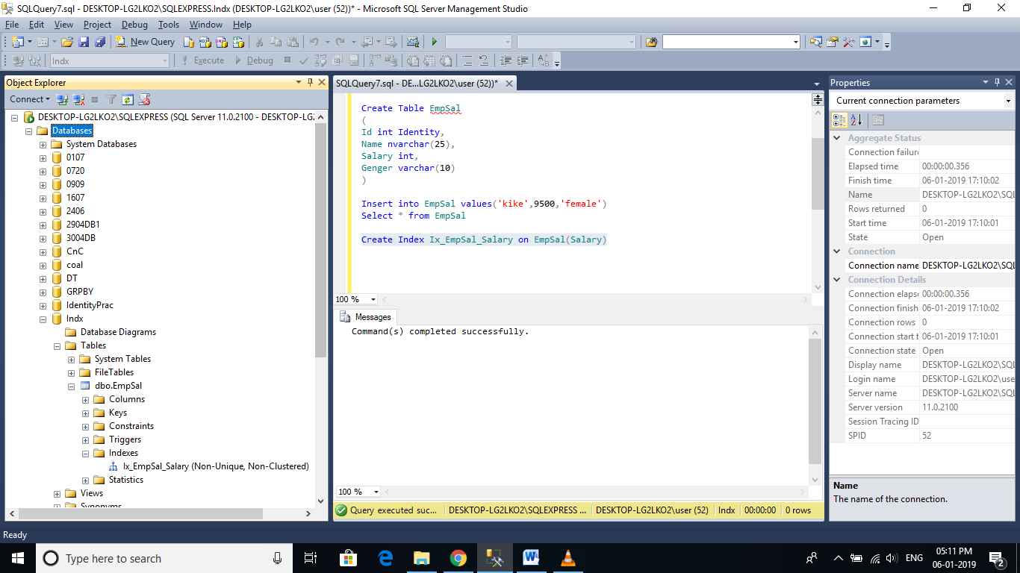

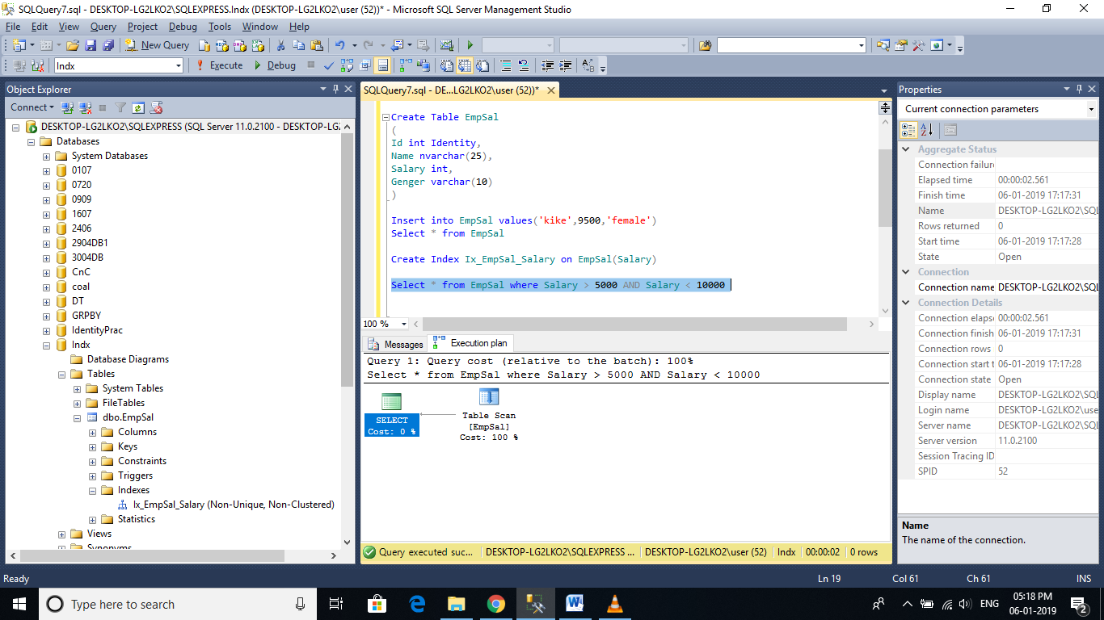

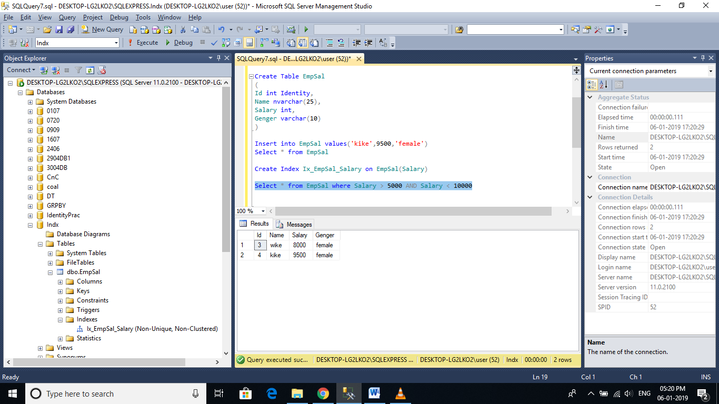

**To delete or drop the index:**When dropping an index, specify the table name as well  
Drop Index tblEmployee.IX_tblEmployee_Salary

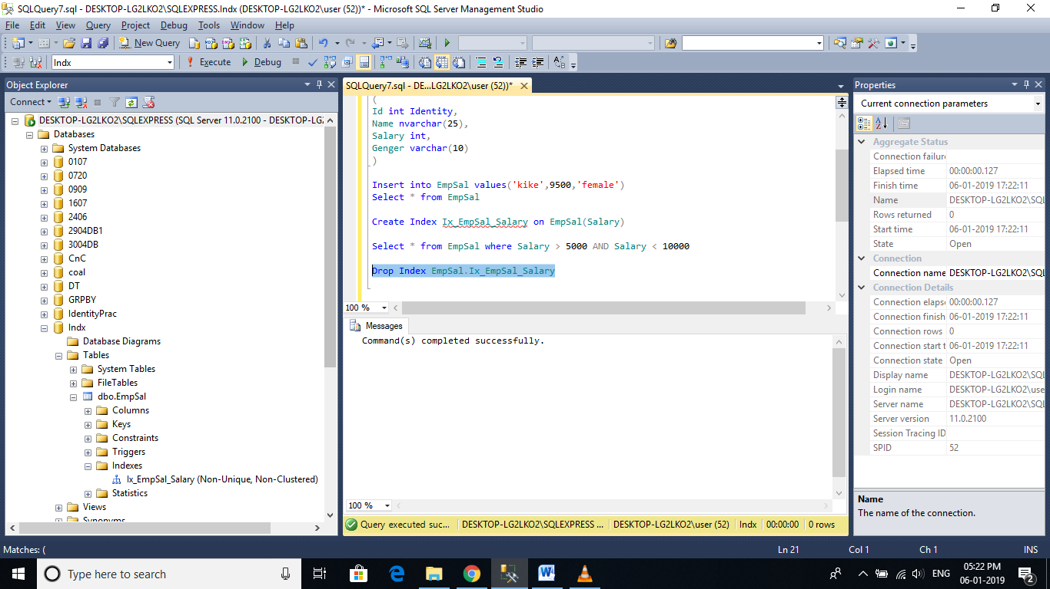

**An Index can also be created graphically using SQL Server Management Studio**  
1. In the Object Explorer, expand the Databases folder and then specific database you are working with.   
2. Expand the Tables folder  
3. Expand the Table on which you want to create the index  
4. Right click on the Indexes folder and select New Index  
5. In the New Index dialog box, type in a meaningful name  
6. Select the Index Type and specify Unique or Non Unique Index  
7. Click the Add  
8. Select the columns that you want to add as index key  
9 Click OK  
10. Save the table

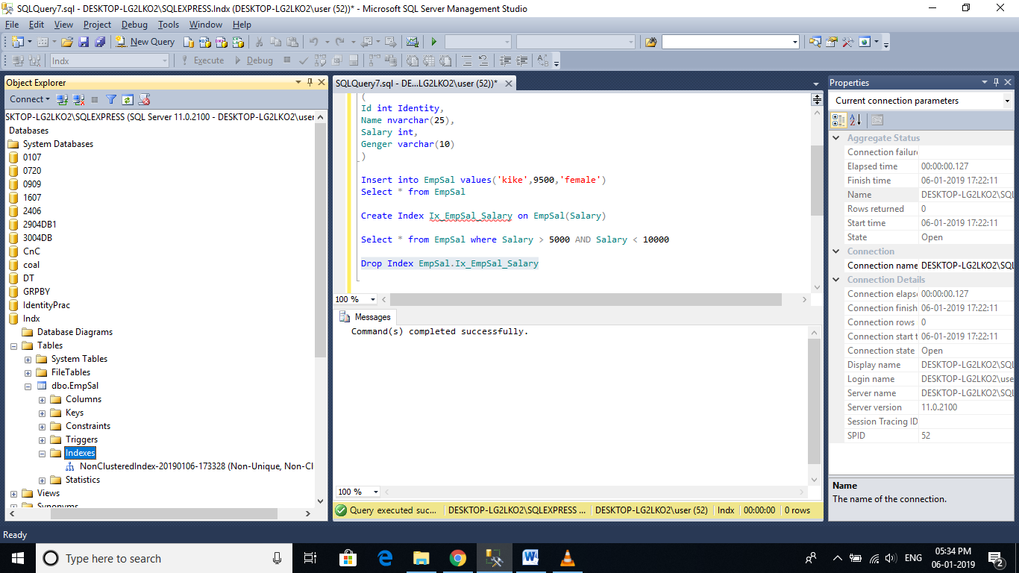

**To view the Indexes**: In the object explorer, expand Indexes folder. Alternatively use sp_helptext system stored procedure. The following command query returns all the indexes on tblEmployee table.  
**Execute sp_helpindex tblEmployee** 

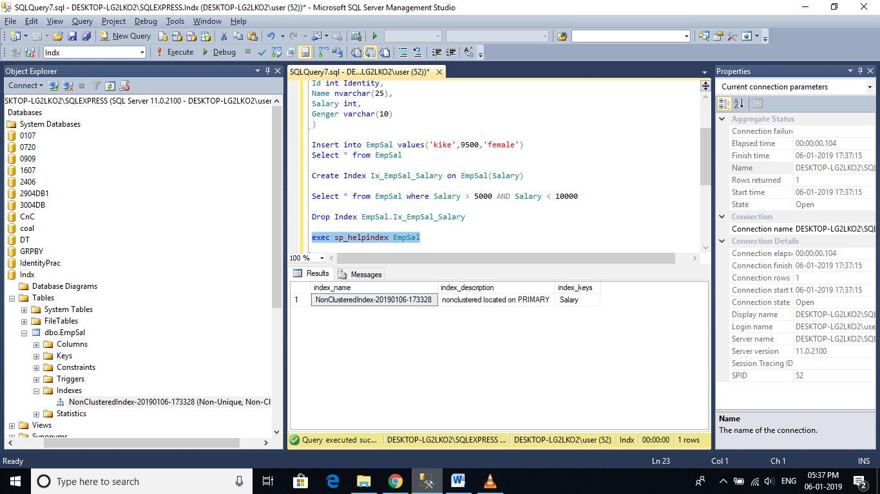

# Clustered and Non-Clustered indexes

**The following are the different types of indexes in SQL Server**  
1. Clustered  
2. Nonclustered  
3. Unique  
4. Filtered  
5. XML  
6. Full Text  
7. Spatial  
8. Columnstore  
9. Index with included columns  
10. Index on computed columns

**Clustered Index:**  
🡪A clustered index determines the physical order of data in a table.

🡪For this reason, a table can have only one clustered index.

**Create tblEmployees table using the script below.**  
CREATE TABLE [tblEmployee]  
(  
 [Id] int Primary Key,  
 [Name] nvarchar(50),  
 [Salary] int,  
 [Gender] nvarchar(10),  
 [City] nvarchar(50)  
)  
  
Note that **Id**column is marked as **primary key**. Primary key, constraint create **clustered indexes automatically** if no clustered index already exists on the table and a nonclustered index is not specified when you create the PRIMARY KEY constraint.   
  
**To confirm this**, execute sp_helpindex tblEmployee, which will show a unique clustered index created on the**Id** column.

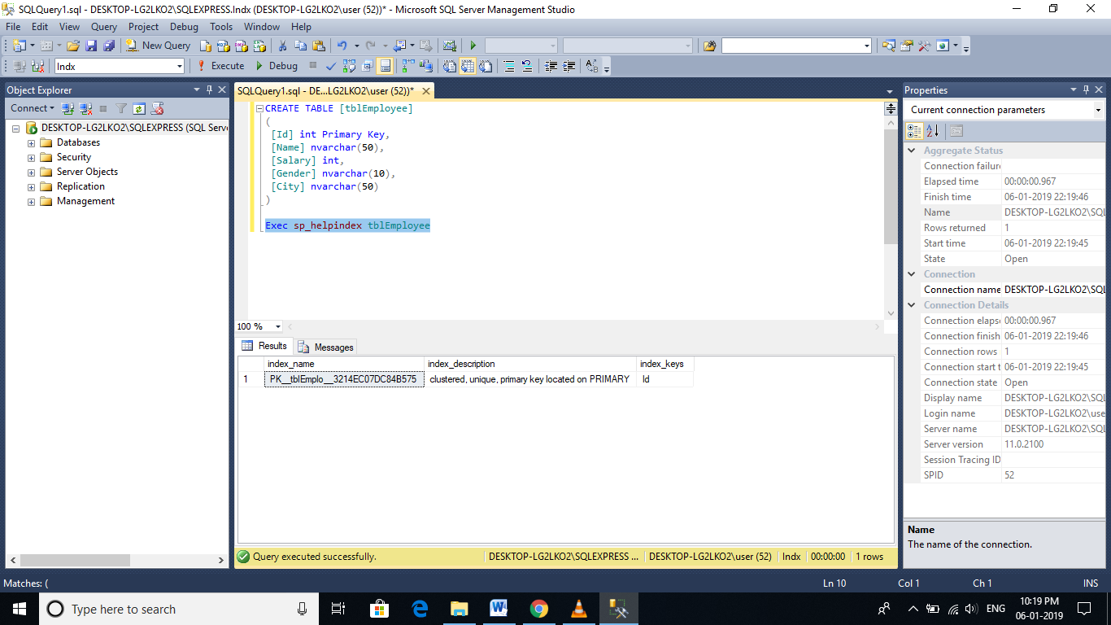

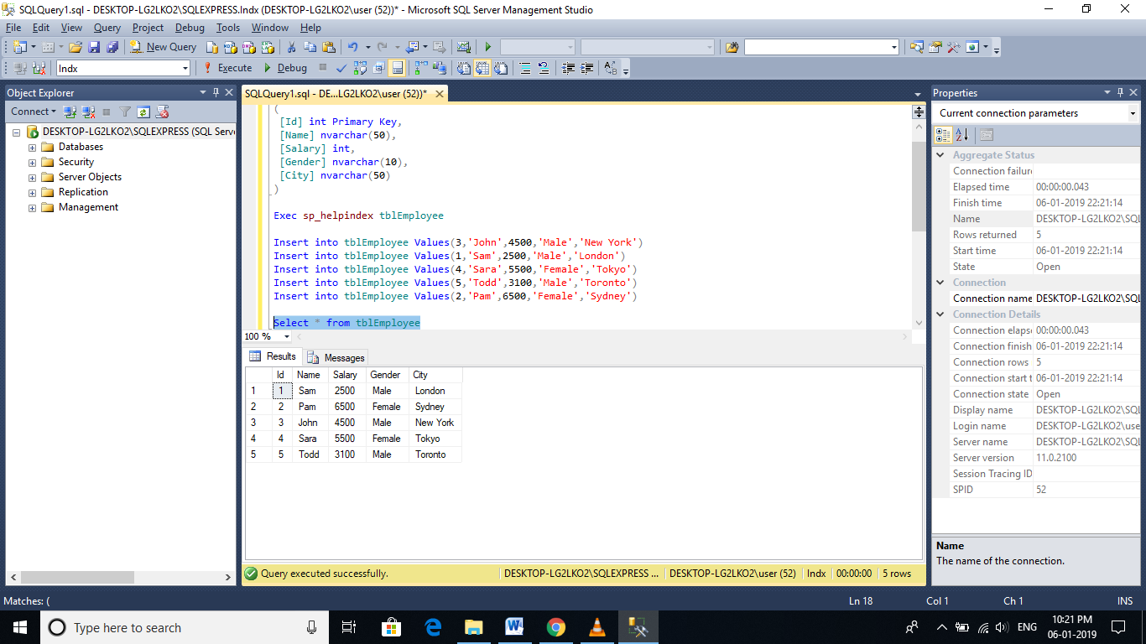

**Inspite, of inserting the rows in a random order**, when we execute the select query we can see that all the rows in the table are arranged in an ascending order based on the Id column. This is because a clustered index determines the physical order of data in a table, and we have got a clustered index on the Id column.  
  
**Because of the fact that, a clustered index dictates the physical storage order** of the data in a table, a table can contain only one clustered index. If you take the example of **tblEmployee** table, the data is already arranged by the Id column, and if we try to create another clustered index on the **Name column**, the data needs to be rearranged based on the **NAME column**, which will affect the ordering of rows that's already done based on the ID column.

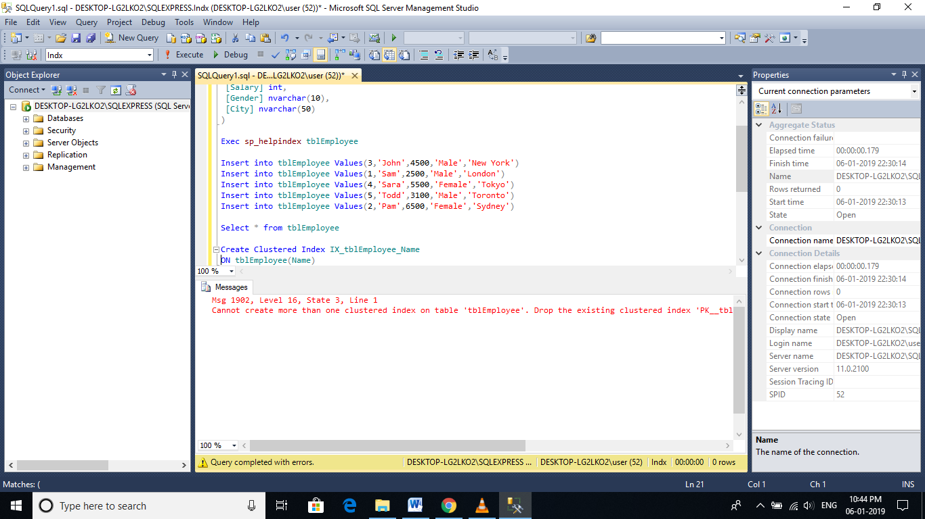

**Let's now create a clustered index on 2 columns**. To do this we first have to drop the existing clustered index on the Id column.   
Drop index tblEmployee.PK__tblEmplo__3214EC070A9D95DB  
  
**When you execute this query**, you get an error message stating 'An explicit DROP INDEX is not allowed on index 'tblEmployee.PK__tblEmplo__3214EC070A9D95DB'. It is being used for PRIMARY KEY constraint enforcement.' We will talk about the role of unique index in the next session. To successfully delete the clustered index, right click on the index in the Object Explorer window and select DELETE.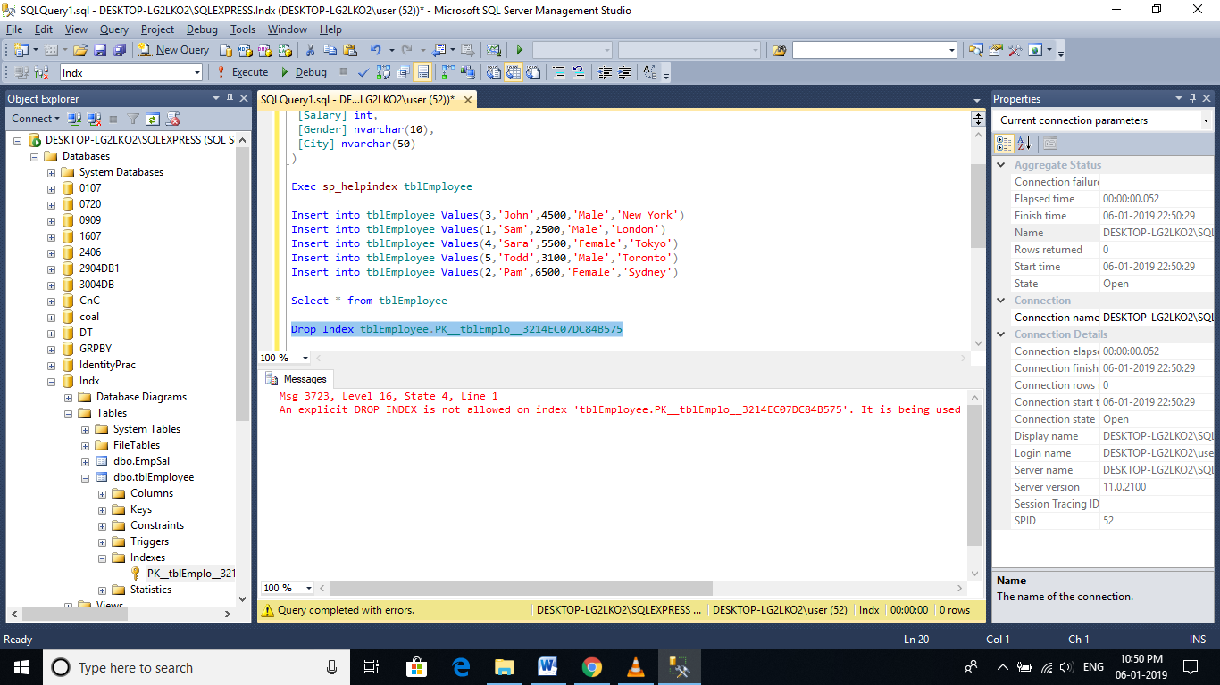

Deleted the index with object explorer.

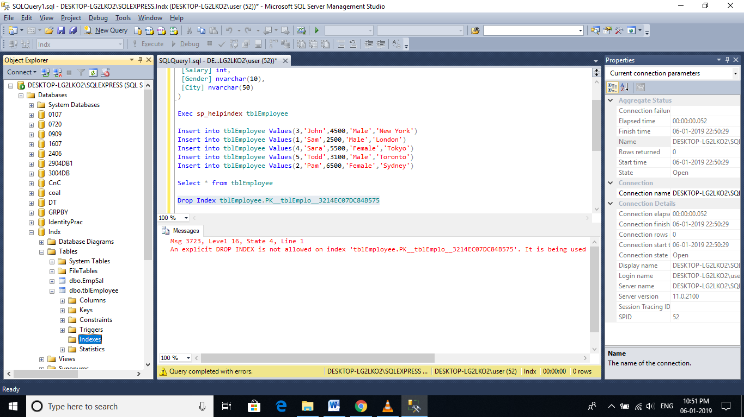

**Now, execute the following CREATE INDEX query**, to create a composite clustered Index on the Gender and Salary columns.  
Create Clustered Index IX_tblEmployee_Gender_Salary  
ON tblEmployee(Gender DESC, Salary ASC)

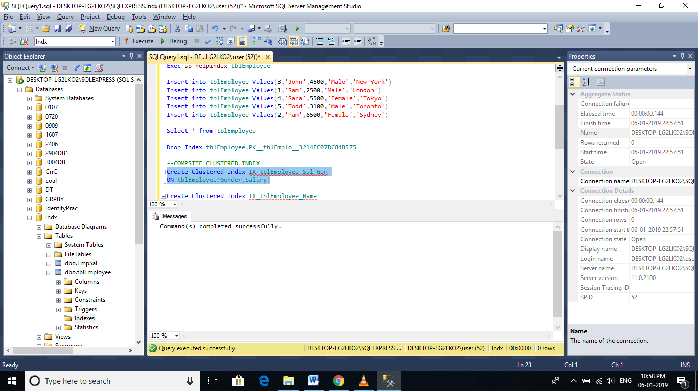

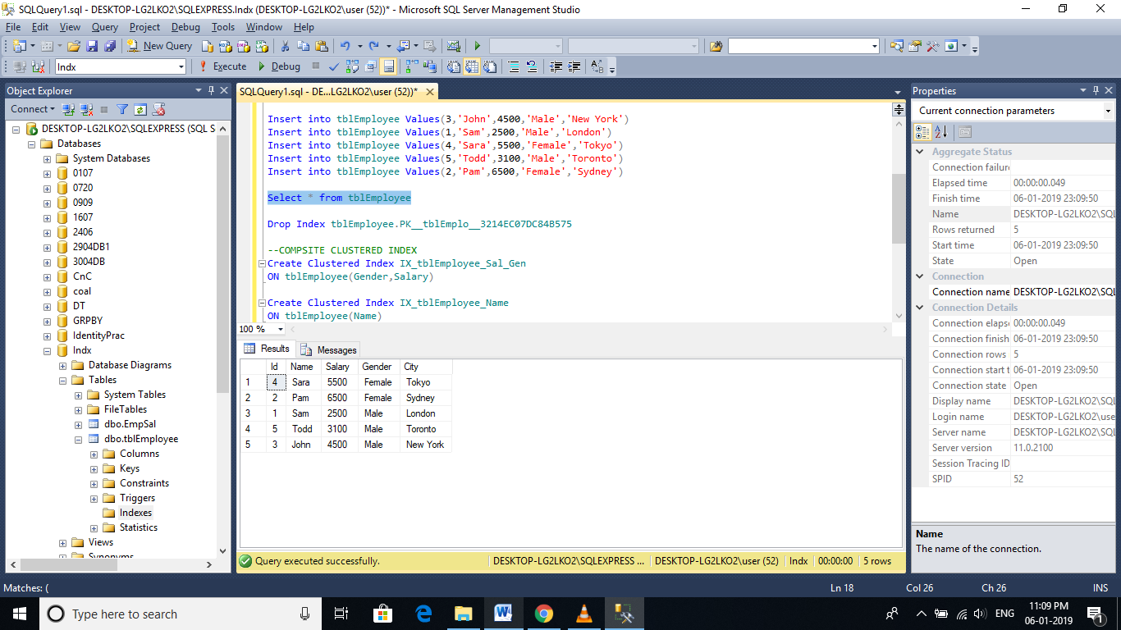

**Difference between Clustered and NonClustered Index:**  
1. **Only one clustered index per table**, where as you can have more than one non clustered index  
2. **Clustered index is faster than a non clustered index**, because, the non-clustered index has to refer back to the table, if the selected column is not present in the index.  
3. **Clustered index determines the storage order of rows in the table**, and hence doesn't require additional disk space, but where as a Non Clustered index is stored seperately from the table, additional storage space is required.

# Unique and Non-Unique Indexes

**Unique index** is used to enforce uniqueness (does not allow duplicate values) of key values in the index. Let's understand this with an example.  
  
**Create the Employee table using the script below**  
CREATE TABLE [tblEmployee]  
(  
 [Id] int Primary Key,  
 [FirstName] nvarchar(50),  
 [LastName] nvarchar(50),  
 [Salary] int,  
 [Gender] nvarchar(10),  
 [City] nvarchar(50)  
)  
  
**Since, we have marked Id column**, as the Primary key for this table, a UNIQUE CLUSTERED INDEX gets created on the Id column, with Id as the index key.   
  
**We can verify** this by executing the sp_helpindex system stored procedure as shown below.  
Execute sp_helpindex tblEmployee  
  
**Output:**  
 

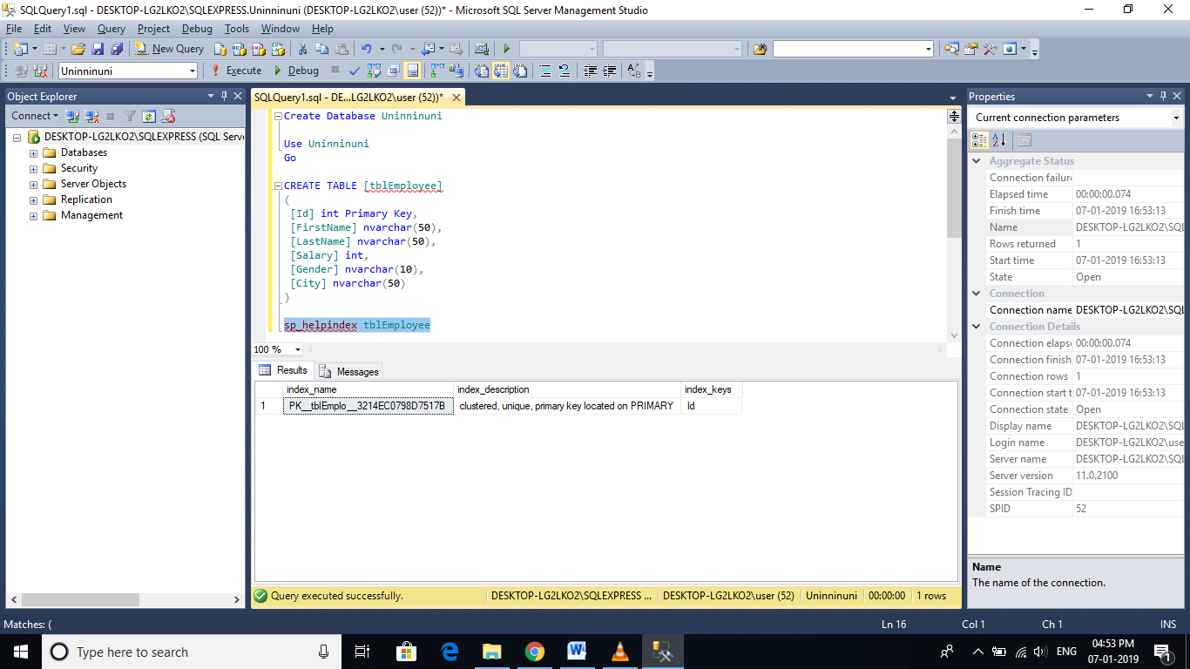  
  
**Since, we now have a UNIQUE CLUSTERED INDEX** **on the Id** **column**, any attempt to duplicate the key values, will throw an error stating 'Violation of PRIMARY KEY constraint 'PK__tblEmplo__3214EC07236943A5'. Cannot insert duplicate key in object dbo.tblEmployee'  
  
**Example**: The following insert queries will fail  
Insert into tblEmployee Values(1,'Mike', 'Sandoz',4500,'Male','New York')  
Insert into tblEmployee Values(1,'John', 'Menco',2500,'Male','London')

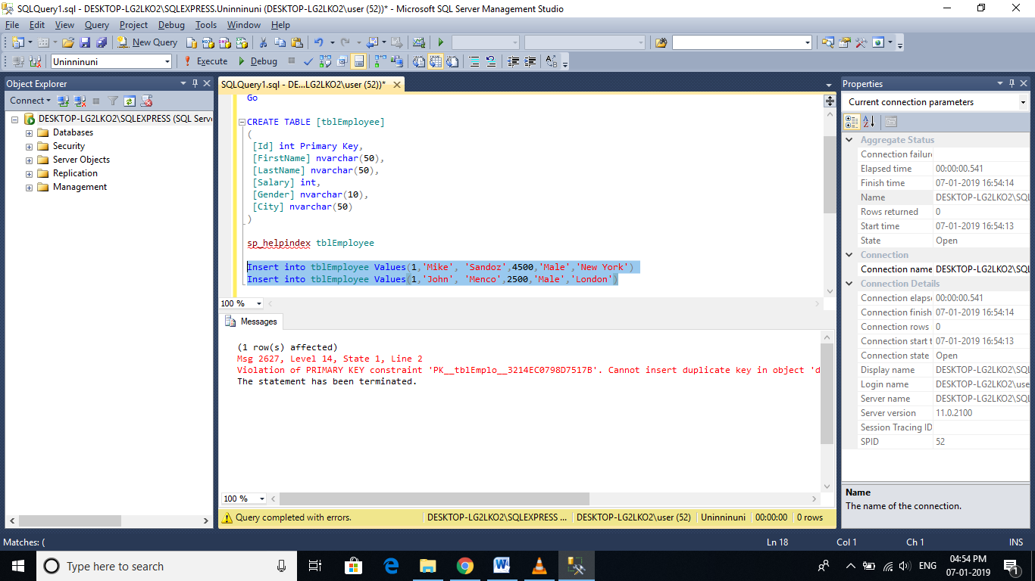

**Now let's try to drop the Unique Clustered index** on the Id column. This will raise an error stating - 'An explicit DROP INDEX is not allowed on index tblEmployee.PK__tblEmplo__3214EC07236943A5. It is being used for PRIMARY KEY constraint enforcement.'  
Drop index tblEmployee.PK__tblEmplo__3214EC07236943A5  
  
**So this error message proves that**, SQL server internally, uses the UNIQUE index to enforce the uniqueness of values and primary key.

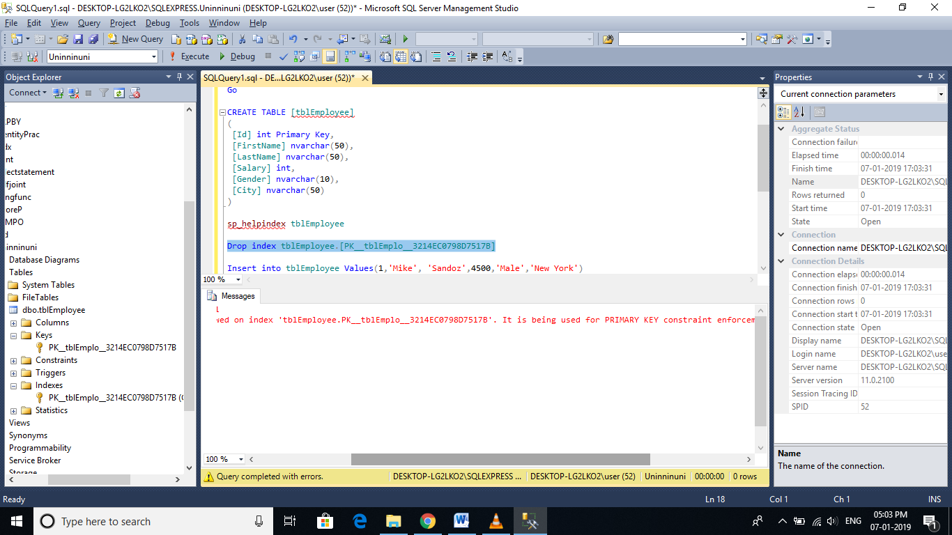

**Expand keys folder in the object explorer window**, and you can see a primary key constraint. Now, expand the indexes folder and you should see a unique clustered index. In the object explorer it just shows the '**CLUSTERED**' word. To, confirm, this is infact an UNIQUE index, right click and select properties. The properties window, shows the UNIQUE checkbox being selected.  
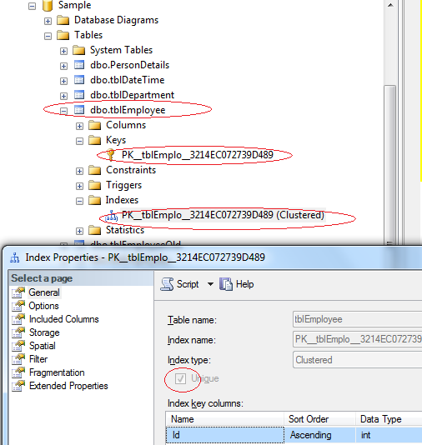  
  
  
**SQL Server allows us to delete this UNIQUE CLUSTERED INDEX** from the object explorer. so, Right click on the index, and select DELETE and finally, click OK. Along with the UNIQUE index, the primary key constraint is also deleted.  
  
**Now, let's try to insert duplicate values** for the ID column. The rows should be accepted, without any primary key violation error.  
Insert into tblEmployee Values(1,'Mike', 'Sandoz',4500,'Male','New York')  
Insert into tblEmployee Values(1,'John', 'Menco',2500,'Male','London')

Deleted the Unique clustered constraint and Primary key gets deleted as well

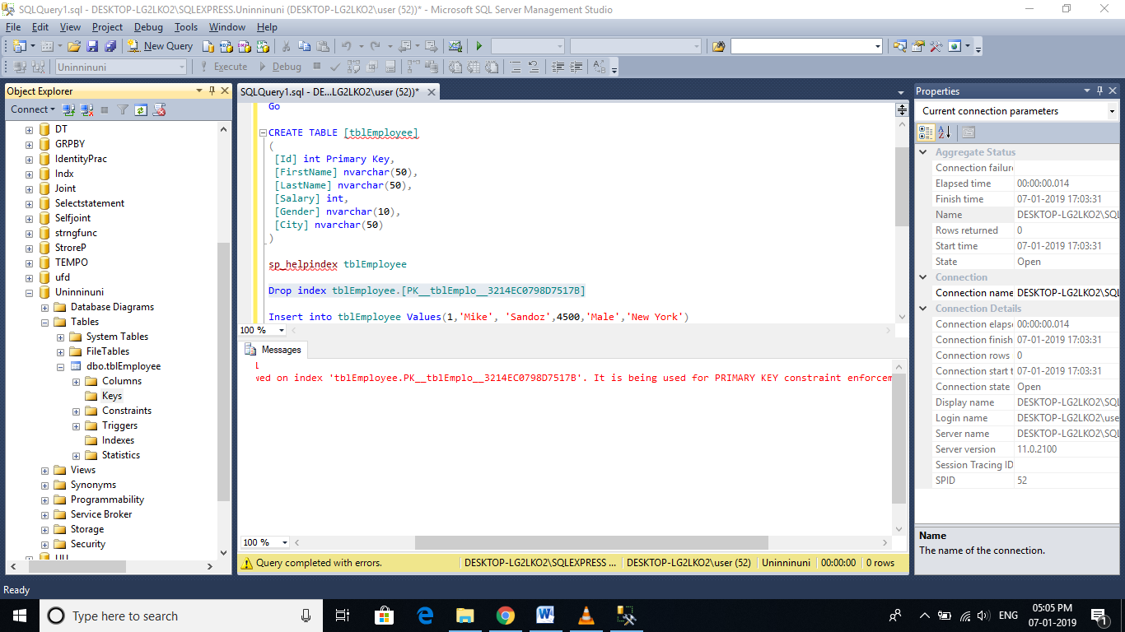

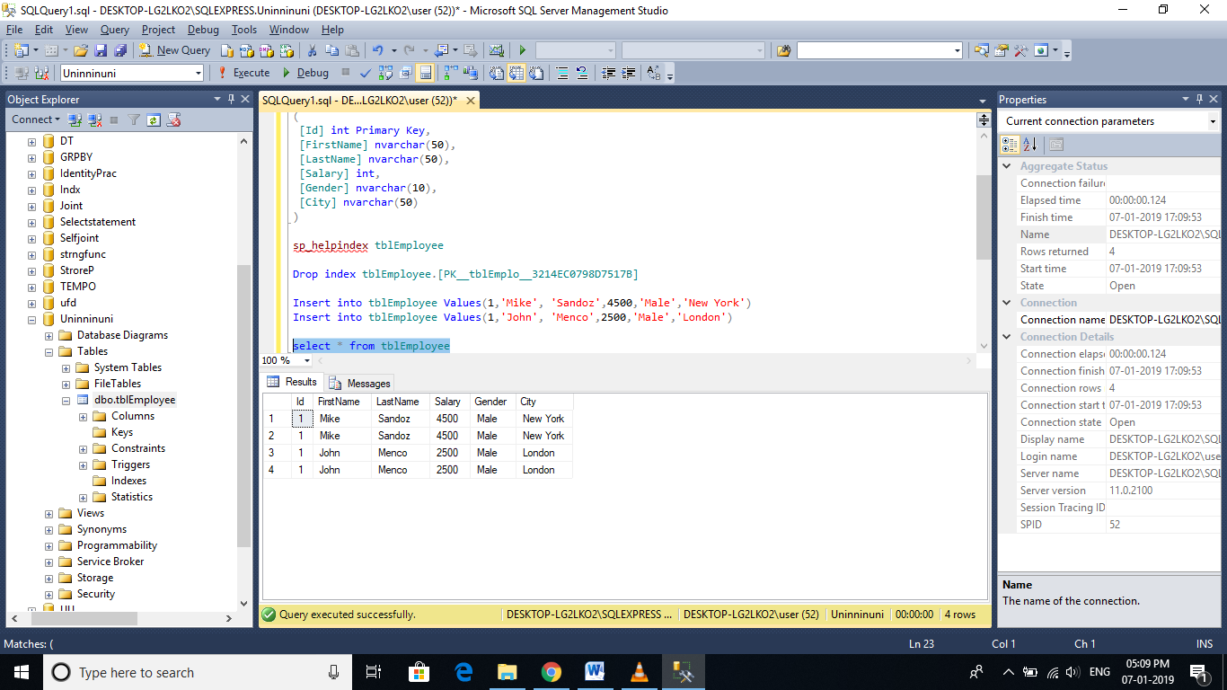

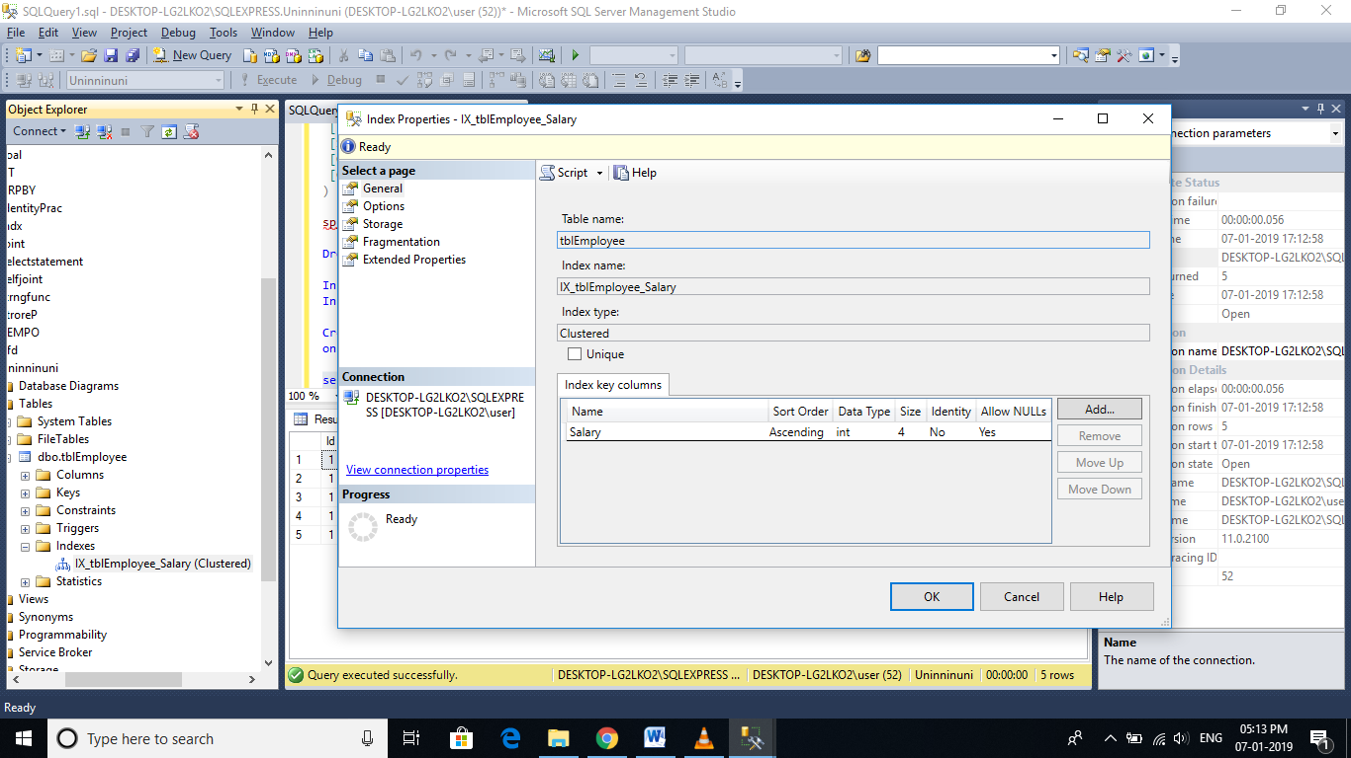

Above screenshot displays Non unique clustered index allowing duplicate records.

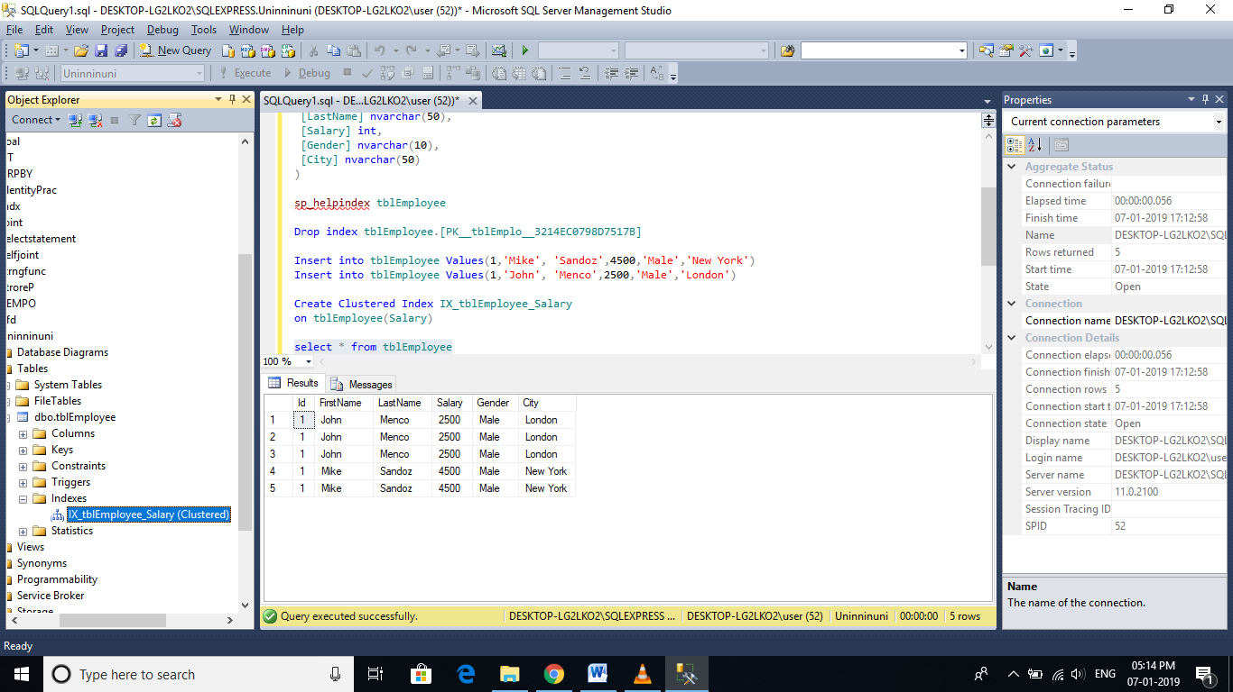  
So, the UNIQUE index is used to enforce the uniqueness of values and primary key constraint.  
**UNIQUENESS is a property of an Index**, and both CLUSTERED and NON-CLUSTERED indexes can be UNIQUE.

**Creating a UNIQUE NON CLUSTERED index** on the FirstName and LastName columns.  
Create Unique NonClustered Index UIX_tblEmployee_FirstName_LastName  
On tblEmployee(FirstName, LastName)  
  
**This unique non clustered index**, ensures that no 2 entires in the index has the same first and last names. [In Part 9, of this video series](http://csharp-video-tutorials.blogspot.com/2012/08/unique-key-constraint-part-9.html), we have learnt that, a Unique Constraint, can be used to enforce the uniqueness of values, across one or more columns. There are no major differences between a unique constraint and a unique index.

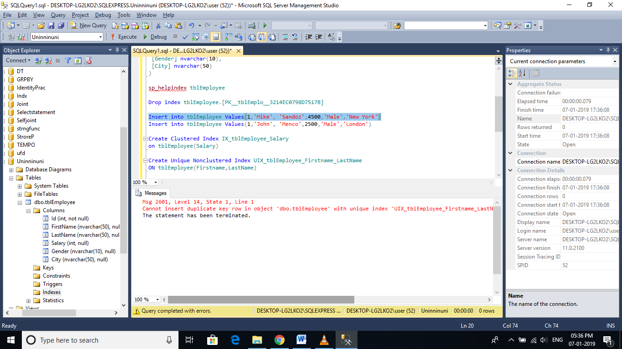

**In fact, when you add a unique constraint**, a unique non clustered index gets created behind the scenes. To prove this, let's add a unique constraint on the city column of the tblEmployee table.  
ALTER TABLE tblEmployee   
ADD CONSTRAINT UQ_tblEmployee_City   
UNIQUE NONCLUSTERED (City)  
  
**At this point, we expect a unique constraint to be created**. Refresh and Expand the constraints folder in the object explorer window. The constraint is not present in this folder. Now, refresh and expand the 'indexes' folder. In the indexes folder, you will see a UNIQUE NONCLUSTERED index with name UQ_tblEmployee_City.  
  
Also, executing EXECUTE SP_HELPCONSTRAINT tblEmployee, lists the constraint as a UNIQUE NONCLUSTERED index.  


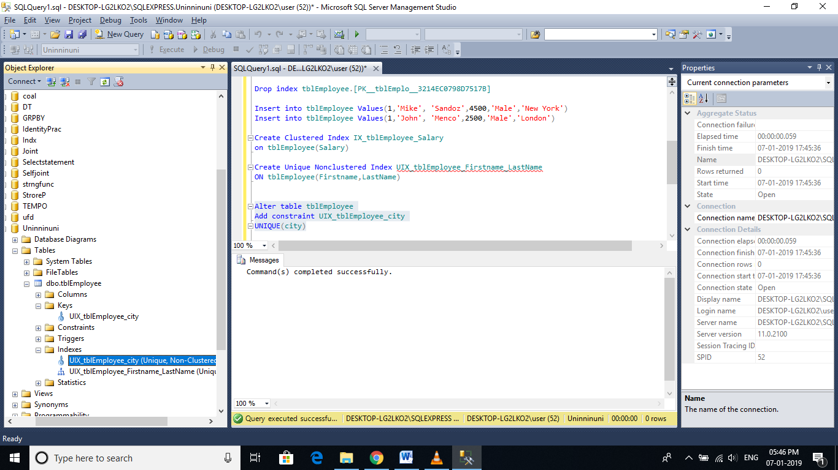

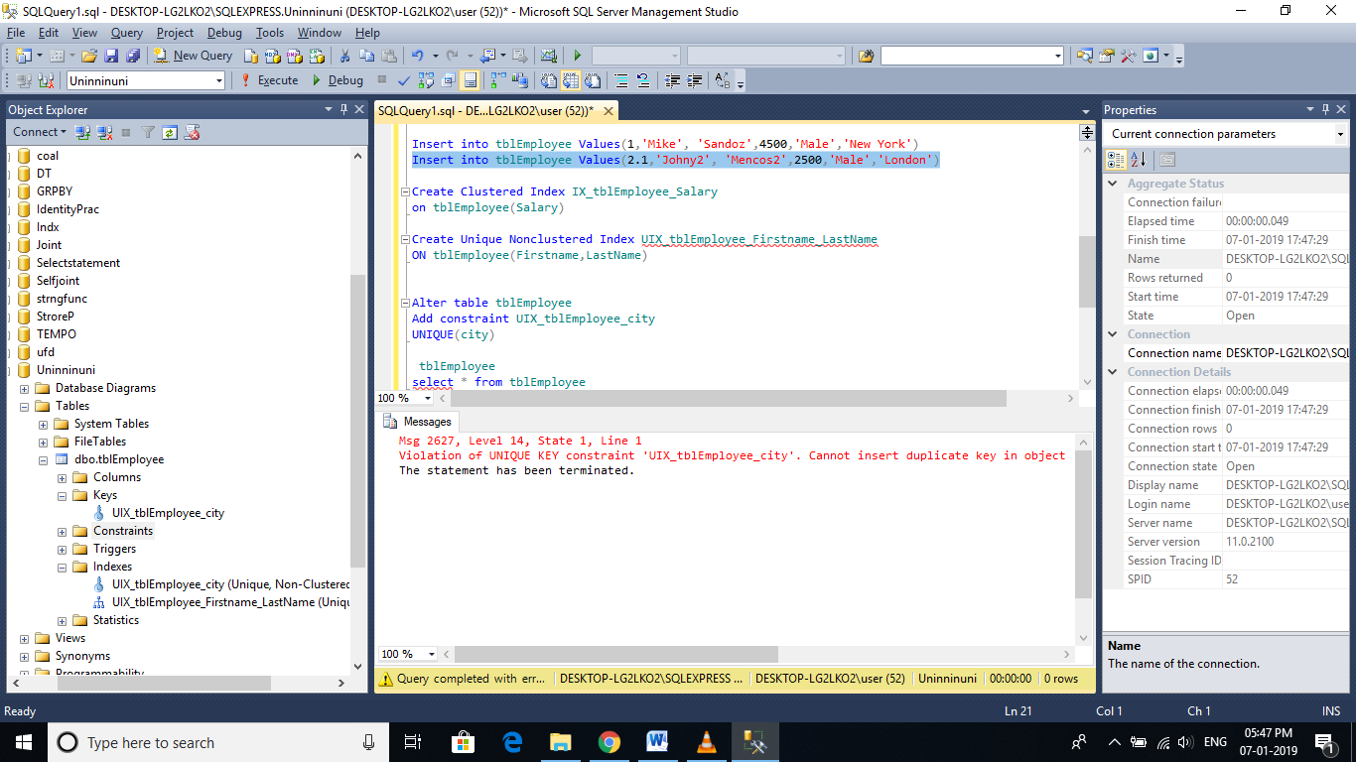

**So creating a UNIQUE constraint**, actually creates a UNIQUE non clustered index.

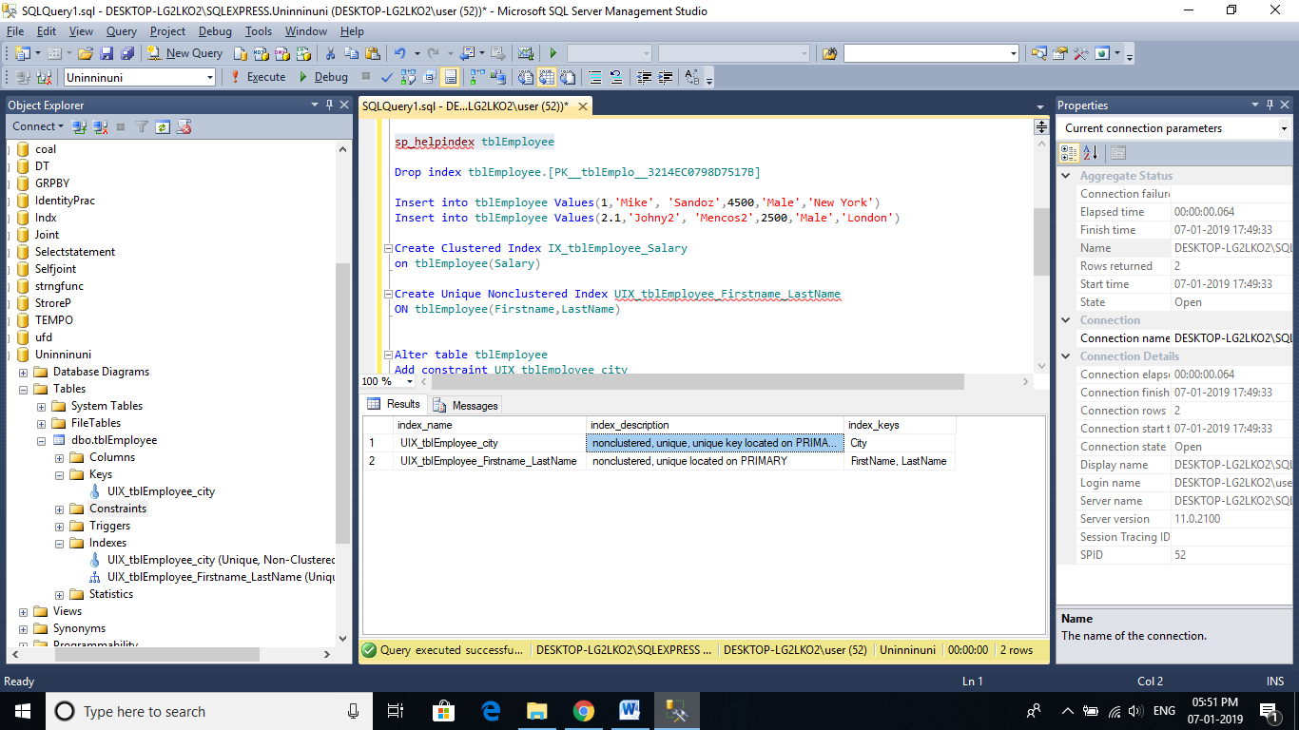

**Note:**  
**1. By default, a PRIMARY KEY constraint**, creates a unique clustered index, where as a UNIQUE constraint creates a unique nonclustered index. These defaults can be changed if you wish to.  
  
**2. A UNIQUE constraint or a UNIQUE index** cannot be created on an existing table, if the table contains duplicate values in the key columns. Obviously, to solve this,remove the key columns from the index definition or delete or update the duplicate values.  
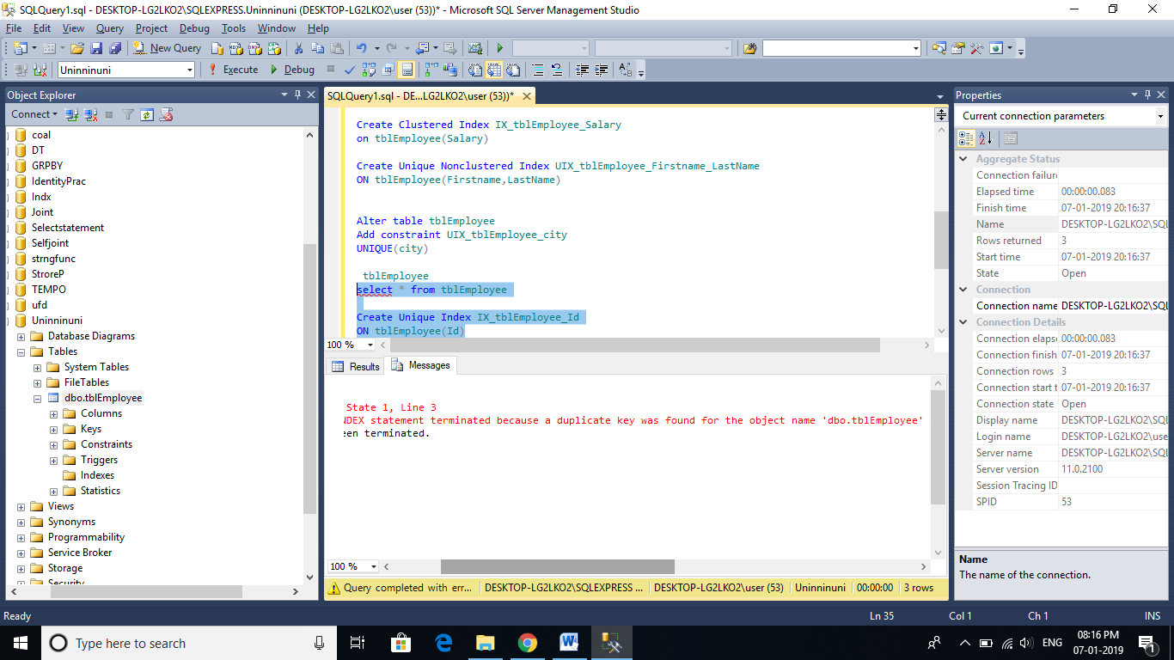

1. **By default, duplicate values are not allowed on key columns**, when you have a unique index or constraint. For, example, if I try to insert 10 rows, out of which 5 rows contain duplicates, then all the 10 rows are rejected. However, if I want only the 5 duplicate rows to be rejected and accept the non-duplicate 5 rows, then I can use IGNORE_DUP_KEY option. An example of using IGNORE_DUP_KEY option is shown below.  
   CREATE UNIQUE INDEX IX_tblEmployee_City  
   ON tblEmployee(City)  
   WITH IGNORE_DUP_KEY

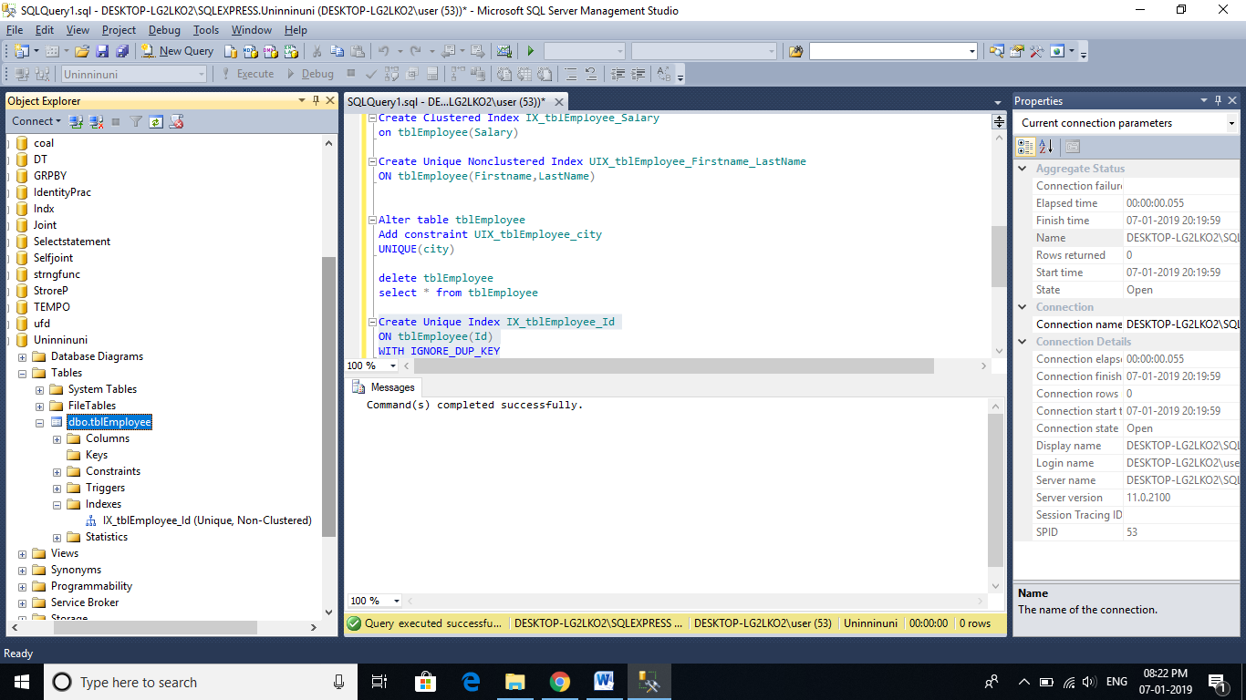

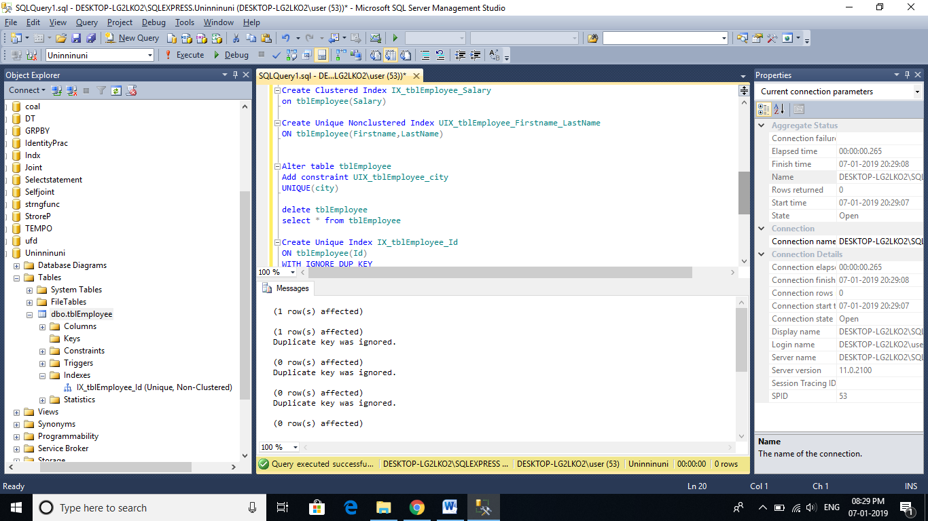

# Advantage and disadvantage of index

Indexes are used by queries to find data quickly. In this part, we will learn about the different queries that can benefit from indexes.  
  
**Create Employees table**  
CREATE TABLE [tblEmployee]  
(  
 [Id] int Primary Key,  
 [FirstName] nvarchar(50),  
 [LastName] nvarchar(50),  
 [Salary] int,  
 [Gender] nvarchar(10),  
 [City] nvarchar(50)  
)  
  
**Insert sample data:**  
Insert into tblEmployee Values(1,'Mike', 'Sandoz',4500,'Male','New York')  
Insert into tblEmployee Values(2,'Sara', 'Menco',6500,'Female','London')  
Insert into tblEmployee Values(3,'John', 'Barber',2500,'Male','Sydney')  
Insert into tblEmployee Values(4,'Pam', 'Grove',3500,'Female','Toronto')  
Insert into tblEmployee Values(5,'James', 'Mirch',7500,'Male','London')  
  
**Create a Non-Clustered Index on Salary Column**  
Create NonClustered Index IX_tblEmployee_Salary  
On tblEmployee (Salary Asc)  
  
**Data from tblEmployee table**  
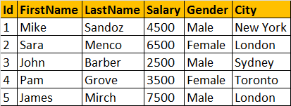  
  
**NonClustered Index**  
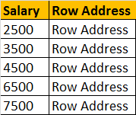  
  
  
**The following select query benefits from the index on the Salary column**, because the salaries are sorted in ascending order in the index. From the index, it's easy to identify the records where salary is between 4000 and 8000, and using the row address the corresponding records from the table can be fetched quickly.  
Select * from tblEmployee where Salary > 4000 and Salary < 8000  
  
**Not only, the SELECT statement, even the following DELETE and UPDATE**statements can also benefit from the index. To update or delete a row, SQL server needs to first find that row, and the index can help in searching and finding that specific row quickly.  
Delete from tblEmployee where Salary = 2500  
Update tblEmployee Set Salary = 9000 where Salary = 7500  
  
**Indexes can also help queries**, that ask for sorted results. Since the Salaries are already sorted, the database engine, simply scans the index from the first entry to the last entry and retrieve the rows in sorted order. This avoids, sorting of rows during query execution, which can significantly imrpove the processing time.  
Select * from tblEmployee order by Salary  
  
**The index on the Salary column**, can also help the query below, by scanning the index in reverse order.  
Select * from tblEmployee order by Salary Desc  
  
**GROUP BY queries can also benefit from indexes**. To group the Employees with the same salary, the query engine, can use the index on Salary column, to retrieve the already sorted salaries. Since matching salaries are present in consecutive index entries, it is to count the total number of Employees  at each Salary quickly.   
Select Salary, COUNT(Salary) as Total  
from tblEmployee  
Group By Salary  
  
**Diadvantages of Indexes:**  
**Additional Disk Space**: Clustered Index does not, require any additional storage. Every Non-Clustered index requires additional space as it is stored separately from the table.The amount of space required will depend on the size of the table, and the number and types of columns used in the index.  
  
**Insert Update and Delete statements can become slow**: When **DML** (Data Manipulation Language) statements (**INSERT, UPDATE, DELETE**) modifies data in a table, the data in all the indexes also needs to be updated. Indexes can help, to search and locate the rows, that we want to delete, but too many indexes to update can actually hurt the performance of data modifications.  
  
**What is a covering query?**  
**If all the columns** that you have requested in the SELECT clause of query, are present in the index, then there is no need to lookup in the table again. The requested columns data can simply be returned from the index.  
  
**A clustered index**, always covers a query, since it contains all of the data in a table. A composite index is an index on two or more columns. Both clustered and nonclustered indexes can be composite indexes. To a certain extent, a composite index, can cover a query.

# Views in sql server

🡪A view is nothing more than a**saved SQL query**. A view can also be considered as a **virtual table**.

**Let's understand views with an example**. We will base all our examples on **tblEmployee** and **tblDepartment** tables.    
  
  
**SQL Script to create tblEmployee table:**  
CREATE TABLE tblEmployee  
(  
  Id int Primary Key,  
  Name nvarchar(30),  
  Salary int,  
  Gender nvarchar(10),  
  DepartmentId int  
)  
  
**SQL Script to create tblDepartment table:**  
CREATE TABLE tblDepartment  
(  
 DeptId int Primary Key,  
 DeptName nvarchar(20)  
)  
  
**Insert data into tblDepartment table**  
Insert into tblDepartment values (1,'IT')  
Insert into tblDepartment values (2,'Payroll')  
Insert into tblDepartment values (3,'HR')  
Insert into tblDepartment values (4,'Admin')  
  
**Insert data into tblEmployee table**  
Insert into tblEmployee values (1,'John', 5000, 'Male', 3)  
Insert into tblEmployee values (2,'Mike', 3400, 'Male', 2)  
Insert into tblEmployee values (3,'Pam', 6000, 'Female', 1)  
Insert into tblEmployee values (4,'Todd', 4800, 'Male', 4)  
Insert into tblEmployee values (5,'Sara', 3200, 'Female', 1)  
Insert into tblEmployee values (6,'Ben', 4800, 'Male', 3)  
  
**At this point Employees and Departments table should look like this.**  
Employees Table:   
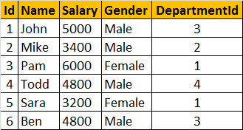  
  
Departments Table:   
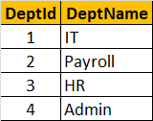  
  
**Now, let's write a Query which returns the output as shown below:**  
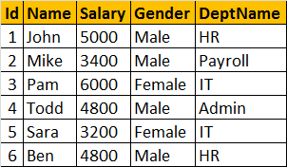  
  
  
**To get the expected output**, we need to join **tblEmployees** table with **tblDepartments**table. [If you are new to joins, please click here to view the video on Joins in SQL Server.](http://csharp-video-tutorials.blogspot.com/2012/08/joins-in-sql-server-part-12.html)   
Select Id, Name, Salary, Gender, DeptName  
from tblEmployee  
join tblDepartment  
on tblEmployee.DepartmentId = tblDepartment.DeptId

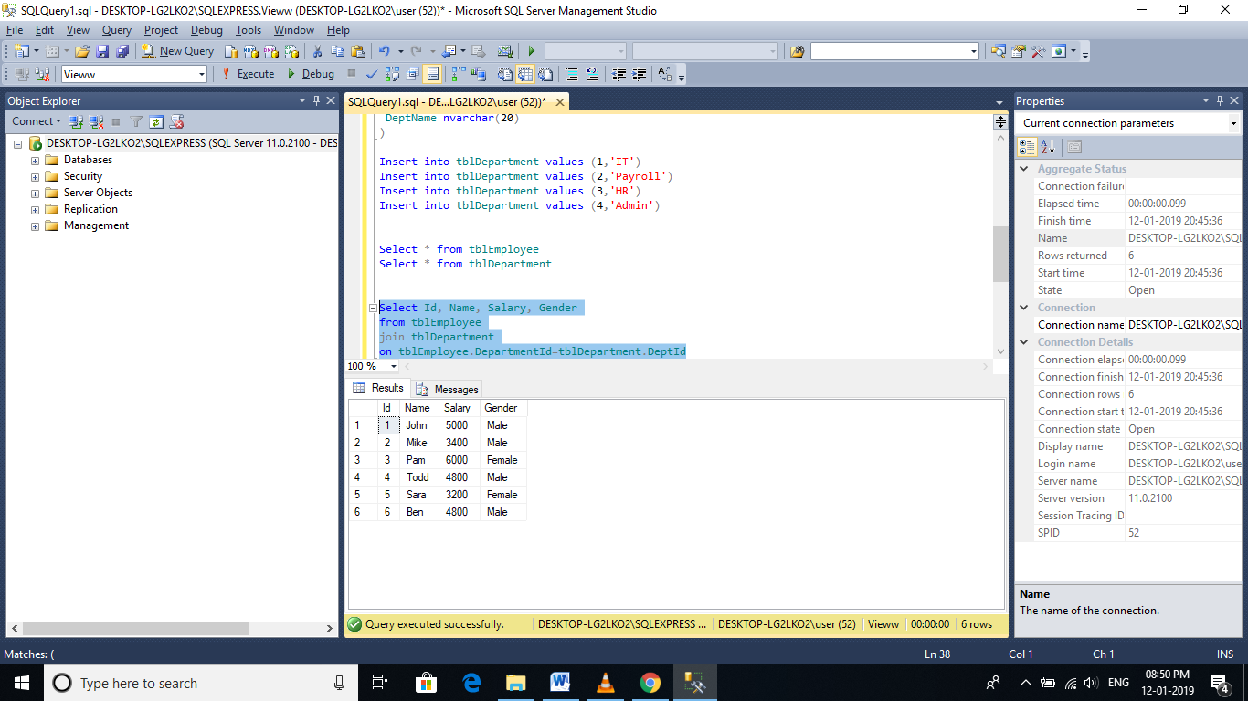

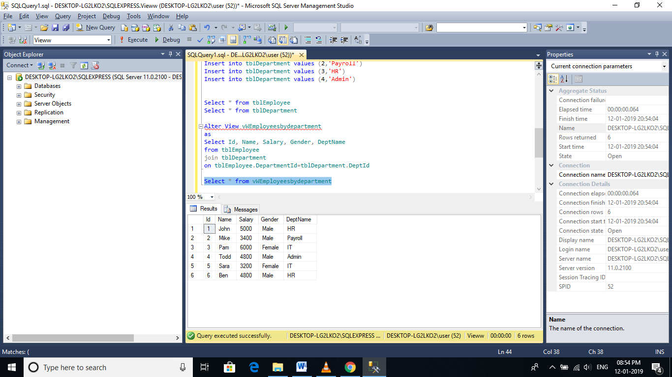

**To select data from the view**, SELECT statement can be used the way, we use it with a table.  
SELECT * from vWEmployeesByDepartment

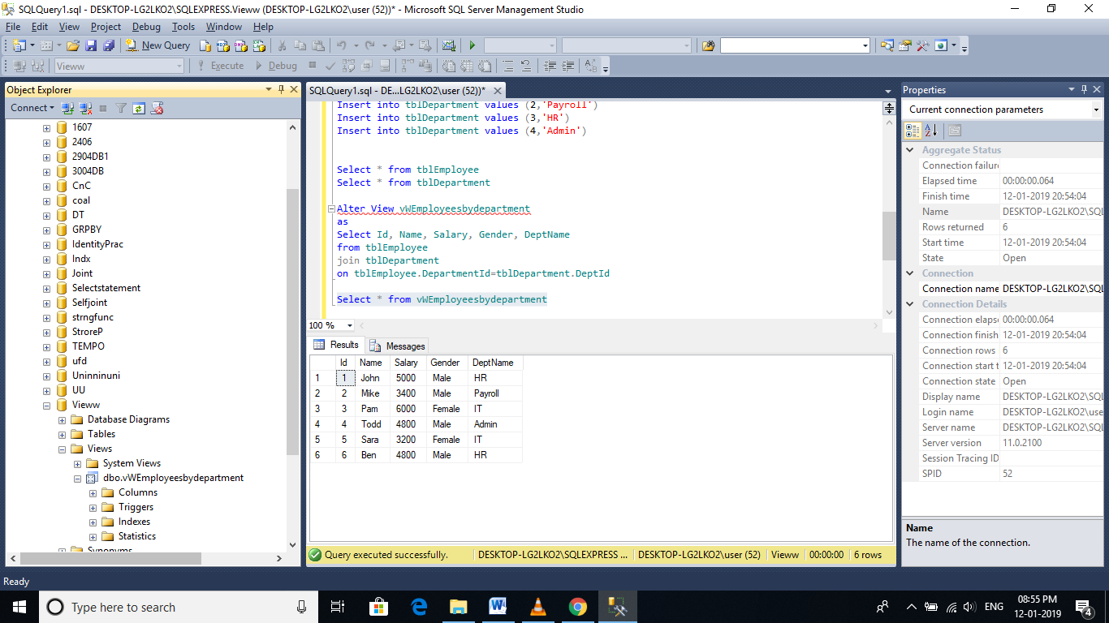

**When this query is executed**, the database engine actually retrieves the data from the underlying base tables, **tblEmployees and tblDepartments**. The View itself, doesnot store any data by default. However, we can change this default behaviour, which we will talk about in a later session. So, this is the reason, a view is considered, as just, a stored query or a virtual table

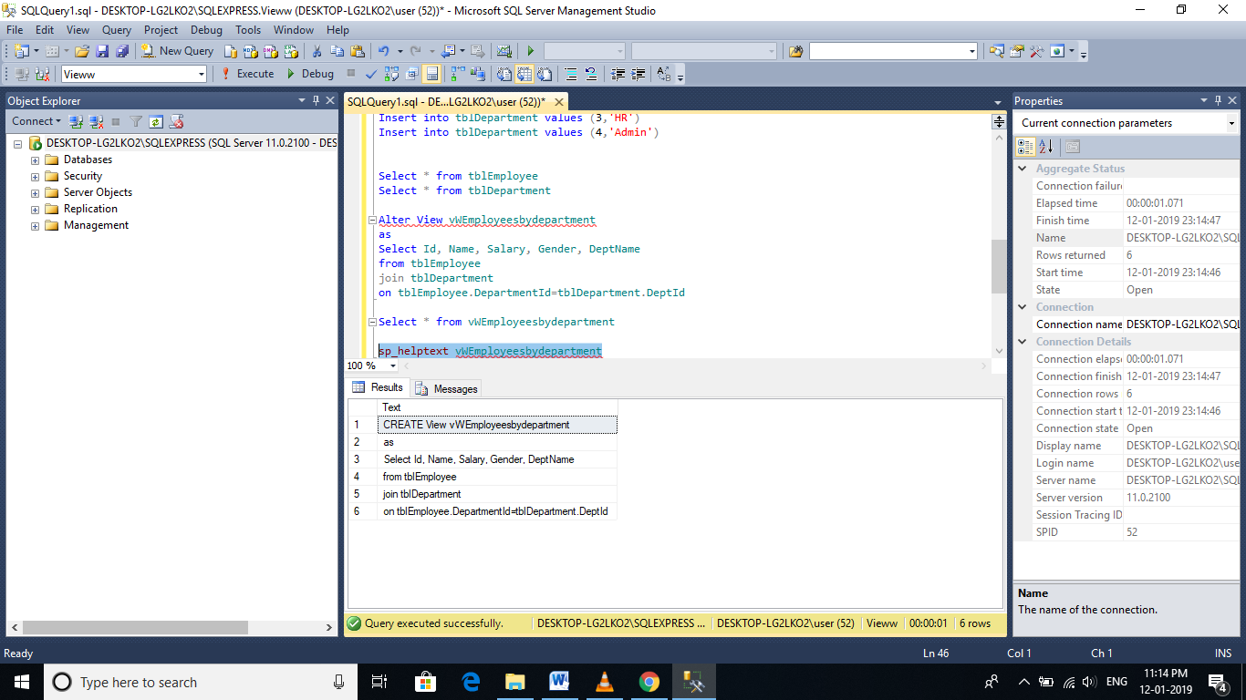

**Advantages of using views:**  
1. Views can be used to reduce the **complexity of the database schema**, for non IT users. The sample view, **vWEmployeesByDepartment**, hides the complexity of joins. Non-IT users, finds it easy to query the view, rather than writing complex joins.  
  
2. Views can be used as a mechanism to implement **row and column level security**.  
**Row Level Security:**  
For example, I want an end user, to have access only to IT Department employees. If I grant him access to the underlying tblEmployees and tblDepartments tables, he will be able to see, every department employees. To achieve this, I can create a view, which returns only IT Department employees, and grant the user access to the view and not to the underlying table.

Create View vWITDepartment_Employees  
as  
Select Id, Name, Salary, Gender, DeptName  
from tblEmployee  
join tblDepartment  
on tblEmployee.DepartmentId = tblDepartment.DeptId  
where tblDepartment.DeptName = 'IT'

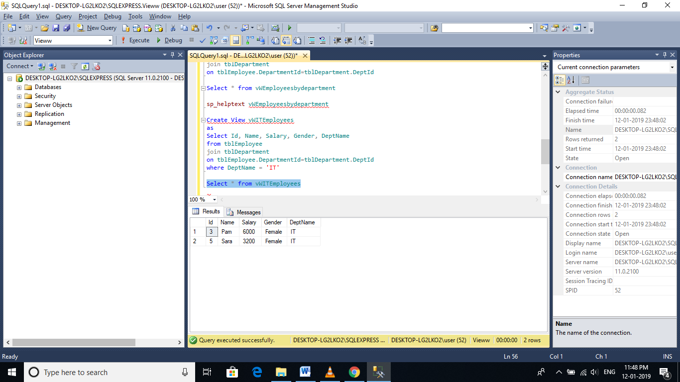

**Column Level Security:**  
Salary is confidential information and I want to prevent access to that column. To achieve this, we can create a view, which excludes the Salary column, and then grant the end user access to this views, rather than the base tables.

**View that returns all columns except Salary column:**  
Create View vWEmployeesNonConfidentialData  
as  
Select Id, Name, Gender, DeptName  
from tblEmployee  
join tblDepartment  
on tblEmployee.DepartmentId = tblDepartment.DeptId

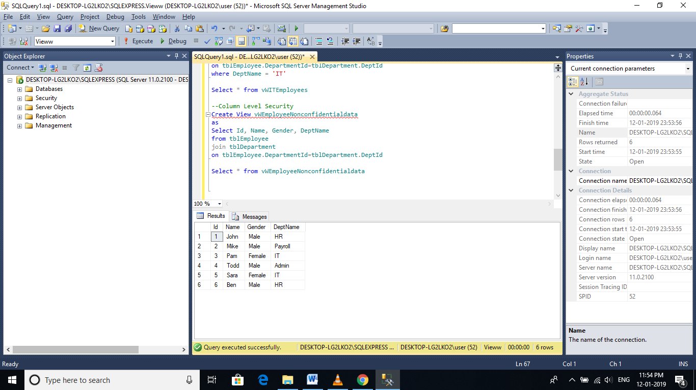

1. Views can be used to present **only aggregated data** and **hide detailed data**.  
     
   **View that returns summarized data**, Total number of employees by Department.  
   Create View vWEmployeesCountByDepartment  
   as  
   Select DeptName, COUNT(Id) as TotalEmployees  
   from tblEmployee  
   join tblDepartment  
   on tblEmployee.DepartmentId = tblDepartment.DeptId  
   Group By DeptName

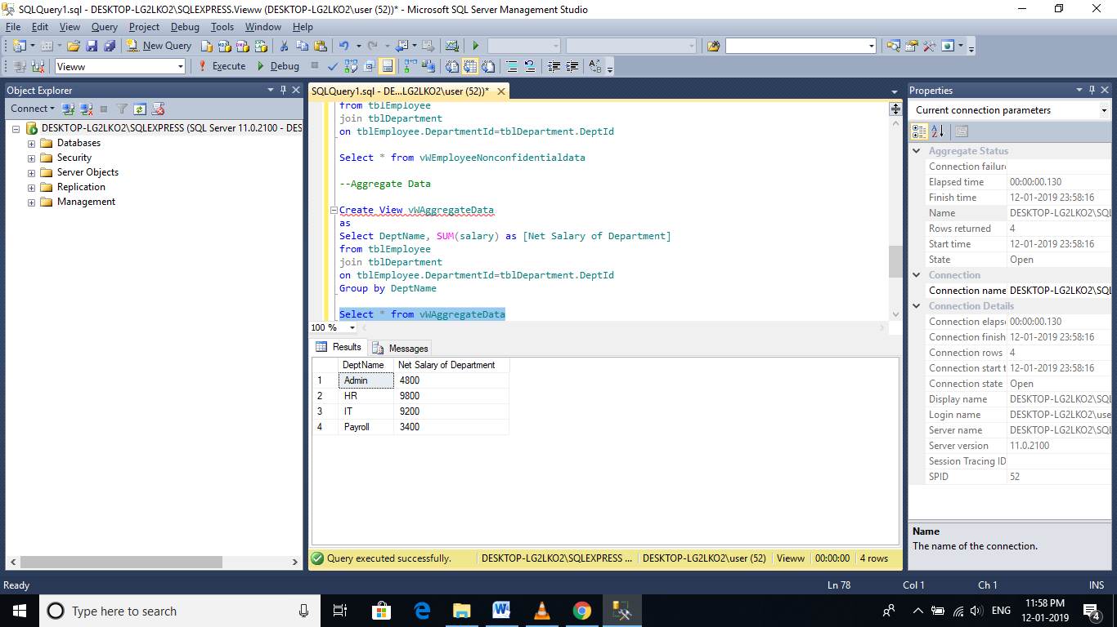

To look at view definition - sp_helptext vWName

To modify a view - ALTER VIEW statement

To Drop a view - DROP VIEW vWName

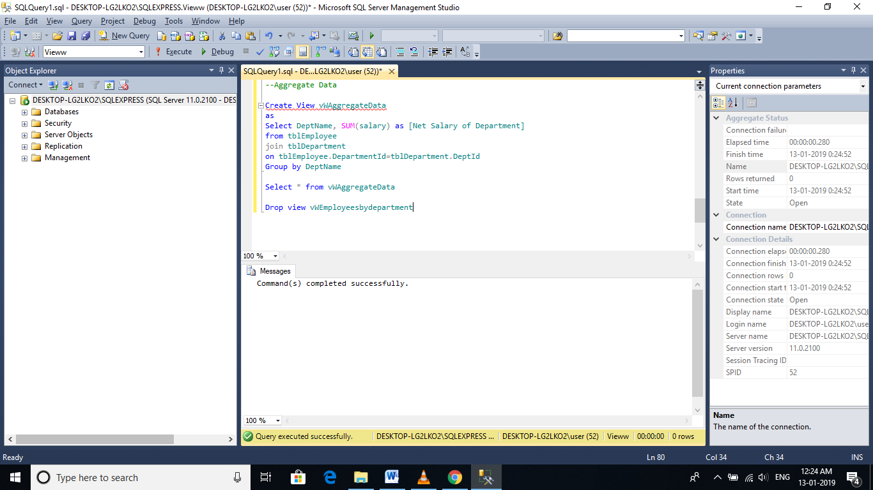

# Updateable Views

**Let's create a view**, which returns all the columns from the tblEmployees table, except Salary column

Create view vWEmployeesDataExceptSalary  
as  
Select Id, Name, Gender, DepartmentId  
from tblEmployee

**Select data from the view**: A view does not store any data. So, when this query is executed, the database engine actually retrieves data, from the underlying tblEmployee base table.  
Select * from vWEmployeesDataExceptSalary

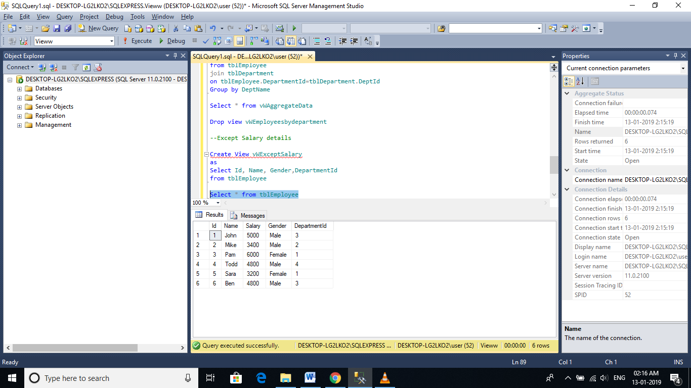

**Is it possible to Insert, Update and delete rows**, from the underlying tblEmployees table, using view vWEmployeesDataExceptSalary?  
**Yes**, SQL server views are updateable.

**The following query updates, Name column from Mike to Mikey**. Though, we are updating the view, SQL server, correctly updates the base table tblEmployee. To verify, execute, SELECT statement, on tblEmployee table.  
Update vWEmployeesDataExceptSalary   
Set Name = 'Mikey' Where Id = 2

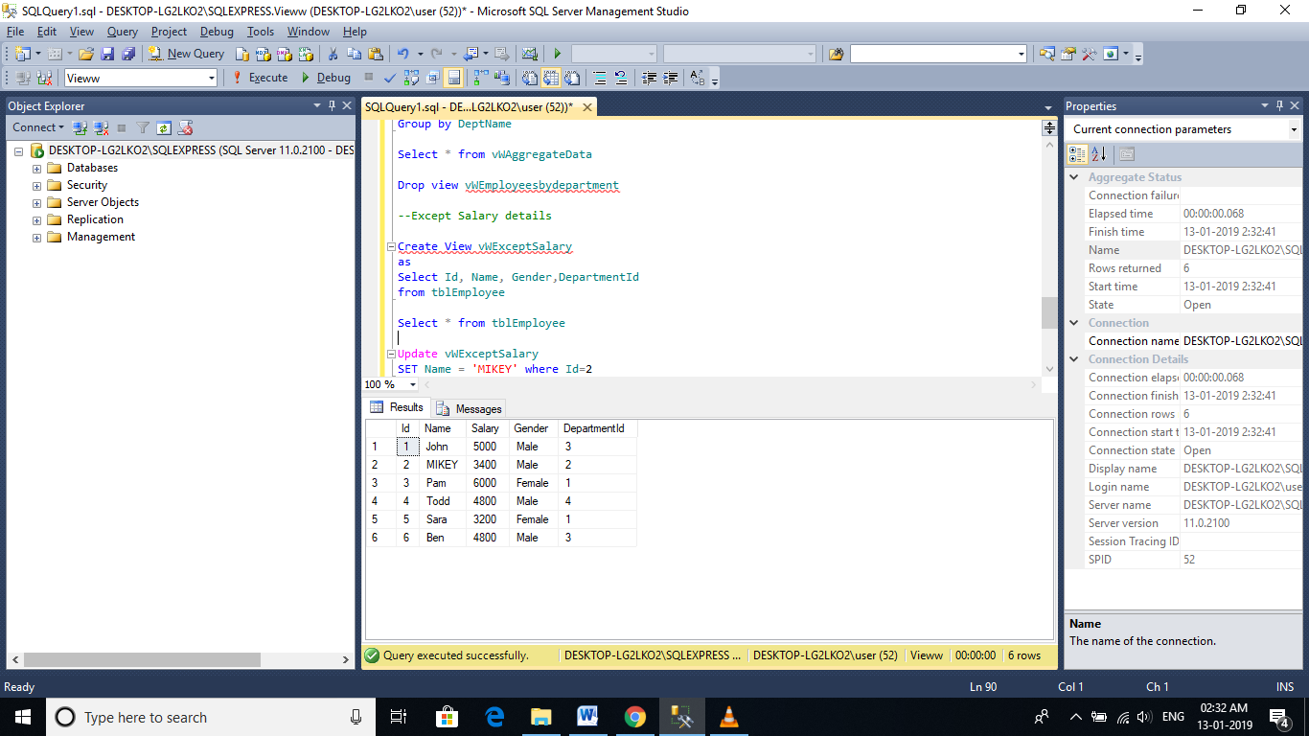

Delete from vWEmployeesDataExceptSalary where Id = 2

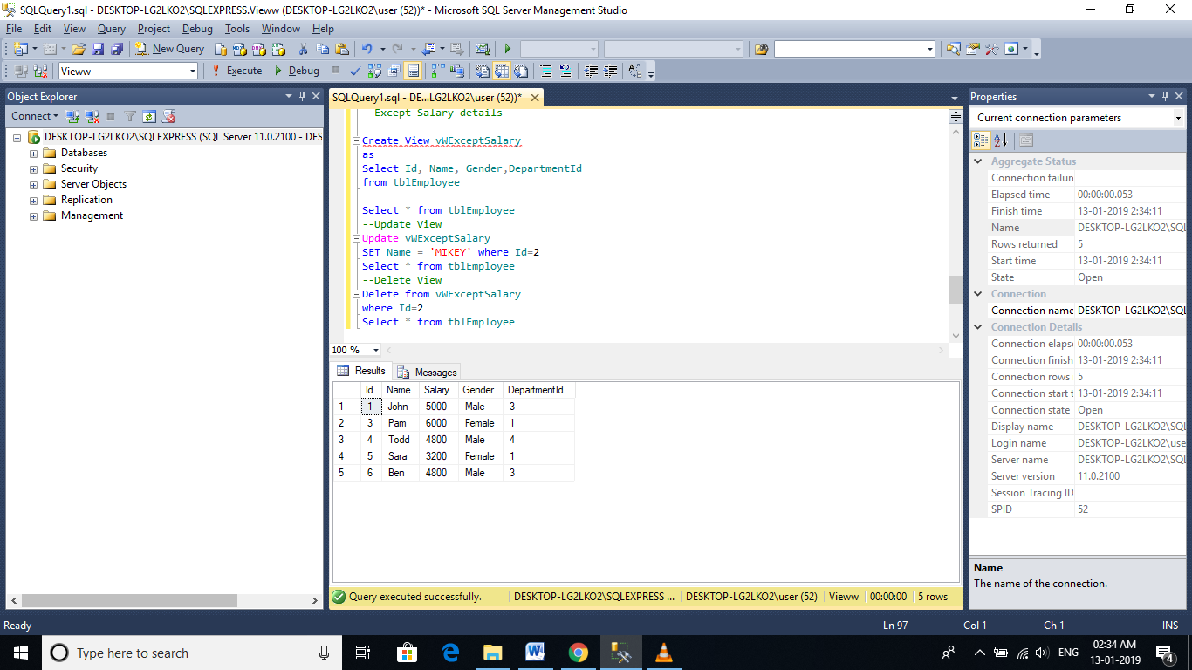

Insert into vWEmployeesDataExceptSalary values (2, 'Mikey', 'Male', 2)

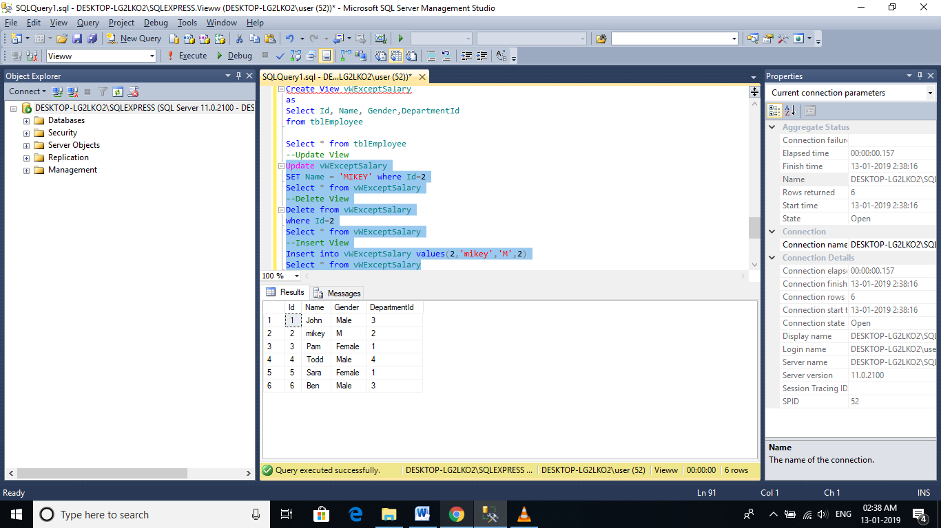

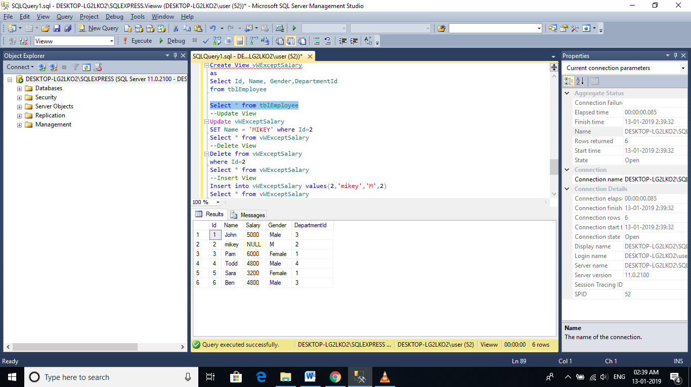

**Now, let us see, what happens if our view is based on multiple base tables**. For this purpose, let's create tblDepartment table and populate with some sample data.  
**SQL Script to create tblDepartment table**

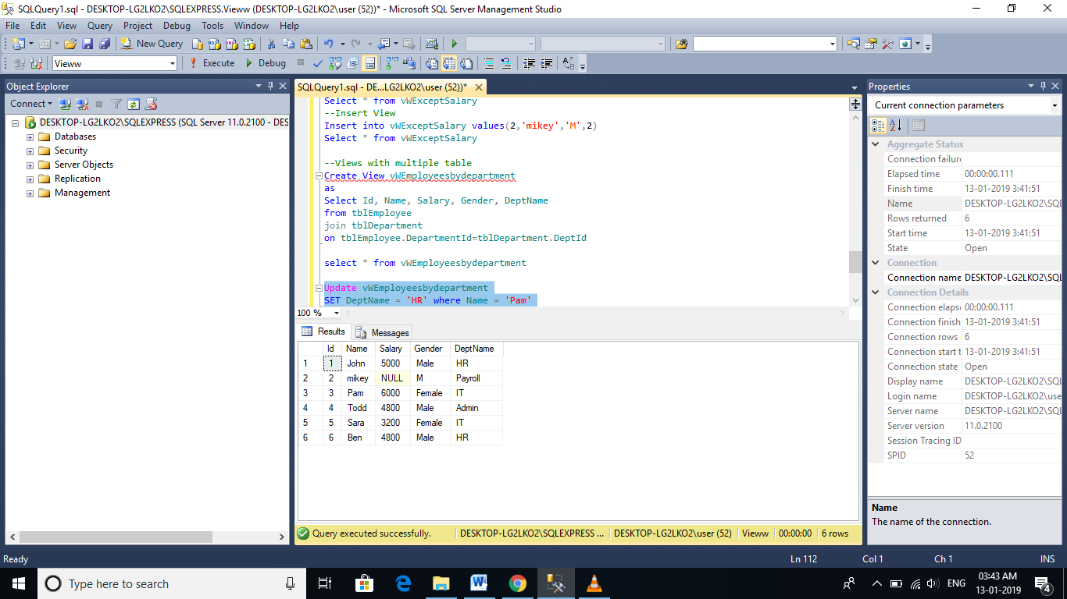

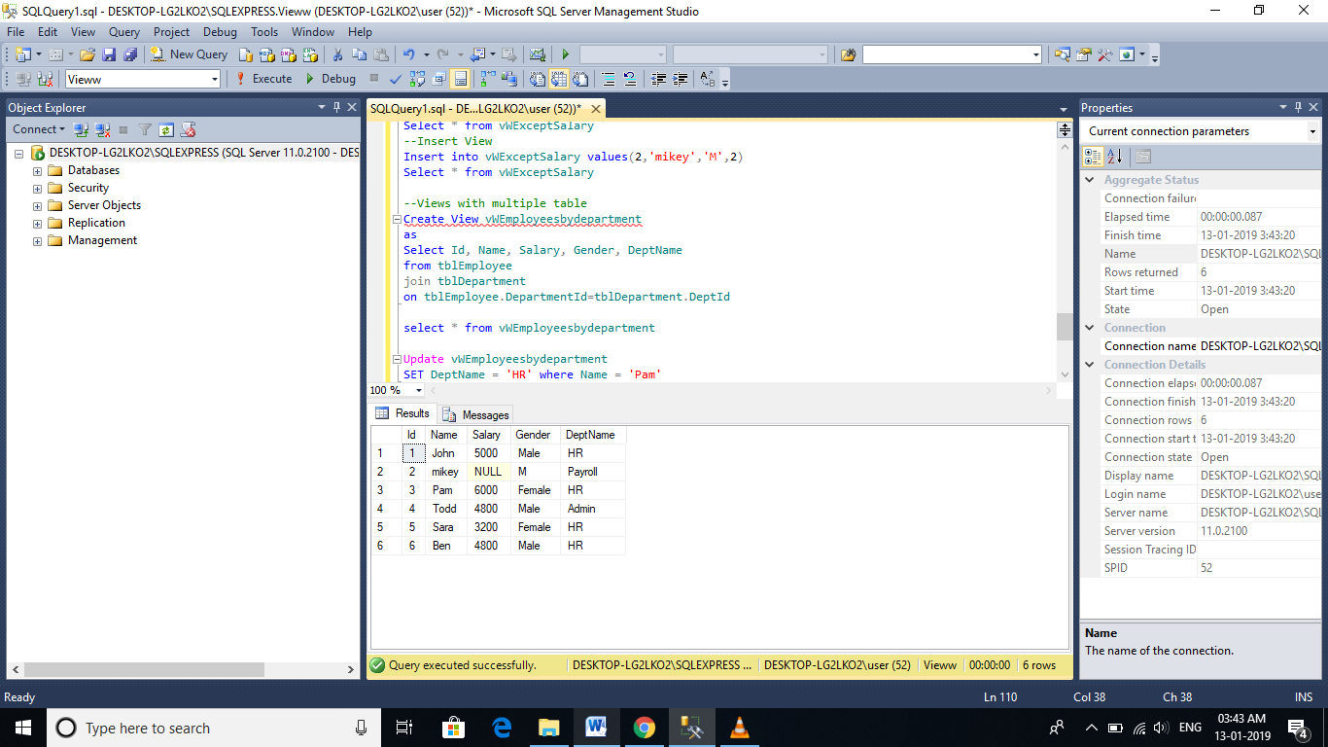

**The UPDATE statement, updated DeptName from HR to IT in tblDepartment table**, instead of upadting **DepartmentId** column in **tblEmployee** table. So, the conclusion - If a view is based on multiple tables, and if you update the view, it may not update the underlying base tables correctly. To correctly update a view, that is based on multiple table, INSTEAD OF triggers are used.

# Indexed views in sql server

A **standard** or **Non-indexed** view, is just a stored SQL query. When, we try to retrieve data from the view, the data is actually retrieved from the underlying base tables. So, a view is just a virtual table it does not store any data, by default.  
  
**However, when you create an index**, on a view, the view gets materialized. This means, the view is now, capable of storing data. In SQL server, we call them Indexed views and in Oracle, Materialized views.

**Script to create table tblProduct**  
Create Table tblProduct  
(  
 ProductId int primary key,  
 Name nvarchar(20),  
 UnitPrice int  
)  
  
**Script to pouplate tblProduct, with sample data**  
Insert into tblProduct Values(1, 'Books', 20)  
Insert into tblProduct Values(2, 'Pens', 14)  
Insert into tblProduct Values(3, 'Pencils', 11)  
Insert into tblProduct Values(4, 'Clips', 10)  
  
**Script to create table tblProductSales**  
Create Table tblProductSales  
(  
 ProductId int,  
 QuantitySold int  
)  
  
**Script to pouplate tblProductSales, with sample data**  
Insert into tblProductSales values(1, 10)  
Insert into tblProductSales values(3, 23)  
Insert into tblProductSales values(4, 21)  
Insert into tblProductSales values(2, 12)  
Insert into tblProductSales values(1, 13)  
Insert into tblProductSales values(3, 12)  
Insert into tblProductSales values(4, 13)  
Insert into tblProductSales values(1, 11)  
Insert into tblProductSales values(2, 12)  
Insert into tblProductSales values(1, 14)   
  
**tblProduct Table**  
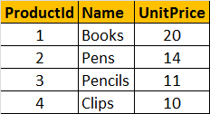   
  
**tblProductSales Table**  
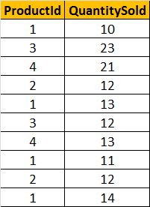  
  
**Create a view which returns Total Sales and Total Transactions by Product.** The output should be, as shown below.   
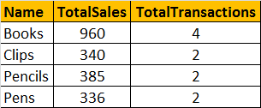   
  
**Script to create view vWTotalSalesByProduct**  
Create view vWTotalSalesByProduct  
with SchemaBinding  
as  
Select Name,   
SUM(ISNULL((QuantitySold * UnitPrice), 0)) as TotalSales,   
COUNT_BIG(*) as TotalTransactions  
from dbo.tblProductSales  
join dbo.tblProduct  
on dbo.tblProduct.ProductId = dbo.tblProductSales.ProductId  
group by Name

**If you want to create an Index**, on a view, the following rules should be followed by the view. For the complete list of all rules, please check [MSDN](http://msdn.microsoft.com/en-us/library/ms191432(v=sql.105).aspx).  
1. The view should be created with SchemaBinding option  
  
2. If an Aggregate function in the SELECT LIST, references an expression, and if there is a possibility for that expression to become NULL, then, a replacement value should be specified. In this example, we are using, ISNULL() function, to replace NULL values with ZERO.  
  
3. If GROUP BY is specified, the view select list must contain a COUNT_BIG(*) expression  
  
4. The base tables in the view, should be referenced with 2 part name. In this example, tblProduct and tblProductSales are referenced using dbo.tblProduct and dbo.tblProductSales respectively.

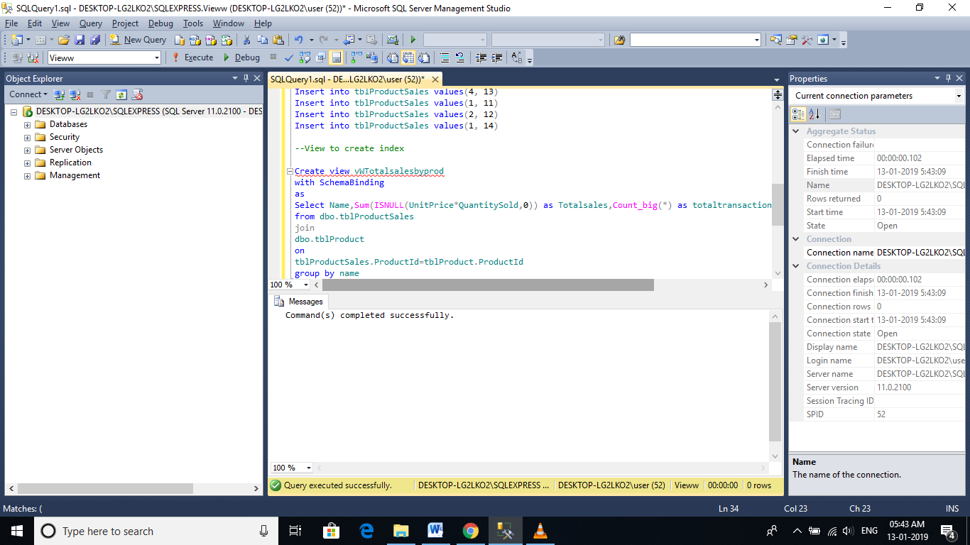

**Now, let's create an Index on the view:**  
The first index that you create on a view, must be a unique clustered index. After the unique clustered index has been created, you can create additional nonclustered indexes.  
Create Unique Clustered Index UIX_vWTotalSalesByProduct_Name  
on vWTotalSalesByProduct(Name)

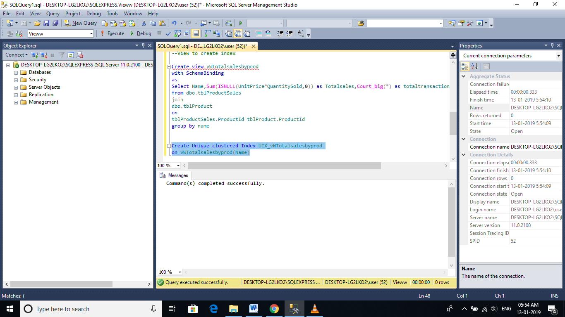

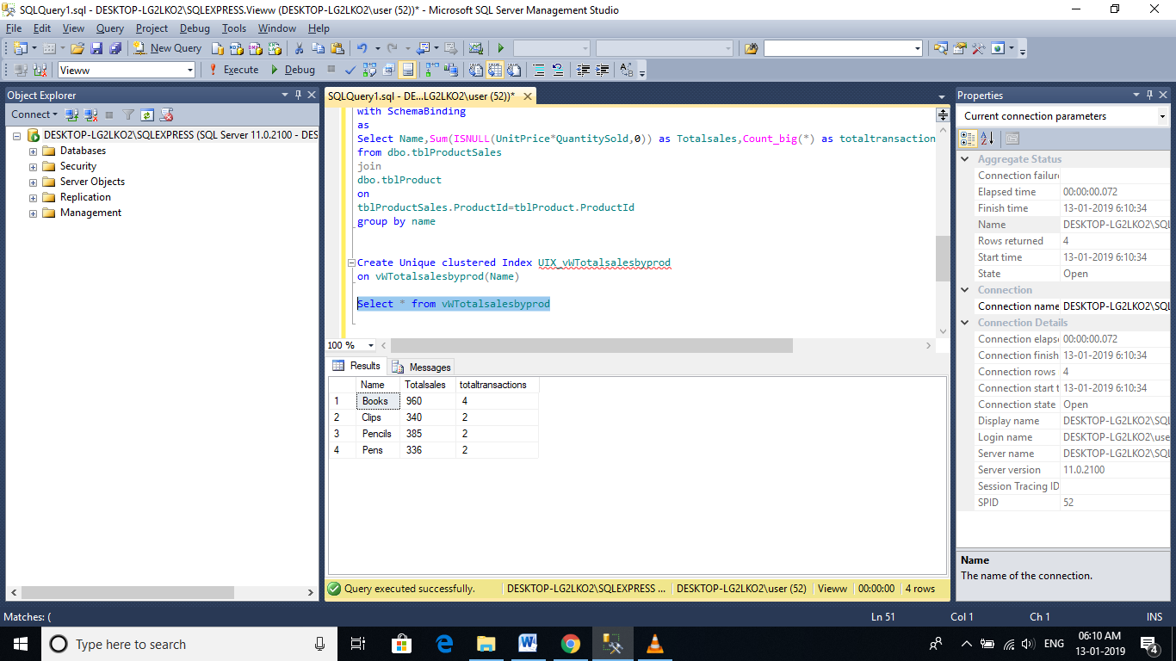

**Since, we now have an index on the view, the view gets materialized**. The data is stored in the view. So when we execute Select * from vWTotalSalesByProduct, the data is retrurned from the view itself, rather than retrieving data from the underlying base tables.   
  
Indexed views, can significantly improve the performance of queries that involves JOINS and Aggeregations. The cost of maintaining an indexed view is much higher than the cost of maintaining a table index.   
  
Indexed views are ideal for scenarios, where the underlying data is not frequently changed. Indexed views are more often used in OLAP systems, because the data is mainly used for reporting and analysis purposes. Indexed views, may not be suitable for OLTP systems, as the data is frequently addedd and changed.

# Limitations of views

1. **You cannot pass parameters to a view**. Table Valued functions are an excellent replacement for parameterized views.

**-- Error : Cannot pass Parameters to Views**  
Create View vWEmployeeDetails  
@Gender nvarchar(20)  
as  
Select Id, Name, Gender, DepartmentId  
from  tblEmployee  
where Gender = @Gender  
  
**Table Valued functions can be used as a replacement** for parameterized views.  
Create function fnEmployeeDetails(@Gender nvarchar(20))  
Returns Table  
as  
Return   
(Select Id, Name, Gender, DepartmentId  
from tblEmployee where Gender = @Gender)  
  
**Calling the function**  
Select * from dbo.fnEmployeeDetails('Male')

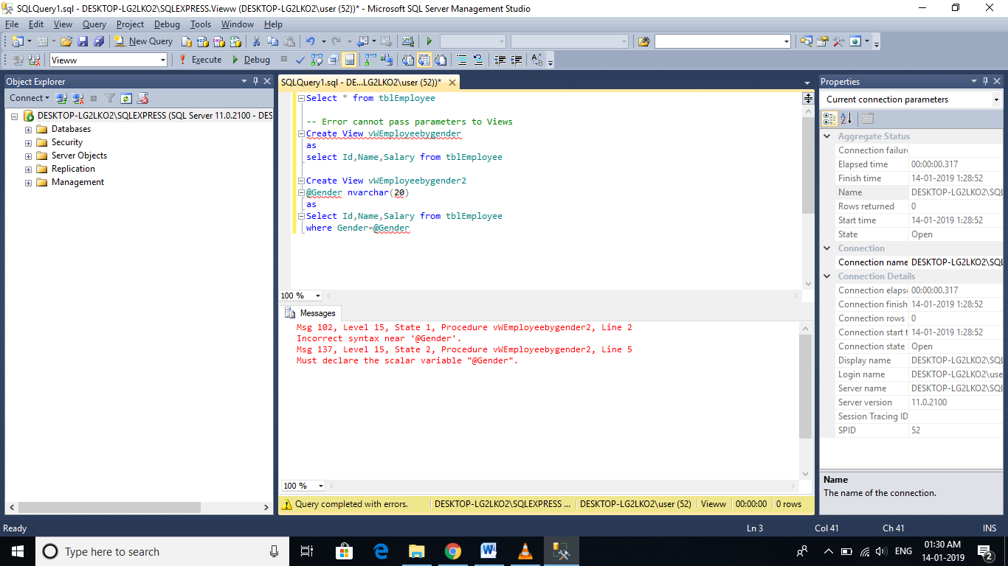

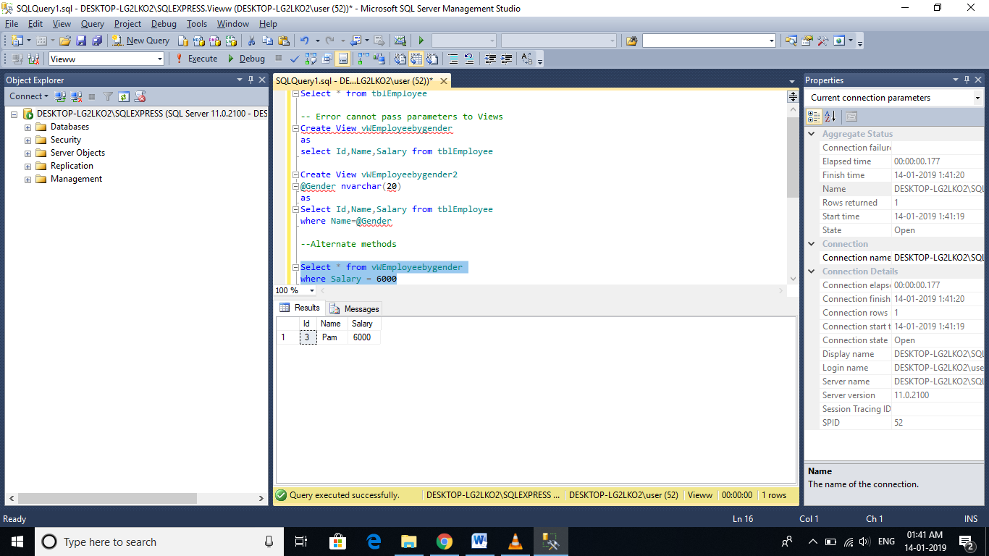

Inline Table Value function alternate for parameterised Views

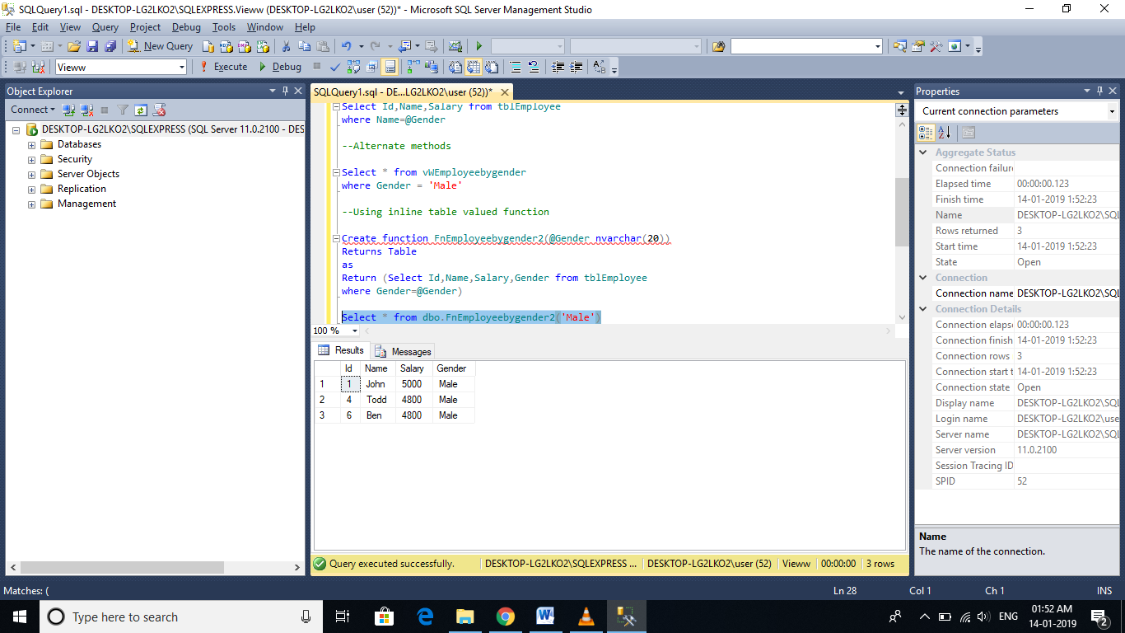

1. **Rules and Defaults cannot be associated with views.**

Reference: http://www.dotnetspider.com/forum/291754-difference-between-rule-constraint-sql.aspx

1. **The ORDER BY clause is invalid in views** unless TOP or FOR XML is also specified.

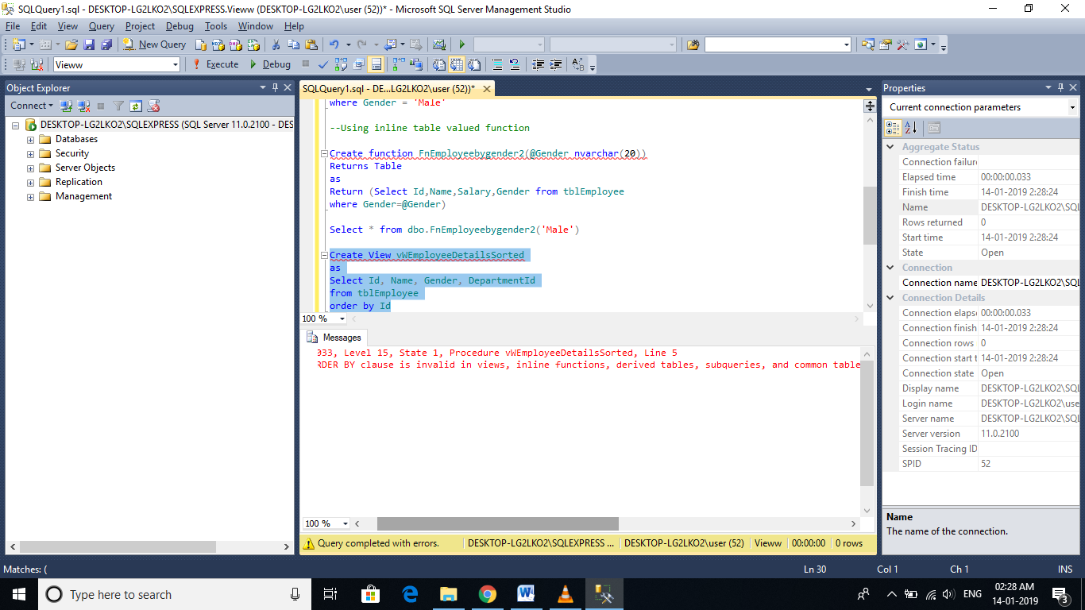

Create View vWEmployeeDetailsSorted  
as  
Select Id, Name, Gender, DepartmentId  
from tblEmployee  
order by Id  
If you use ORDER BY, you will get an error stating - 'The ORDER BY clause is invalid in views, inline functions, derived tables, subqueries, and common table expressions, unless TOP or FOR XML is also specified.'

1. **Views and Functions cannot be based on temporary tables.**

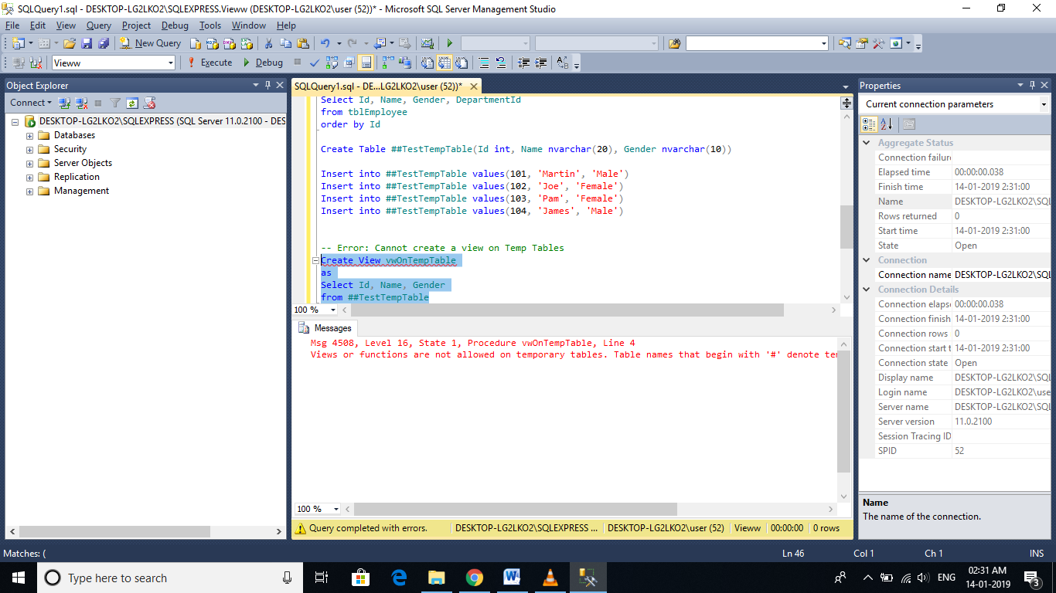

# DML Triggers

**In SQL server there are 3 types of triggers**  
1. DML triggers   
2. DDL triggers  
3. Logon trigger

DML triggers:

"A trigger is a special kind of Stored Procedure or stored program that is automatically fired or executed when some event (insert, delete and update) occurs."

**🡪DML stands for Data Manipulation Language.**

🡪INSERT, UPDATE, and DELETE statements are DML statements.

🡪DML triggers are fired, when ever data is modified using INSERT, UPDATE, and DELETE events

**DML triggers can be again classified into 2 types.**  
1. After triggers (Sometimes called as FOR triggers)  
2. Instead of triggers

**🡪After triggers, as the name says, fires after the triggering action**.

🡪The INSERT, UPDATE, and DELETE statements, causes an after trigger to fire after the respective statements complete execution.

**🡪On the other hand, as the name says, INSTEAD of triggers, fires instead of the triggering action**.

🡪The INSERT, UPDATE, and DELETE statements, can cause an INSTEAD OF trigger to fire INSTEAD OF the respective statement execution.

**SQL Script to create tblEmployee table:**  
CREATE TABLE tblEmployee  
(  
  Id int Primary Key,  
  Name nvarchar(30),  
  Salary int,  
  Gender nvarchar(10),  
  DepartmentId int  
)  
  
**Insert data into tblEmployee table**  
Insert into tblEmployee values (1,'John', 5000, 'Male', 3)  
Insert into tblEmployee values (2,'Mike', 3400, 'Male', 2)  
Insert into tblEmployee values (3,'Pam', 6000, 'Female', 1)   
  
**tblEmployee**  
   
  
  
**SQL Script to create tblEmployeeAudit table:**  
CREATE TABLE tblEmployeeAudit  
(  
  Id int identity(1,1) primary key,  
  AuditData nvarchar(1000)  
)  
**🡪When ever, a new Employee is added**, we want to capture the ID and the date and time, the new employee is added in tblEmployeeAudit table. The easiest way to achieve this, is by having an AFTER TRIGGER for INSERT event.

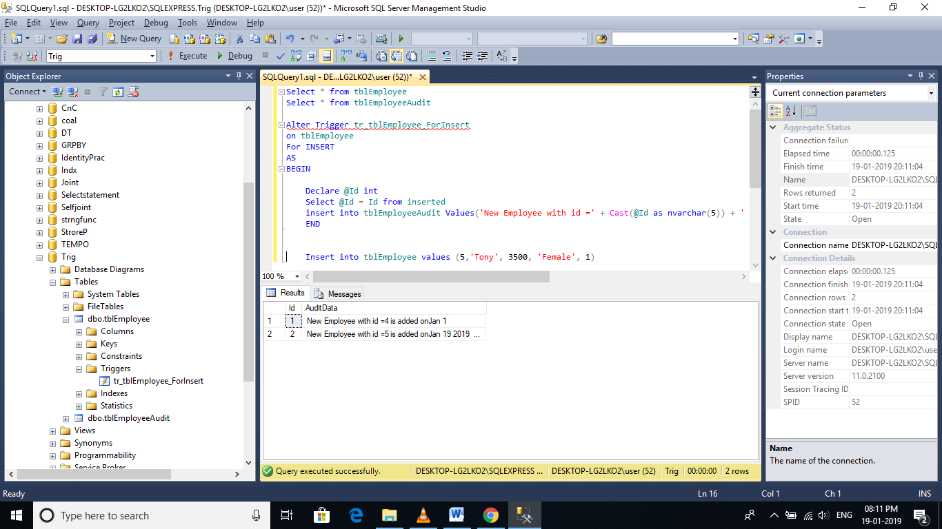

**In the trigger, we are getting the id from inserted table.** So, what is this inserted table? INSERTED table, is a special table used by DML triggers. When you add a new row into tblEmployee table, a copy of the row will also be made into inserted table, which only a trigger can access. You cannot access this table outside the context of the trigger. The structure of the inserted table will be identical to the structure of tblEmployee table.

**So, now if we execute the following INSERT statement on tblEmployee.**Immediately, after inserting the row into tblEmployee table, the trigger gets fired (executed automatically), and a row into tblEmployeeAudit, is also inserted.  
**Insert into tblEmployee values (7,'Tan', 2300, 'Female', 3)**

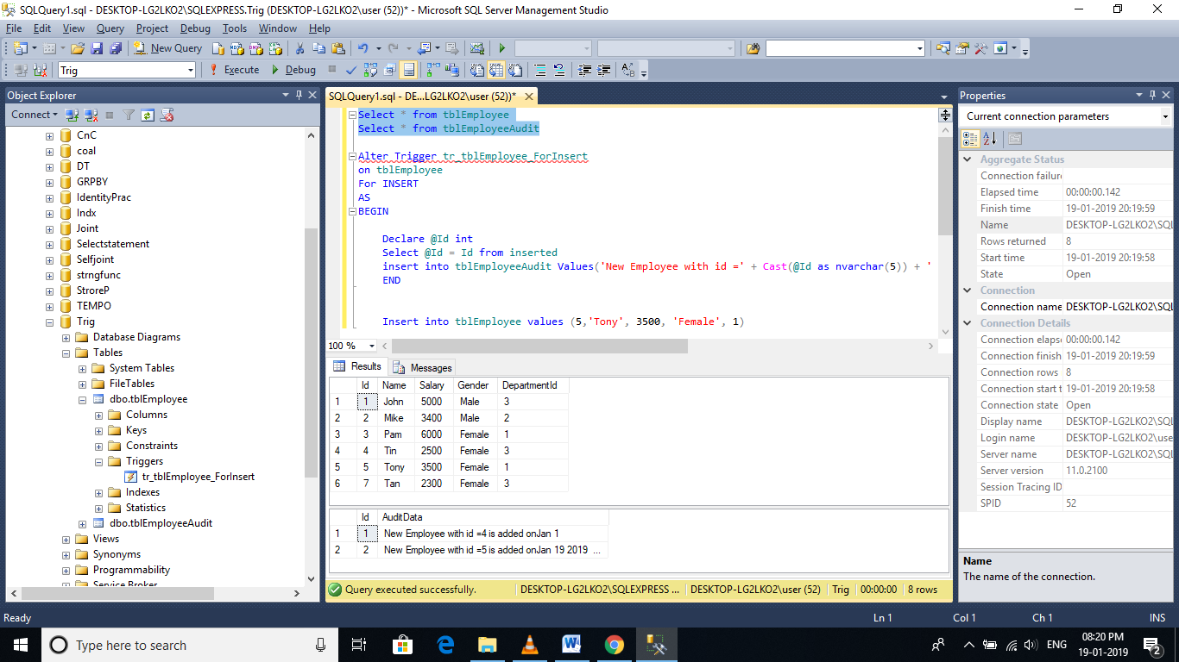

**Along, the same lines, let us now capture audit information, when a row is deleted**from the table, tblEmployee.  
**Example for AFTER TRIGGER for DELETE event on tblEmployee table:**  
CREATE TRIGGER tr_tblEMployee_ForDelete  
ON tblEmployee  
FOR DELETE  
AS  
BEGIN  
 Declare @Id int  
 Select @Id = Id from deleted  
   
 insert into tblEmployeeAudit   
 values('An existing employee with Id  = ' + Cast(@Id as nvarchar(5)) + ' is deleted at ' + Cast(Getdate() as nvarchar(20)))  
END  
  
**🡪The only difference here is that**, we are specifying, the triggering event as **DELETE**and retrieving the deleted row ID from **DELETED** table.

**🡪**DELETED table, is a special table used by DML triggers. When you delete a row from tblEmployee table, a copy of the deleted row will be made available in DELETED table, which only a trigger can access.

**🡪**Just like INSERTED table, DELETED table cannot be accessed, outside the context of the trigger and, the structure of the DELETED table will be identical to the structure of tblEmployee table.

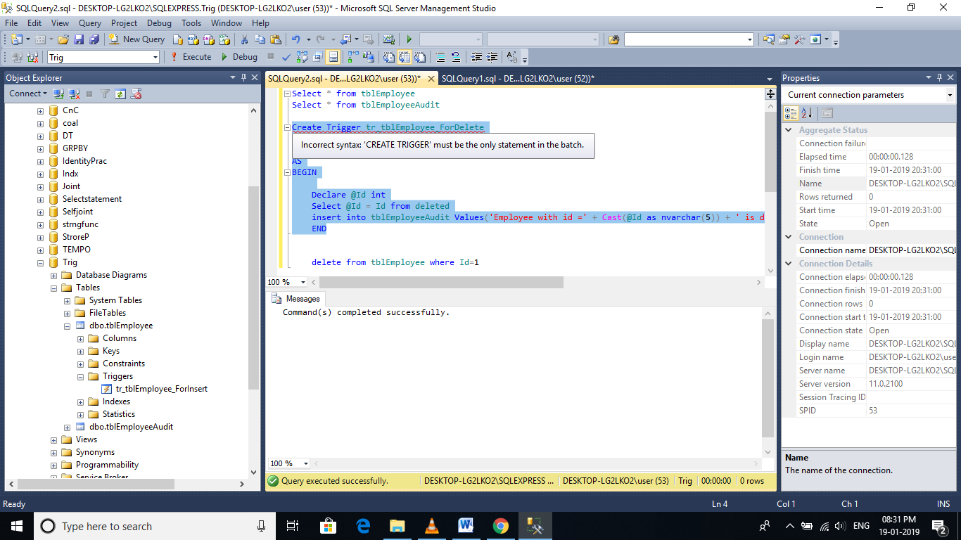

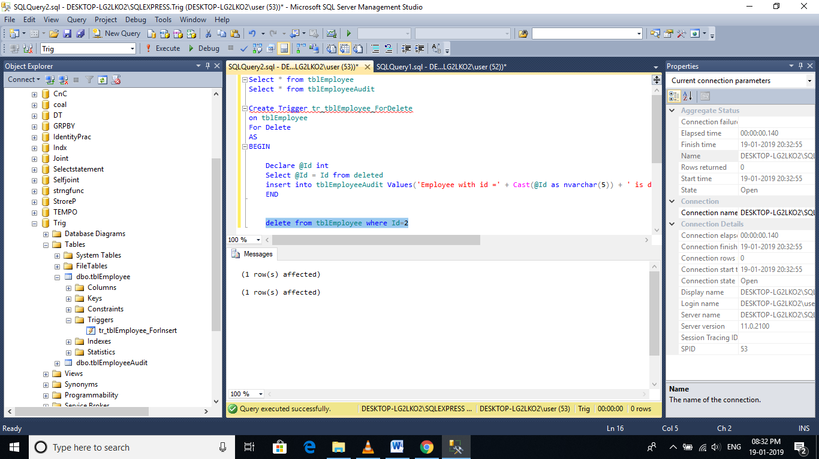

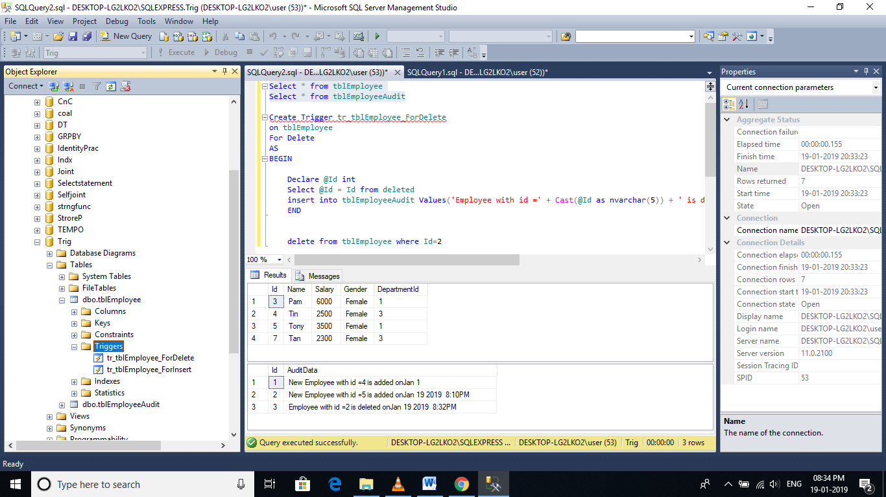

# After update trigger

**Triggers make use of 2 special tables**, INSERTED and DELETED.

🡪 The inserted table contains the updated data and the deleted table contains the old data. 🡪The After trigger for UPDATE event, makes use of both inserted and deleted tables.

**Create AFTER UPDATE trigger script:**  
Create trigger tr_tblEmployee_ForUpdate  
on tblEmployee  
for Update  
as  
Begin  
 Select * from deleted  
 Select * from inserted   
End

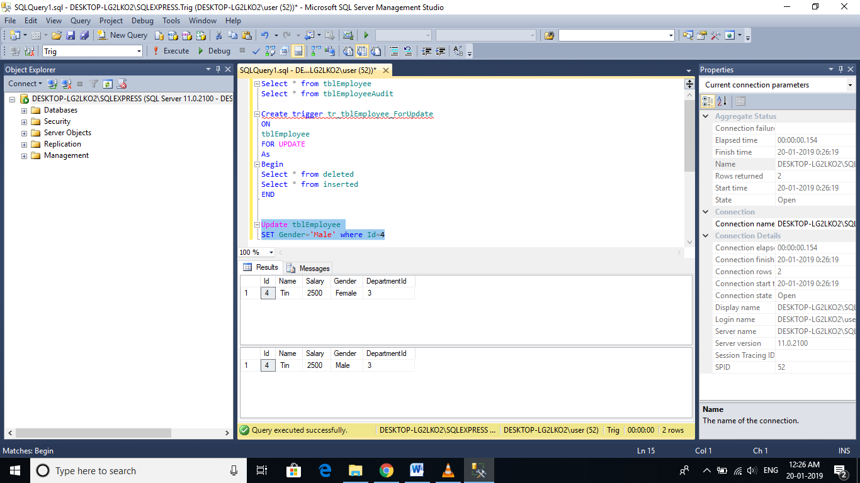

**Now, execute this query:**  
Update tblEmployee set Name = 'Tods', Salary = 2000,   
Gender = 'Female' where Id = 4  
  
**Immediately after the UPDATE statement execution**, the AFTER UPDATE trigger gets fired, and you should see the contenets of INSERTED and DELETED tables.

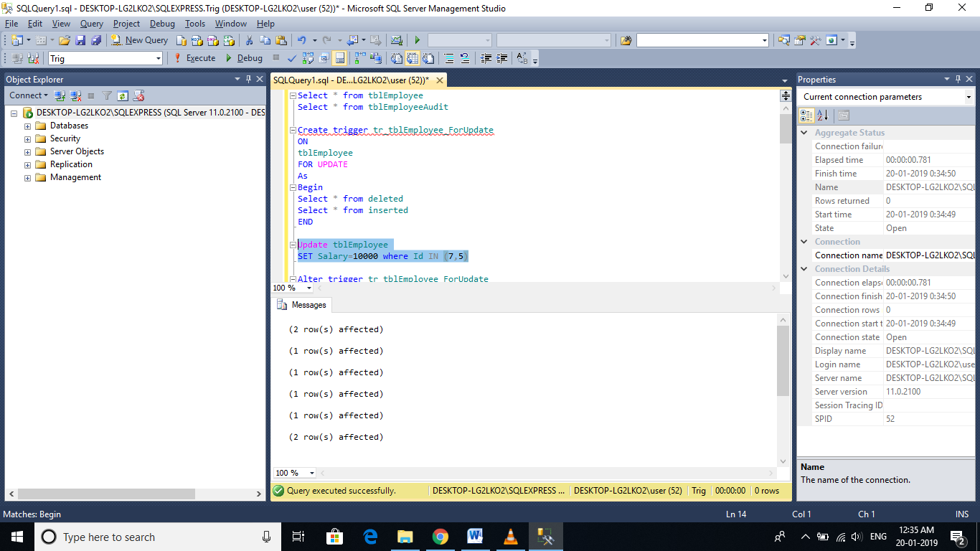

**The following AFTER UPDATE trigger, audits employee information upon UPDATE**, and stores the audit data in tblEmployeeAudit table.  
Alter trigger tr_tblEmployee_ForUpdate  
on tblEmployee  
for Update  
as  
Begin  
      -- Declare variables to hold old and updated data  
      Declare @Id int  
      Declare @OldName nvarchar(20), @NewName nvarchar(20)  
      Declare @OldSalary int, @NewSalary int  
      Declare @OldGender nvarchar(20), @NewGender nvarchar(20)  
      Declare @OldDeptId int, @NewDeptId int  
       
      -- Variable to build the audit string  
      Declare @AuditString nvarchar(1000)  
        
      -- Load the updated records into temporary table  
      Select *  
      into #TempTable  
      from inserted  
       
      -- Loop thru the records in temp table  
      While(Exists(Select Id from #TempTable))  
      Begin  
            --Initialize the audit string to empty string  
            Set @AuditString = ''  
             
            -- Select first row data from temp table  
            Select Top 1 @Id = Id, @NewName = Name,   
            @NewGender = Gender, @NewSalary = Salary,  
            @NewDeptId = DepartmentId  
            from #TempTable  
             
            -- Select the corresponding row from deleted table  
            Select @OldName = Name, @OldGender = Gender,   
            @OldSalary = Salary, @OldDeptId = DepartmentId  
            from deleted where Id = @Id  
   
     -- Build the audit string dynamically             
            Set @AuditString = 'Employee with Id = ' + Cast(@Id as nvarchar(4)) + ' changed'  
            if(@OldName <> @NewName)  
                  Set @AuditString = @AuditString + ' NAME from ' + @OldName + ' to ' + @NewName  
                   
            if(@OldGender <> @NewGender)  
                  Set @AuditString = @AuditString + ' GENDER from ' + @OldGender + ' to '+ @NewGender  
                   
            if(@OldSalary <> @NewSalary)  
                  Set @AuditString = @AuditString + ' SALARY from ' + Cast(@OldSalary as nvarchar(10))+ ' to ' + Cast(@NewSalary as nvarchar(10))  
                    
     if(@OldDeptId <> @NewDeptId)  
                  Set @AuditString = @AuditString + ' DepartmentId from ' + Cast(@OldDeptId as nvarchar(10))+ ' to ' + Cast(@NewDeptId as nvarchar(10))  
             
            insert into tblEmployeeAudit values(@AuditString)  
              
            -- Delete the row from temp table, so we can move to the next row  
            Delete from #TempTable where Id = @Id  
      End  
End

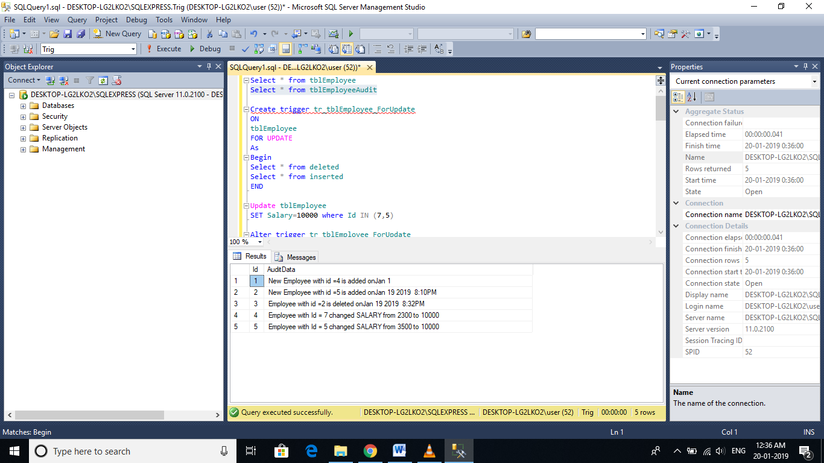

# Instead of insert trigger

🡪AFTER triggers are fired after the triggering event(INSERT, UPDATE or DELETE events), where as, INSTEAD OF triggers are fired instead of the triggering event(INSERT, UPDATE or DELETE events).

🡪In general, INSTEAD OF triggers are usually used to correctly update views that are based on multiple tables.

**Since, we now have the required tables**, let's create a view based on these tables. The view should return Employee Id, Name, Gender and DepartmentName columns. So, the view is obviously based on multiple tables.  
  
**Script to create the view:**  
Create view vWEmployeeDetails  
as  
Select Id, Name, Gender, DeptName  
from tblEmployee   
join tblDepartment  
on tblEmployee.DepartmentId = tblDepartment.DeptId  
  
**When you execute**, **Select * from vWEmployeeDetails**, the data from the view, should be as shown below  
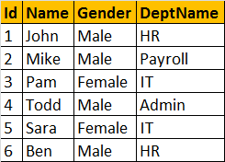   
  
**Now, let's try to insert a row into the view, vWEmployeeDetails**, by executing the following query. At this point, an error will be raised stating 'View or function vWEmployeeDetails is not updatable because the modification affects multiple base tables.'  
Insert into vWEmployeeDetails values(7, 'Valarie', 'Female', 'IT')  
  
**So, inserting a row into a view that is based on multipe tables**, raises an error by default. Now, let's understand, how INSTEAD OF TRIGGERS can help us in this situation. Since, we are getting an error, when we are trying to insert a row into the view, let's create an INSTEAD OF INSERT trigger on the view **vWEmployeeDetails.**

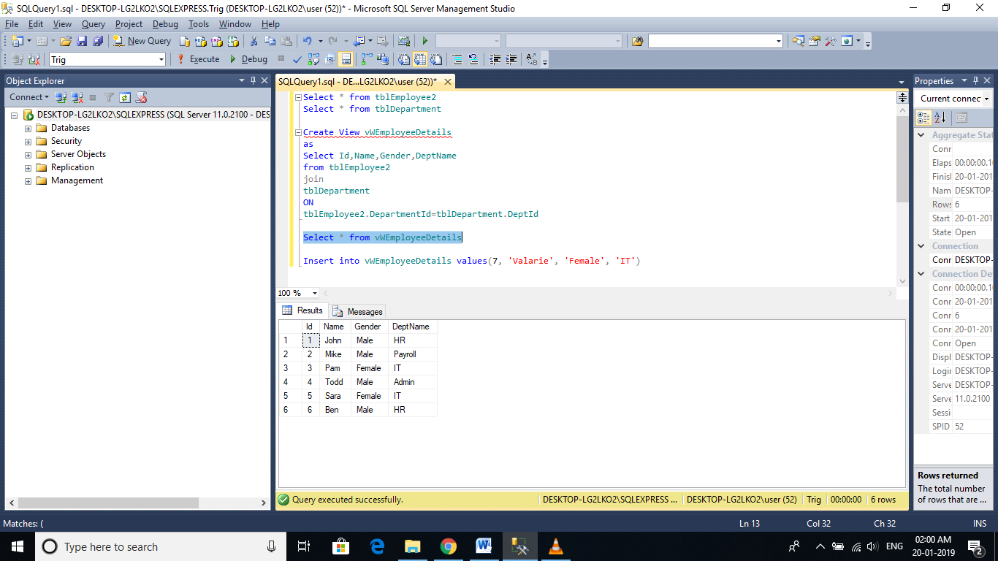

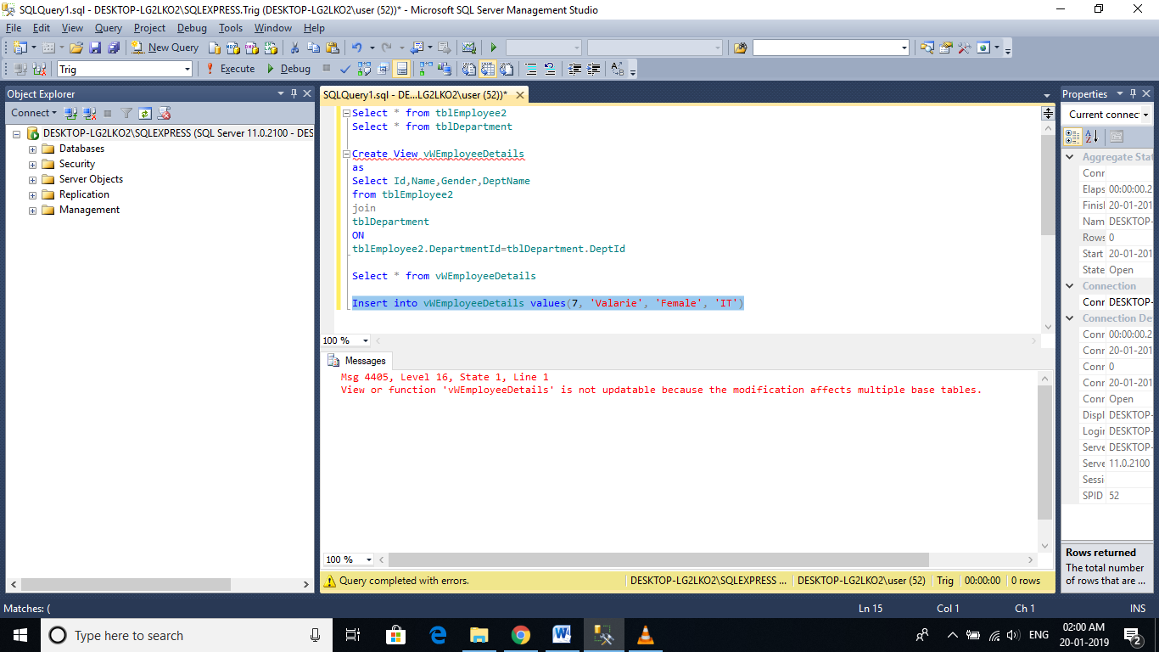

**So, inserting a row into a view that is based on multipe tables**, raises an error by default. Now, let's understand, how INSTEAD OF TRIGGERS can help us in this situation. Since, we are getting an error, when we are trying to insert a row into the view, let's create an INSTEAD OF INSERT trigger on the view **vWEmployeeDetails.**

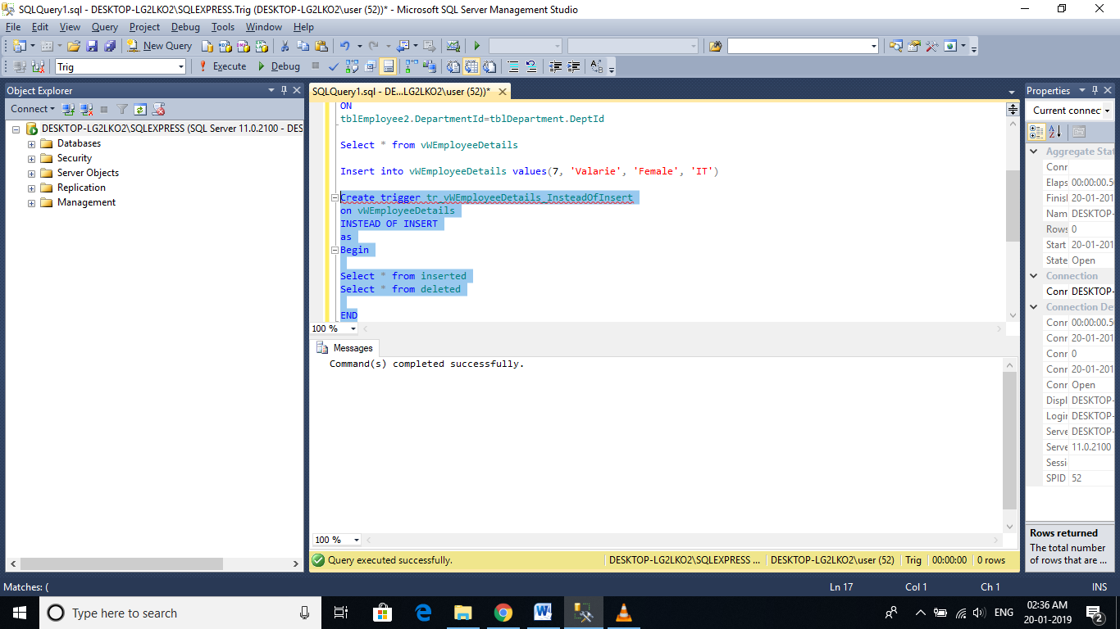

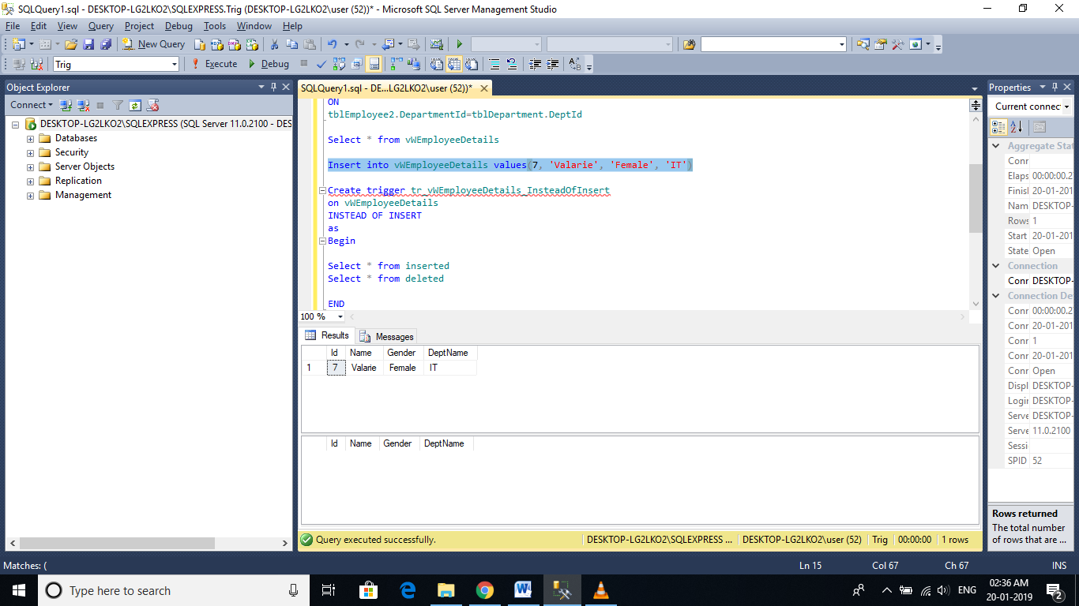

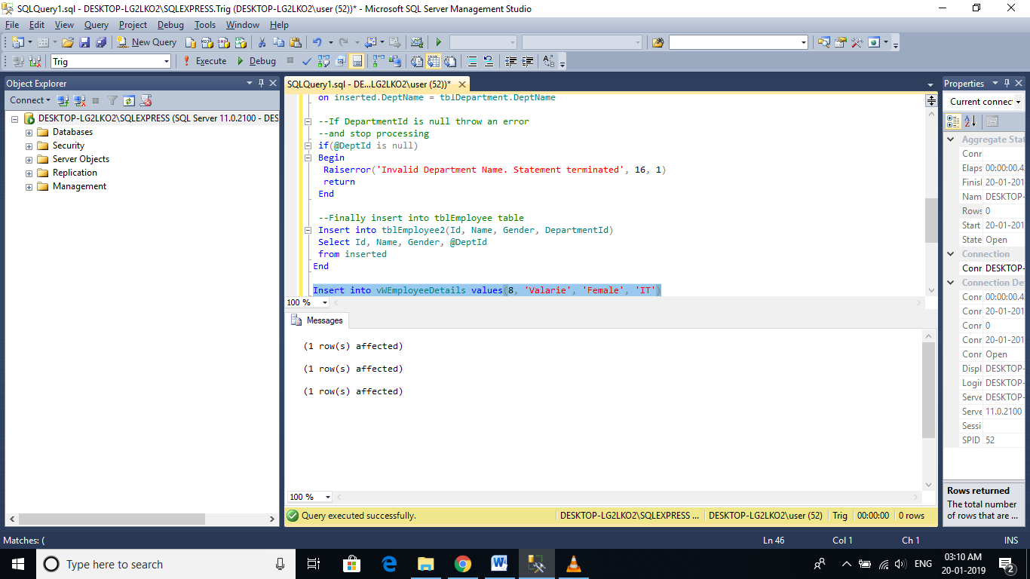

**The instead of trigger correctly inserts**, the record into tblEmployee table. Since, we are inserting a row, the **inserted** table, contains the newly added row, where as the **deleted** table will be empty.   
  
**In the trigger, we used Raiserror() function**, to raise a custom error, when the DepartmentName provided in the insert query, doesnot exist. We are passing 3 parameters to the Raiserror() method. The first parameter is the error message, the second parameter is the severity level. Severity level 16, indicates general errors that can be corrected by the user. The final parameter is the state. We will talk about Raiserror() and exception handling in sql server, in a later video session.

# Instead of update triggers

An INSTEAD OF UPDATE triggers gets fired instead of an update event, on a table or a view. For example, let's say we have, an INSTEAD OF UPDATE trigger on a view or a table, and then when you try to update a row with in that view or table, instead of the UPDATE, the trigger gets fired automatically. INSTEAD OF UPDATE TRIGGERS, are of immense help, to correctly update a view, that is based on multiple tables.  
  
**Let's create the required Employee and Department tables**, that we will be using for this demo.  
  
**SQL Script to create tblEmployee table:**  
CREATE TABLE tblEmployee  
(  
  Id int Primary Key,  
  Name nvarchar(30),  
  Gender nvarchar(10),  
  DepartmentId int  
)  
  
**SQL Script to create tblDepartment table**  
CREATE TABLE tblDepartment  
(  
 DeptId int Primary Key,  
 DeptName nvarchar(20)  
)  
  
**Insert data into tblDepartment table**  
Insert into tblDepartment values (1,'IT')  
Insert into tblDepartment values (2,'Payroll')  
Insert into tblDepartment values (3,'HR')  
Insert into tblDepartment values (4,'Admin')  
  
**Insert data into tblEmployee table**  
Insert into tblEmployee values (1,'John', 'Male', 3)  
Insert into tblEmployee values (2,'Mike', 'Male', 2)  
Insert into tblEmployee values (3,'Pam', 'Female', 1)  
Insert into tblEmployee values (4,'Todd', 'Male', 4)  
Insert into tblEmployee values (5,'Sara', 'Female', 1)  
Insert into tblEmployee values (6,'Ben', 'Male', 3)  
  
**Since, we now have the required tables**, let's create a view based on these tables. The view should return Employee Id, Name, Gender and DepartmentName columns. So, the view is obviously based on multiple tables.  
**Script to create the view:**  
Create view vWEmployeeDetails  
as  
Select Id, Name, Gender, DeptName  
from tblEmployee   
join tblDepartment  
on tblEmployee.DepartmentId = tblDepartment.DeptId  
  
**When you execute, Select * from vWEmployeeDetails**, the data from the view, should be as shown below  
   
  
**In Part 45, we tried to insert a row into the view**, and we got an error stating - 'View or function vWEmployeeDetails is not updatable because the modification affects multiple base tables.'  
  
**Now, let's try to update the view**, in such a way that, it affects, both the underlying tables, and see, if we get the same error. The following UPDATE statement changes **Name column** from **tblEmployee** and **DeptName column** from **tblDepartment**. So, when we execute this query, we get the same error.  
Update vWEmployeeDetails   
set Name = 'Johny', DeptName = 'IT'  
where Id = 1

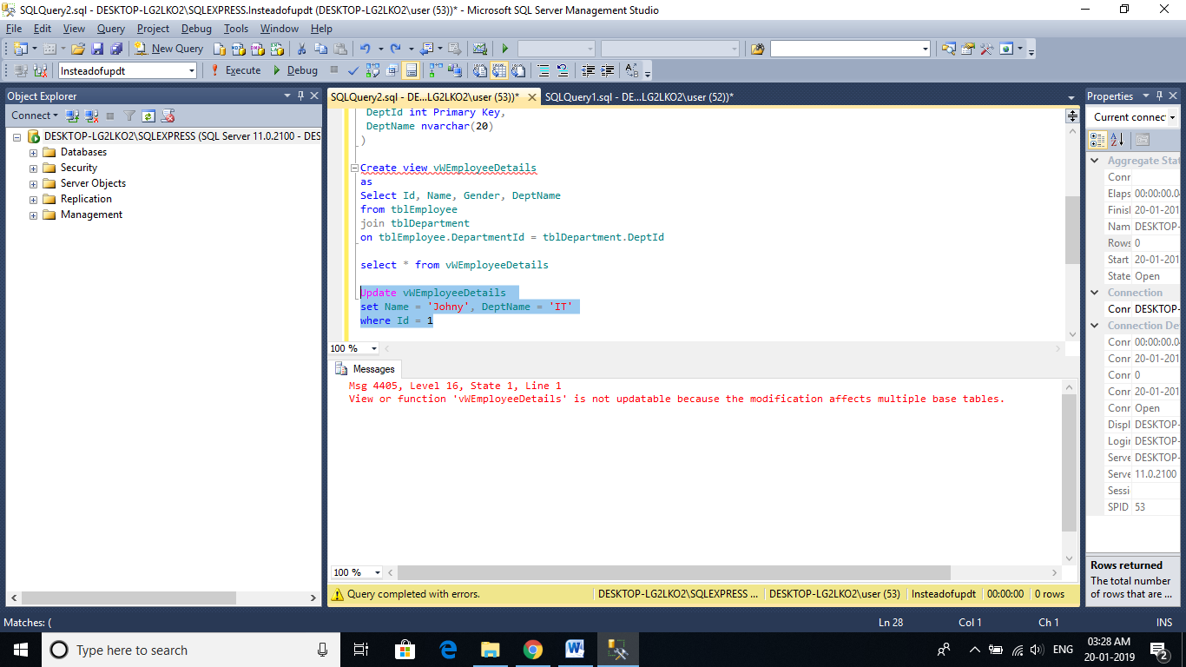

**Now, let's try to change, just the department of John from HR to IT**. The following UPDATE query, affects only one table, tblDepartment. So, the query should succeed. But, before executing the query, please note that, employees **JOHN** and **BEN** are in **HR**department.  
Update vWEmployeeDetails   
set DeptName = 'IT'  
where Id = 1  
  
**After executing the query**, select the data from the view, and notice that **BEN'sDeptName** is also changed to **IT**. We intended to just change **JOHN's DeptName**. So, the UPDATE didn't work as expected. This is because, the UPDATE query, updated the **DeptName from HR to IT**, in tblDepartment table. For the UPDATE to work correctly, we should change the **DeptId** of **JOHN** from 3 to 1.   
  
**Incorrectly Updated View**  
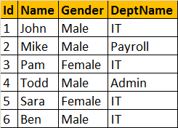

**Incorrectly Updated View**  
   
  
**Record with Id = 3, has the DeptName changed from 'HR' to 'IT'**  
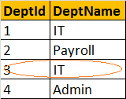   
  
**We should have actually updated, JOHN's DepartmentId from 3 to 1**  
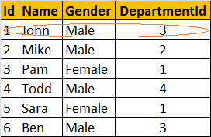  
  
  
**So, the conclusion is that, if a view is based on multiple tables**, and if you update the view, the UPDATE may not always work as expected. To correctly update the underlying base tables, thru a view, INSTEAD OF UPDATE TRIGGER can be used.  
  
**Before, we create the trigger, let's update the DeptName to HR for record with Id = 3.**  
Update tblDepartment set DeptName = 'HR' where DeptId = 3

Create Trigger tr_vWEmployeeDetails_InsteadOfUpdate  
on vWEmployeeDetails  
instead of update  
as  
Begin  
 -- if EmployeeId is updated  
 if(Update(Id))  
 Begin  
 Raiserror('Id cannot be changed', 16, 1)  
 Return  
 End  
   
 -- If DeptName is updated  
 if(Update(DeptName))   
 Begin  
 Declare @DeptId int  
  
 Select @DeptId = DeptId  
 from tblDepartment  
 join inserted  
 on inserted.DeptName = tblDepartment.DeptName  
   
 if(@DeptId is NULL )  
 Begin  
 Raiserror('Invalid Department Name', 16, 1)  
 Return  
 End  
   
 Update tblEmployee set DepartmentId = @DeptId  
 from inserted  
 join tblEmployee  
 on tblEmployee.Id = inserted.id  
 End  
   
 -- If gender is updated  
 if(Update(Gender))  
 Begin  
 Update tblEmployee set Gender = inserted.Gender  
 from inserted  
 join tblEmployee  
 on tblEmployee.Id = inserted.id  
 End  
   
 -- If Name is updated  
 if(Update(Name))  
 Begin  
 Update tblEmployee set Name = inserted.Name  
 from inserted  
 join tblEmployee  
 on tblEmployee.Id = inserted.id  
 End  
End  
  
**Now, let's try to update JOHN's Department to IT.**  
Update vWEmployeeDetails   
set DeptName = 'IT'  
where Id = 1

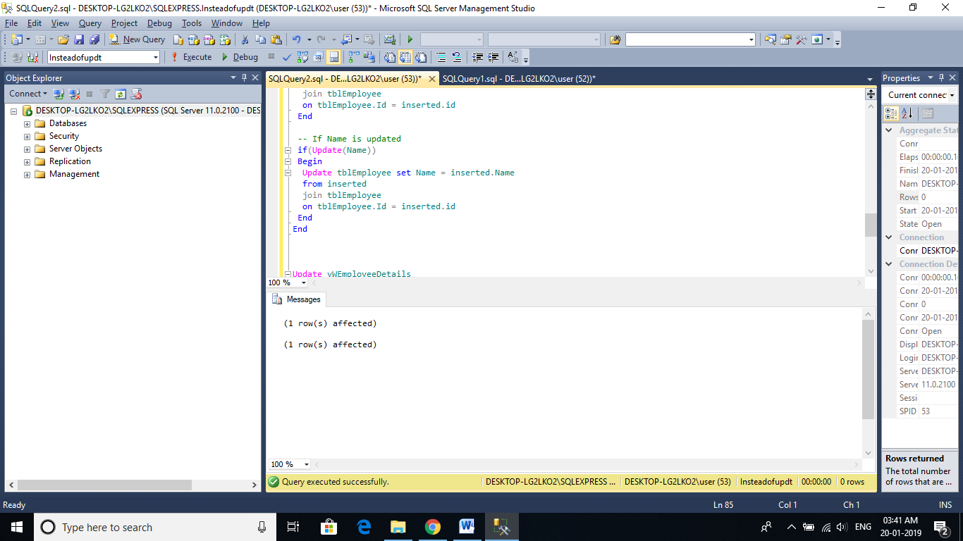

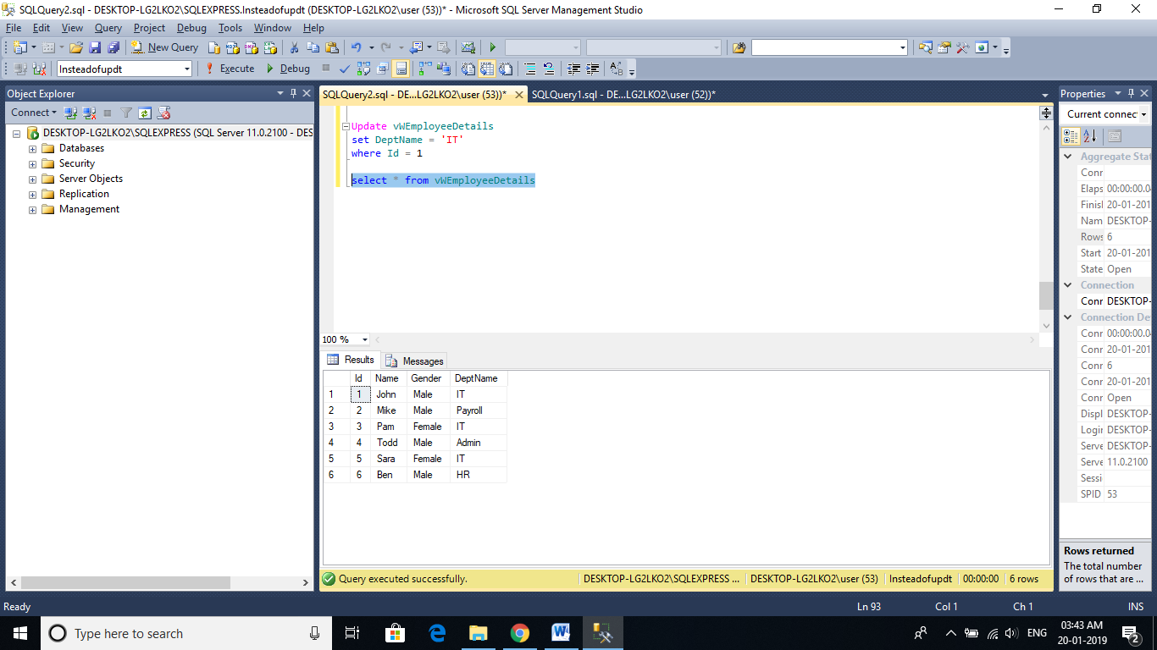

# Instead of delete trigger

An INSTEAD OF DELETE trigger gets fired instead of the DELETE event, on a table or a view. For example, let's say we have, an INSTEAD OF DELETE trigger on a view or a table, and then when you try to update a row from that view or table, instead of the actual DELETE event, the trigger gets fired automatically. INSTEAD OF DELETE TRIGGERS, are used, to delete records from a view, that is based on multiple tables.

**SQL Script to create tblEmployee table:**  
CREATE TABLE tblEmployee  
(  
  Id int Primary Key,  
  Name nvarchar(30),  
  Gender nvarchar(10),  
  DepartmentId int  
)  
  
**SQL Script to create tblDepartment table**  
CREATE TABLE tblDepartment  
(  
 DeptId int Primary Key,  
 DeptName nvarchar(20)  
)  
  
**Insert data into tblDepartment table**  
Insert into tblDepartment values (1,'IT')  
Insert into tblDepartment values (2,'Payroll')  
Insert into tblDepartment values (3,'HR')  
Insert into tblDepartment values (4,'Admin')  
  
**Insert data into tblEmployee table**  
Insert into tblEmployee values (1,'John', 'Male', 3)  
Insert into tblEmployee values (2,'Mike', 'Male', 2)  
Insert into tblEmployee values (3,'Pam', 'Female', 1)  
Insert into tblEmployee values (4,'Todd', 'Male', 4)  
Insert into tblEmployee values (5,'Sara', 'Female', 1)  
Insert into tblEmployee values (6,'Ben', 'Male', 3)  
  
**Since, we now have the required tables**, let's create a view based on these tables. The view should return Employee Id, Name, Gender and DepartmentName columns. So, the view is obviously based on multiple tables.  
**Script to create the view:**  
Create view vWEmployeeDetails  
as  
Select Id, Name, Gender, DeptName  
from tblEmployee   
join tblDepartment  
on tblEmployee.DepartmentId = tblDepartment.DeptId  
  
**When you execute, Select * from vWEmployeeDetails**, the data from the view, should be as shown below  
   
  
**In**[**Part 45**](http://csharp-video-tutorials.blogspot.com/2012/09/instead-of-insert-trigger-part-45.html), we tried to insert a row into the view, and we got an error stating - 'View or function vWEmployeeDetails is not updatable because the modification affects multiple base tables'. Along, the same lines, in [**Part 46**](http://csharp-video-tutorials.blogspot.com/2012/09/instead-of-update-triggers-part-46.html), when we tried to update a view that is based on multiple tables, we got the same error. To get the error, the UPDATE should affect both the base tables. If the update affects only one base table, we don't get the error, but the UPDATE does not work correctly, if the **DeptName**column is updated.  
  
**Now, let's try to delete a row from the view, and we get the same error.**  
Delete from vWEmployeeDetails where Id = 1  
  
**Script to create INSTEAD OF DELETE trigger:**  
Create Trigger tr_vWEmployeeDetails_InsteadOfDelete  
on vWEmployeeDetails  
instead of delete  
as  
Begin  
 Delete tblEmployee   
 from tblEmployee  
 join deleted  
 on tblEmployee.Id = deleted.Id  
   
 --Subquery  
 --Delete from tblEmployee   
 --where Id in (Select Id from deleted)  
End  
  
**Notice that, the trigger tr_vWEmployeeDetails_InsteadOfDelete**, makes use of DELETED table. DELETED table contains all the rows, that we tried to DELETE from the view. So, we are joining the DELETED table with tblEmployee, to delete the rows. You can also use sub-queries to do the same. In most cases JOINs are faster than SUB-QUERIEs. However, in cases, where you only need a subset of records from a table that you are joining with, sub-queries can be faster.  
  
**Upon executing the following DELETE statement**, the row gets DELETED as expected from tblEmployee table  
Delete from vWEmployeeDetails where Id = 1

|  |  |
| --- | --- |
| **Trigger** | **INSERTED or DELETED?** |
| Instead of Insert | DELETED table is always empty and the INSERTED table contains the newly inserted data. |
| Instead of Delete | INSERTED table is always empty and the DELETED table contains the rows deleted |
| Instead of Update | DELETED table contains OLD data (before update), and inserted table contains NEW data(Updated data) |

# Pivot operator in sql server

**🡪Pivot is a sql server operator**that can be used to turn **unique values from one column**, into **multiple columns**in the output, there by effectively **rotating a table**.

Create Table tblProductSales  
(  
 SalesAgent nvarchar(50),  
 SalesCountry nvarchar(50),  
 SalesAmount int   
)  
  
Insert into tblProductSales values('Tom', 'UK', 200)  
Insert into tblProductSales values('John', 'US', 180)  
Insert into tblProductSales values('John', 'UK', 260)  
Insert into tblProductSales values('David', 'India', 450)  
Insert into tblProductSales values('Tom', 'India', 350)  
Insert into tblProductSales values('David', 'US', 200)  
Insert into tblProductSales values('Tom', 'US', 130)  
Insert into tblProductSales values('John', 'India', 540)  
Insert into tblProductSales values('John', 'UK', 120)  
Insert into tblProductSales values('David', 'UK', 220)  
Insert into tblProductSales values('John', 'UK', 420)  
Insert into tblProductSales values('David', 'US', 320)  
Insert into tblProductSales values('Tom', 'US', 340)  
Insert into tblProductSales values('Tom', 'UK', 660)  
Insert into tblProductSales values('John', 'India', 430)  
Insert into tblProductSales values('David', 'India', 230)  
Insert into tblProductSales values('David', 'India', 280)  
Insert into tblProductSales values('Tom', 'UK', 480)  
Insert into tblProductSales values('John', 'US', 360)  
Insert into tblProductSales values('David', 'UK', 140)

**A simple GROUP BY query can produce this output.**  
Select SalesCountry, SalesAgent, SUM(SalesAmount) as Total   
from tblProductSales  
group by SalesCountry, SalesAgent  
order by SalesCountry, SalesAgent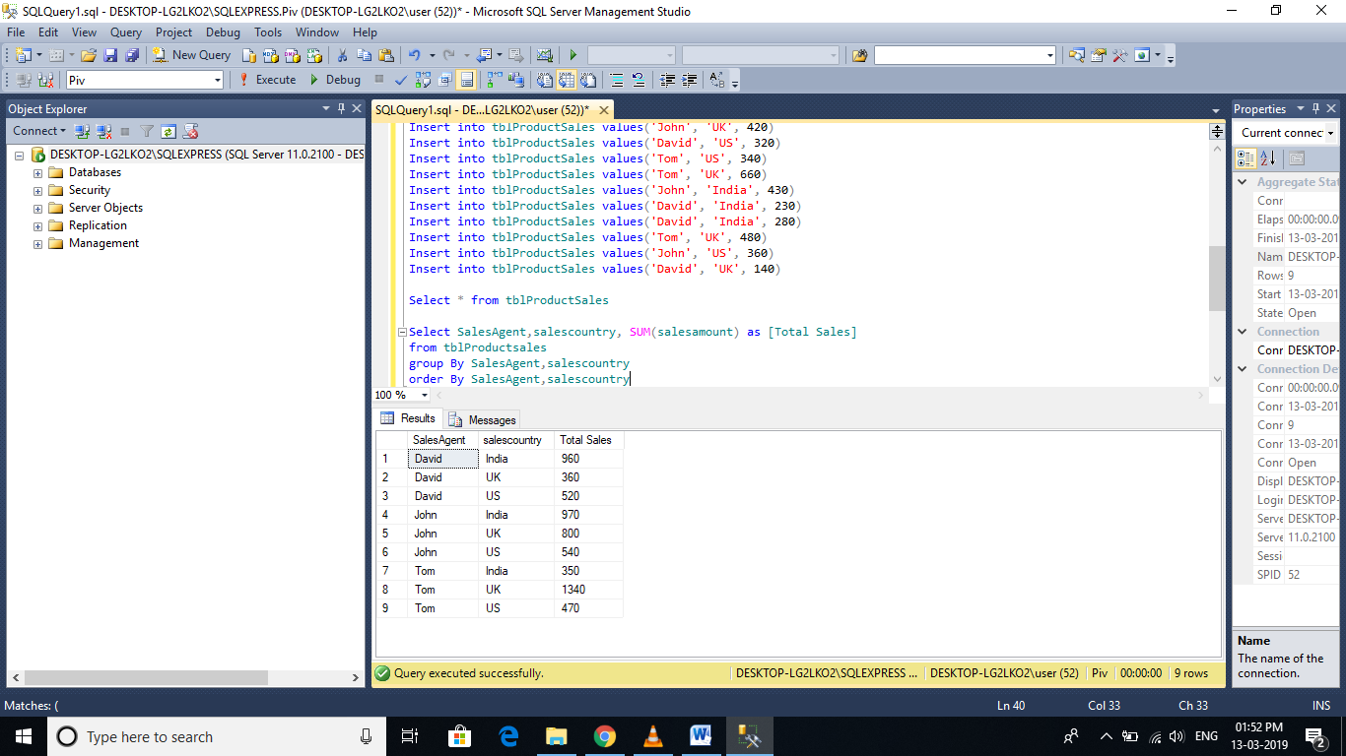

**This PIVOT query is converting the unique column values**(India, US, UK) in **SALESCOUNTRY** column, **into Columns**in the output, along with performing aggregations on the **SALESAMOUNT**column. The Outer query, simply, selects **SALESAGENT**column from **tblProductSales**table, along with pivoted columns from the PivotTable.  
  
**Having understood the basics of PIVOT**, let's look at another example. Let's create **tblProductsSale**, a slight variation of **tblProductSales**, that we have already created. The table, that we are creating now, has got an additional**Id** column.  
Create Table tblProductsSale  
(  
   Id int primary key,  
   SalesAgent nvarchar(50),  
   SalesCountry nvarchar(50),  
   SalesAmount int   
)  
  
Insert into tblProductsSale values(1, 'Tom', 'UK', 200)  
Insert into tblProductsSale values(2, 'John', 'US', 180)  
Insert into tblProductsSale values(3, 'John', 'UK', 260)  
Insert into tblProductsSale values(4, 'David', 'India', 450)  
Insert into tblProductsSale values(5, 'Tom', 'India', 350)  
Insert into tblProductsSale values(6, 'David', 'US', 200)  
Insert into tblProductsSale values(7, 'Tom', 'US', 130)  
Insert into tblProductsSale values(8, 'John', 'India', 540)  
Insert into tblProductsSale values(9, 'John', 'UK', 120)  
Insert into tblProductsSale values(10, 'David', 'UK', 220)  
Insert into tblProductsSale values(11, 'John', 'UK', 420)  
Insert into tblProductsSale values(12, 'David', 'US', 320)  
Insert into tblProductsSale values(13, 'Tom', 'US', 340)  
Insert into tblProductsSale values(14, 'Tom', 'UK', 660)  
Insert into tblProductsSale values(15, 'John', 'India', 430)  
Insert into tblProductsSale values(16, 'David', 'India', 230)  
Insert into tblProductsSale values(17, 'David', 'India', 280)  
Insert into tblProductsSale values(18, 'Tom', 'UK', 480)  
Insert into tblProductsSale values(19, 'John', 'US', 360)  
Insert into tblProductsSale values(20, 'David', 'UK', 140)  
  
**Now, run the same PIVOT query**that we have already created, just by changing the name of the table to **tblProductsSale**instead of **tblProductSales**  
Select SalesAgent, India, US, UK   
from tblProductsSale  
Pivot   
(  
   Sum(SalesAmount) for SalesCountry in ([India],[US],[UK])  
)   
as PivotTable  
  
**This output is not what we have expected.**  
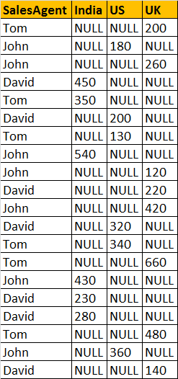

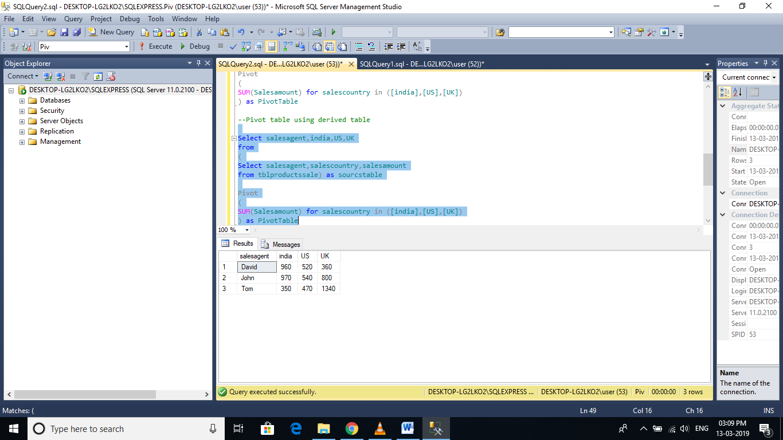

**This is because**of the presence of **Id**column in **tblProductsSale**, which is also considered when performing pivoting and group by. To eliminate this from the calculations, we have used derived table, which only selects, **SALESAGENT, SALESCOUNTRY**, and **SALESAMOUNT**. The rest of the query is very similar to what we have already seen.  
Select SalesAgent, India, US, UK  
from   
(  
   Select SalesAgent, SalesCountry, SalesAmount from tblProductsSale  
) as SourceTable  
Pivot  
(  
 Sum(SalesAmount) for SalesCountry in (India, US, UK)  
) as PivotTable  
  
**UNPIVOT**performs the opposite operation to **PIVOT**by rotating columns of a table-valued expression into column values.   
  
**The syntax of PIVOT operator from MSDN**  
SELECT <non-pivoted column>,  
    [first pivoted column] AS <column name>,  
    [second pivoted column] AS <column name>,  
    ...  
    [last pivoted column] AS <column name>  
FROM  
    (<SELECT query that produces the data>)   
    AS <alias for the source query>  
PIVOT  
(  
    <aggregation function>(<column being aggregated>)  
FOR   
    [<column that contains the values that will become column headers>]   
    IN ( [first pivoted column], [second pivoted column], ... [last pivoted column])  
)   
AS <alias for the pivot table>  
<optional ORDER BY clause>;

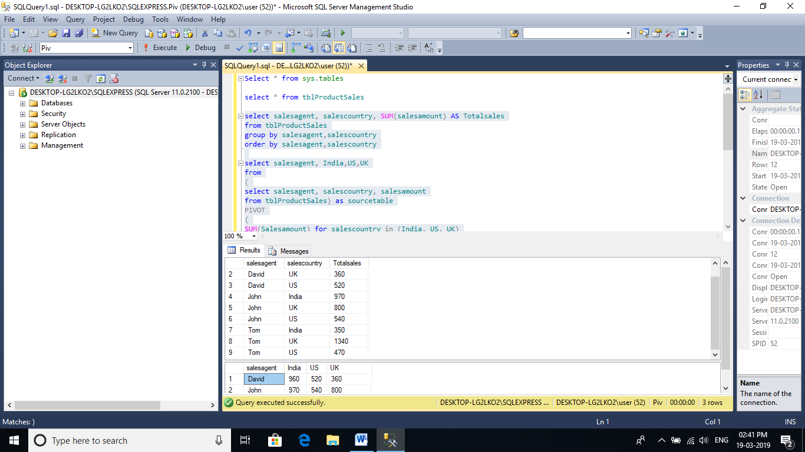

# Difference between Delete, DROP, TRUNCATE

🡪**DROP**

* The DROP command removes a table from the database.
* All the tables' rows, indexes and privileges will also be removed.
* No DML triggers will be fired.
* The operation cannot be rolled back.
* DROP and TRUNCATE are DDL commands, whereas DELETE is a DML command.
* DELETE operations can be rolled back (undone), while DROP and TRUNCATE operations cannot be rolled back

🡪**DELETE**

* DELETE is a DML command.
* DELETE is executed using a row lock, each row in the table is locked for deletion.
* We can use where clause with DELETE to filter & delete specific records.
* The DELETE command is used to remove rows from a table based on WHERE condition.
* It maintain the log, so it slower than TRUNCATE.
* The DELETE statement removes rows one at a time and records an entry in the transaction log for each deleted row.
* Identity of column keep DELETE retains the identity.
* To use Delete you need DELETE permission on the table.
* Delete uses the more transaction space than Truncate statement.
* Delete can be used with indexed views.

🡪**TRUNCATE**

* TRUNCATE is a DDL command
* TRUNCATE is executed using a table lock and whole table is locked for remove all records.
* We cannot use WHERE clause with TRUNCATE.
* TRUNCATE removes all rows from a table.
* Minimal logging in transaction log, so it is faster performance wise.
* TRUNCATE TABLE removes the data by deallocating the data pages used to store the table data and records only the page deallocations in the transaction log.
* Identify column is reset to its seed value if table contains any identity column.
* To use Truncate on a table you need at least ALTER permission on the table.
* Truncate uses less transaction space than the Delete statement.
* Truncate cannot be used with indexed views.
* TRUNCATE is faster than DELETE.

# Sub query

🡪Subqueries are always enclosed in paranthesis and are also called as inner queries, and the query containing the subquery is called as outer query.

Create Database [subquery]

use subquery

Go

Create Table tblProducts

(

[Id] int identity primary key,

[Name] nvarchar(50),

[Description] nvarchar(250)

)

Create Table tblProductSales

(

Id int primary key identity,

ProductId int foreign key references tblProducts(Id),

UnitPrice int,

QuantitySold int

)

Insert into tblProducts values ('TV', '52 inch black color LCD TV')

Insert into tblProducts values ('Laptop', 'Very thin black color acer laptop')

Insert into tblProducts values ('Desktop', 'HP high performance desktop')

Insert into tblProductSales values(3, 450, 5)

Insert into tblProductSales values(2, 250, 7)

Insert into tblProductSales values(3, 450, 4)

Insert into tblProductSales values(3, 450, 9)

select * from tblProducts

select * from tblProductSales

select Id,Name,[Description]

from tblProducts

where Id NOT IN

(Select DISTINCT ProductId from tblProductSales)

🡪The columns from a table that is present only inside a subquery, cannot be used in the SELECT list of the outer query.

Sql Exists

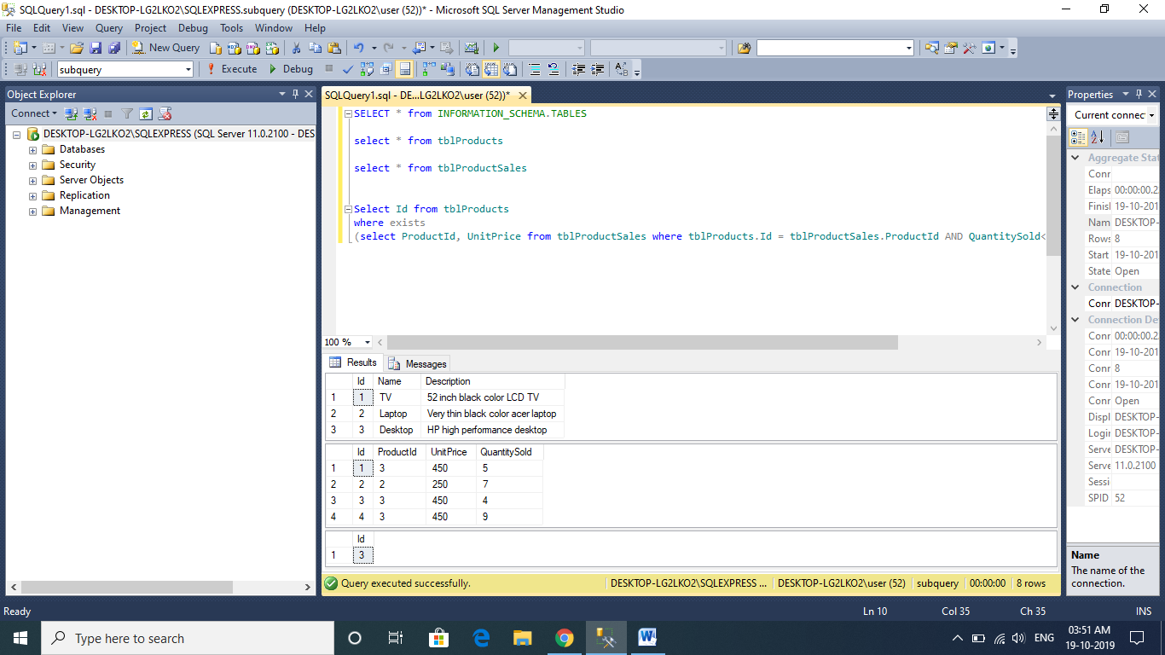

delete tblProducts

where id IN(select id from tblProductSales where QuantitySold=5)

update tblProducts

set Name = 'Washing Machine'

where id IN(select id from tblProductSales where QuantitySold=5)